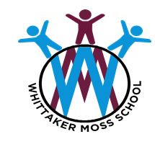
Year 2
Autumn Term
Movers and Shakers
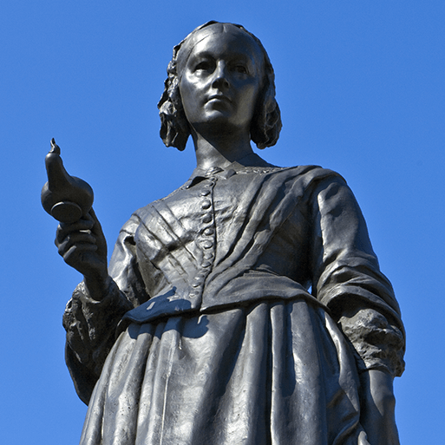
In spelling we will be learning…
- j sound spelt edge and g
- s sound spelt c before e, i and y.
- n sound spelt gn and kn
- r sound spelt wr
- l or ul sound spelt le, el and al
- Words ending il
- How to spell the year 2 common exception words.
Using our computing skills, we will be …
- Leaning about IT being all around us
- Learning about digital photography

As historians and geographers, we
will discover…
- Study local historically local people
- Study of historically important people
- Let's explore the world- look at a contrasting locality

In Music we will be discovering…
- Exploring simple patterns
- Dynamics and Tempo

As artists we will be …
- Learning how to draw Still life
As designers we will be …
- Designing our own recipes for a rice or pasts salad and learning about which foods need to be cooked to be eaten.
In PE we will be …
- Dancing
- Learning about games
- Completing an athletic unit
As readers we will be reading …
Rosa Parks by Lisbeth Kaiser
Greta and the Giants by Zoe Tucker
Our Big Learning Question
- How have historically significant people had a major impact on the world?

In RE we will be discovering…
- Islam: Who is Muslim and what do they believe?

In Life Skills and Healthy Relationships Education lessons we will be exploring…
- Friendship
- Belonging
- Staying safe on line
- Fair and Unfair

As mathematicians we will be learning …
- Place value
- Addition and Subtraction
- Shape

As writers we will be …
- Writing Genres: Biographies, Posters, Speeches, Newspaper reports
- SPAG: verbs, tense full stops and capital letters

As scientists we will …
- Learn about Human Survival
- Learn about Habitats

