
Reception
Autumn 1

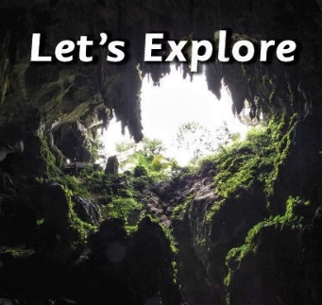
In PE we will be …
- Exploring agility, space and movement.
The children will negotiate space and obstacles safely, with consideration for themselves and others. They will develop body strength, coordination, balance and agility and join in with or make up games that involve energetic movements
As readers we will be reading …
*We’re Going on a Bear Hunt by Michael Rosen
*Where the Wild Things Are by Maurice Sendak
*In Every House, on Every Street by Jess Hitchman
*My Cat Likes to Hide in Boxes by Eve Sutton

The children will demonstrate understanding of what has been read to them by retelling stories and narratives using their own words and recently introduced vocabulary.

In phonics we will be learning…
- Phase 2 phonics sounds following the Bug Club Phonics Scheme.
Our Big Learning Questions
- Where do I live?
- Who lives in a place like this?
- What is in my new environment?

Using our computing skills, we will be …
- Using the class interactive whiteboard, taking photographs and using the school ipads.

In RE we will be discovering…
- Which stories are special and why.
In Life Skills lessons we will be exploring…
- Our emotions. Children will talk about times they have felt angry, happy, sad or scared. We will then practise making different faces to show the emotions we are feeling.
In Healthy Relationships Education we will be exploring …
- the development of relationships with other children through circle time activities and turn-taking games.
As artists we will be …
- enjoying free painting, exploring colour, materials, tools and techniques. We will use language to describe/talk about our work and our paintings.
As designers we will be …
- experimenting with colour, design, texture, form and function.
As historians and geographers, we
will discover…
- Their immediate environment using knowledge from observation, discussion, stories, non-fiction texts and maps. We will take photographs, draw simple picture maps and collect simple data during fieldwork activities.
- Children will introduce themselves to the teachers and adults they meet and take their photographs. They will explore the jobs of the adults in school and take photographs of the classrooms and areas around the school.

As mathematicians we will be learning …
Number
- Match and sort & compare amounts/groups/quantities
- Representing, comparing and composition of 1, 2, 3
- Representing numbers to 5. One more and one less
Shape
- 2D shape, circles, triangles and positional language.

Following the White Rose Scheme

As writers we will be …
- Developing our pencil grip and fine motor skills.
- Writing lists and captions.
- Giving meaning to all of our marks.
- The children will begin to form letter shapes linked to our phonics scheme.

As scientists we will …
- be using our senses and communication skills to explore and talk about our immediate environment.

