Whittaker Moss Curriculum Overview 2023-24

 |  |  | Term 1 |  |  |  |  |  | Term 2 |  |  |  |  |  | Term 3
Nursery | Main project |  |   Me and My Community |  |  | 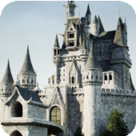  Once Upon a Time |  |  |  Starry Night |  |  | 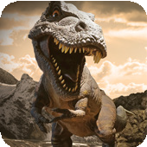  Dangerous Dinosaurs |  |  | 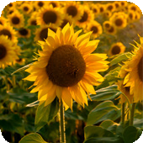  Sunshine and Sunflowers |  |  Big Wide World
Nursery | Mini project |  | Exploring Autumn |  |  | Sparkle and Shine |  |  | Winter Wonderland |  |  | Puddles and Rainbows |  |  | Shadows and Reflections |  | Splash!
Reception | Main project |  | 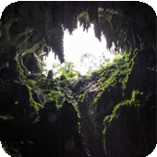 Let’s Explore |  |  |   Marvellous Machines |  |  | 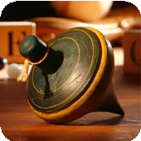 Long Ago |  |  | 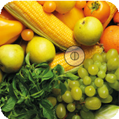  Ready Steady Grow |  |  | 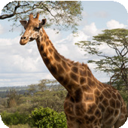 Animal Safari |  | 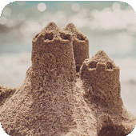 On the Beach
Reception | Mini project |  | Build It Up |  |  | Puppets and Pop Ups |  |  | Stories and Rhymes |  |  | Signs of Spring |  |  | Creep, Crawl and Wriggle |  | Move It |  | Moving On
Year 1 | Main project |  | 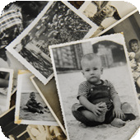  Childhood  History |  |  |  |  |  |   Bright Lights, Big City  Geography  Local History - Pioneers |  |  |  |  |  | 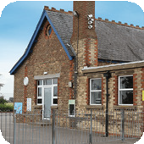  School Days  History
Year 1 | English pack genres |  | Autobiographies |  | Non-chronological reports |  | Riddles |  | Information posters |  | Directions |  | Narratives |  | List poems | Diaries |  | Letters
Year 1 | Book study |  | Wilfrid Gordon McDonald Partridge / The Paper Dolls |  |  |  |  |  | Topsy and Tim Visit London |  |  |  |  |  | Whiffy Wilson: The Wolf who wouldn’t go to school
Year 1 | Mini projects | Science | Everyday Materials |  |  | Animals Including Humans |  |  | Seasonal Changes |  |  |  |  |  | Plant Parts |  | Animals Including Humans
Year 1 | Mini projects | A&D | Mix It (Y1) |  |  | Funny Faces and Fabulous Features |  |  | Rain and Sunrays |  |  |  |  |  | Street View
Year 1 | Mini projects | D&T | Shade and Shelter / Textiles – Christmas decoration |  |  |  |  |  | Taxi! |  |  |  |  |  | Chop, Slice and Mash
Year 1 | Mini projects | Geography | Our Wonderful World |  |  |  |  |  | Geography covered in the main project |  |  |  |  |  | Geography revision and retrieval practice
Year 1 | Mini projects | Maths | Autumn White Rose Maths |  |  |  |  |  | Spring White Rose Maths |  |  |  |  |  | Summer White Rose Maths
Year 2 | Main project |  | 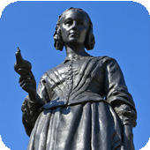  Movers and Shakers  History |  |  |  |  |  | 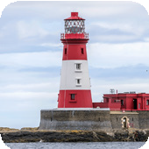  Coastline  Geography |  |  |  |  |  | 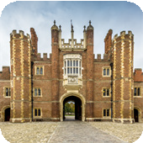  Magnificent Monarchs  History
Year 2 | English pack genres |  | Biographies | Newspaper reports |  | Posters |  | Speeches | Descriptions | Adventure narratives |  | Non-chronological reports |  | Character study | Information leaflets | Kennings poems |  | Comic strips  Recount
Year 2 | Book study |  | Rosa Parks |  |  |  |  |  | Katie Morag and the New Pier |  |  |  |  |  | Queen Victoria’s Bathing Machine
Year 2 | Mini projects | Science | Animals Including Humans |  |  | Living Things & Habitats |  |  | Uses of Materials |  |  | Plants |  |  | Animals Including Humans
Year 2 | Mini projects | A&D | Mix It (Y2) |  |  | Still Life |  |  | Flower Head |  |  |  |  |  | Portraits and Poses
Year 2 | Mini projects | D&T | Remarkable Recipes |  |  |  |  |  | Beach Hut |  |  |  |  |  | Cut, Stitch and Join |  | Push and Pull
Year 2 | Mini projects | Geography | Let’s Explore the World |  |  |  |  |  | Geography covered in the main project |  |  |  |  |  | Geography revision and retrieval practice
Year 2 | Mini projects | Maths | Autumn White Rose Maths |  |  |  |  |  | Spring White Rose Maths |  |  |  |  |  | Summer White Rose Maths

 |  |  | Term 1 |  |  |  | Term 2 |  |  |  | Term 3
Year 3 | Main project |  | 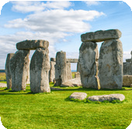  Through the Ages  History |  |  |  | 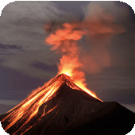  Rocks, Relics and Rumbles  Geography |  |  |  | 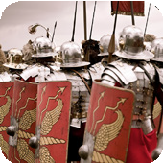  Emperors and Empires  History
Year 3 | English pack genres |  | Narratives | Instructions | Cinquains | Chronological reports | Letters | Shape poems | Newspaper reports | Biographies | Diaries | Letters |  | Myths |  | Poems
Year 3 | Novel study |  | Stone Age Boy |  |  |  | The Firework-Maker’s Daughter |  |  |  | The Life of a Roman Slave
Year 3 | Mini projects | Science | Animals Including Humans |  |  |  | Forces and Magnets Rocks |  |  |  | Plants |  |  | Light
Year 3 | Mini projects | A&D | Contrast and Complement (Y3) |  | Prehistoric Pots |  | Ammonite |  | People and Places |  | Beautiful Botanicals |  |  | Mosaic Masters
Year 3 | Mini projects | D&T | Cook Well, Eatwell |  |  |  | Textiles – cross-stitch sampler |  |  |  | Greenhouse
Year 3 | Mini projects | Geography | One Planet, Our World |  |  |  | Geography covered in the main project |  |  |  | Geography revision and retrieval practice
Year 3 | Mini projects | Maths | Autumn White Rose Maths |  |  |  | Spring White Rose Maths |  |  |  | Summer White Rose Maths
Year 4 | Main project |  | 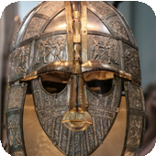  Invasion  History |  |  |  | 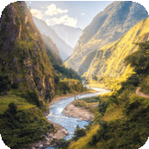  Misty Mountain, Winding River  Geography |  |  |  | 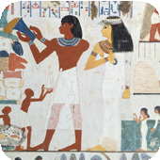  Ancient Civilisations  History
Year 4 | English pack genres |  | Anglo-Saxon poems | Stories from other cultures | Legends | Non-chronological reports | Fantasy narrative | Leaflets | Explanations | Narrative poems | Free verse poems |  | Instructions |  | Playscripts
Year 4 | Novel study |  | The Saga of Erik the Viking |  |  |  | King of the Cloud Forests |  |  |  | Secrets of a Sun King
Year 4 | Mini projects | Science | Animals Including Humans |  | Sound |  | States of Matter |  | Living Things & Habitats |  | Electricity
Year 4 | Mini projects | A&D | Contrast and Complement (Y4) |  | Warp and Weft |  | Vista |  | Animal |  | Statues, Statuettes and Figurines |  |  | Islamic Art
Year 4 | Mini projects | D&T | Fresh Food, Good Food |  |  |  | Functional and Fancy Fabrics |  |  |  | Tomb Builders / Contact and Buzzer game
Year 4 | Mini projects | Geography | Interconnected World |  |  |  | Geography covered in the main project |  |  |  | Geography revision and retrieval practice
Year 4 | Mini projects | Maths | Autumn White Rose Maths |  |  |  | Spring White Rose Maths |  |  |  | Summer White Rose Maths

 |  |  | Term 1 |  |  |  |  |  | Term 2 |  |  |  | Term 3
Year 5 | Main project |  | 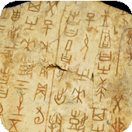  Ancient Mayans  History |  |  |  |  |  | 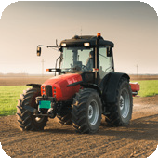  Sow, Grow and Farm  Geography |  |  |  | 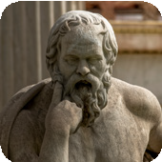  Groundbreaking Greeks  History
Year 5 | English pack genres |  | Narrative poems |  | Biographies |  | Sci-Fi Stories |  | Non-chronological reports | Diaries | Leaflets | Balanced arguments | Narrative Quest | Persuasive writing |  | Playscripts |  | Odes
Year 5 | Novel study |  | Mars Evacuees |  |  |  |  |  | Kensuke’s Kingdom |  |  |  | Who Let the Gods Out?
Year 5 | Mini projects | Science | Forces |  |  | Earth and Space |  |  | Living Things & habitats  Animals including humans |  |  |  | Properties and Changes of Materials
Year 5 | Mini projects | A&D | Tints, Tones and Shades (Y5) |  |  | Taotie |  |  | Line, Light and Shadows |  | Nature’s Art |  | Mixed Media |  |  | Expression
Year 5 | Mini projects | D&T | Moving Mechanisms |  |  |  |  |  | Eat the Seasons |  |  |  | Textiles – Ancient Greek money pouch
Year 5 | Mini projects | Geography | Investigating Our World |  |  |  |  |  | Geography covered in the main project |  |  |  | Geography revision and retrieval practice
Year 5 | Mini projects | Maths | Autumn White Rose Maths |  |  |  |  |  | Spring White Rose Maths |  |  |  | Summer White Rose Maths
Year 6 | Main project |  | 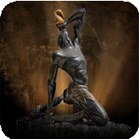  Maafa History  Local History - Pioneers |  |  |  |  |  | 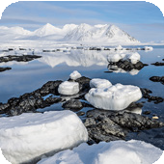  Frozen Kingdoms  Geography |  |  |  | 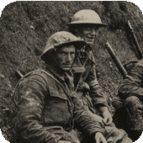  Britain at War  History
Year 6 | English pack genres |  | Diaries | Persuasive letters |  | Non-chronological reports |  | Acrostic poems | Biography | Haikus | Balanced argument | Mystery narratives | Persuasive posters  Explanations |  | Historical narratives |  | Nonets
Year 6 | Novel study |  | Freedom |  |  |  |  |  | Sky Song |  |  |  | When The Sky Falls
Year 6 | Mini projects | Science | Animals Including Humans |  |  |  |  |  | Electricity  Living Things and Habitats |  |  |  | Evolution and Inheritance |  |  | Light
Year 6 | Mini projects | A&D | Tints, Tones and Shades (Y6) |  |  | Trailblazers, Barrier Breakers |  |  | Inuit |  | Environmental Artists |  | Distortion and Abstraction |  |  | Bees, Beetles and Butterflies
Year 6 | Mini projects | D&T | Food for Life |  |  |  |  |  | Engineer |  |  |  | Make Do and Mend
Year 6 | Mini projects | Geography | Our Changing World |  |  |  |  |  | Geography covered in the main project |  |  |  | Geography revision and retrieval practice
Year 6 | Mini projects | Maths | Autumn White Rose Maths |  |  |  |  |  | Spring White Rose Maths |  |  |  | Summer White Rose Maths

