Whittaker Moss Primary School

Educational Visits Policy

September 2023
Review September 2024

Overview

Intent
At Whittaker Moss Primary School, we see the benefits to learning outside the classroom and educational visits to be crucial to the ‘Catch Up’ and recovery to learning post pandemic. We have seen real disruption to our routine, and the traumas faced by students, parents and staff has affected us all in very different ways. The opportunities to rebuild trust and relationships are much greater whilst out of the classroom. Being outside also encourages physical activity, at a time where some of our school community haven’t been able to leave the house for a long period of time.

Implementation
Learning outside the classroom activities and educational visits and are used as teaching and learning tools for the delivery of elements of Whittaker Moss Primary School’s statement of Intent

Impact
Learning outside the classroom activities and educational visits have clear and measurable aims which link to Whittaker Moss Primary School’s statement of intent/curriculum intent. The impact contributes to pupil’s attainment and progress. Whittaker Moss Primary School’s approach to the evaluation of activities and visits is set out in this policy.

Context

We believe that educational visits are an integral part of the entitlement of every pupil to an effective and balanced curriculum. Appropriately planned visits are known to enhance learning and improve attainment, and so form a key part of what makes Whittaker Moss Primary School a supportive and effective learning environment. The benefits to pupils of taking part in visits and learning outside the classroom include, but are not limited to:

- Improvements in their ability to cope with change.
- Increased critical curiosity and resilience.
- Opportunities for meaning making, creativity, developing learning relationships and practicing strategic awareness.
- Increased levels of trust and opportunities to examine the concept of trust (us in them, them in us, them in themselves, them in each other).
- Improved achievement and attainment across a range of curricular subjects. Pupils are active participants not passive consumers, and a wide range of learning styles can flourish.
- Enhanced opportunities for ‘real world’ ‘learning in context’ and the development of the social and emotional aspects of intelligence.
- Increased risk management skills through opportunities for involvement in practical risk-benefit decisions in a range of contexts. ie. encouraging pupils to become more risk aware as opposed to risk averse.
- Greater sense of personal responsibility.
- Possibilities for genuine team working including enhanced communication skills.
- Improved environmental appreciation, knowledge, awareness and understanding of a variety of environments.
- Improved awareness and knowledge of the importance and practices of sustainability.
- Physical skill acquisition and the development of a fit and healthy lifestyle.

Application

Any visit that leaves the school grounds is covered by this policy, whether as part of the curriculum, during school time, or outside the normal school day.

In addition to this Educational Visits Policy, Whittaker Moss Primary School:
- Adopts the Local Authority’s (LA) document: ‘Policy for Educational Visits and Activities Linking to OEAP National Guidance’ (All staff have access to this via Evolve).
- Adopts National Guidance www.oeapng.info, (as recommended by the LA).
- Uses EVOLVE for off-site activities beyond the local learning area.

All staff are required to plan and execute visits in line with school policy (ie this document), Local Authority policy, and National Guidelines. This is also a requirement of the LA’s trips & visits insurance policy for schools. Staff are particularly directed to be familiar with the roles and responsibilities outlined within the guidance.

Types of Visit & Approval

There are three ‘types’ of visit:

- Visits/activities within the ‘School Learning Area’ that are part of the normal curriculum and take place during the normal school day.

- Other non-residential visits within the UK that do not involve an adventurous activity.
These are entered on EVOLVE by the visit leader and submitted to the EVC for checking. The EVC then submits to the Head for approval.

- Visits that are overseas, residential, or involve an adventurous activity.
As above, but the Head authorises and then submits to the LA for approval.

Timescales
Whittaker Moss Primary School uses the Evolve system to plan, manage and record educational visits.

Visit Leaders should plan and prepare visits allowing time for internal and external vetting and approval as required. Normally this will mean that visit plans should be submitted to the EVC by the following deadlines:
- 3 to 6 months before departure for Overseas Visits
- 4 weeks before departure for Residentials
- 4 weeks before departure for Adventure Activities
- 2 weeks before departure for other types of visit
If for any reason these deadlines cannot be met, clarification and approval should be sought from the EVC.

Roles and responsibilities

Visit leaders are responsible for the planning of their visits, and for entering these on EVOLVE (where required). They should obtain outline permission for a visit from the Head Teacher and the EVC prior to planning, and certainly before making any financial commitments. Visit leaders have responsibility for ensuring that their visits will comply with all relevant guidance and requirements.

The Educational Visits Coordinator (EVC) is Dorita Stevenson, who will support and challenge colleagues over visits and learning outside the classroom (LOtC) activities. The EVC is the first point of contact for advice on visit related matters, and will check final visit plans on EVOLVE before submitting them to the Head. The EVC sets up and manages the staff accounts on EVOLVE, and uploads generic school documents, etc.

The Head Teacher has responsibility for authorising all visits and for submitting all overseas, residential or adventurous activity visits to the LA for approval, via EVOLVE. They will also give the guidance on ratios of pupils to staff for all year groups. This will depend on the activity being undertaken and the cohort. See Appendix 4 for help with this.

The Governing Body’s role is that of a ‘critical friend’ and it will:
- Adopt and periodically review this policy, as required.
- Ensure there is a competent Educational Visit Coordinator (EVC) in place who meets the requirements outlined in ‘National Guidance’ and has completed the Employer’s EVC Training Programme and any updates as required.
- Review the range of visits provided by the school via a report submitted twice a year by the EVC.

The Local Authority is responsible for the final approval (via EVOLVE) of all visits that are either overseas, residential, and/or involve an adventurous activity.

Evaluation

We will evaluate our activities and visits using the evaluation tool on Evolve. The following will be used to evaluate the impact on learning of the trip. In addition to usual assessment methods, we will use
- Photographs / Video which may be taken on the trip
- Pupil Voice where appropriate using Google forms
- We will look at the behaviour of our pupils on the trip and any feedback that may be given from the provider or any members of the public who may be present at the time.
- Staff will look at the impact that this trip has had on the learning and discuss with HT if the trip has been value for money to have a significant impact on the learning taking place in the classroom.

Staff Competence

Whittaker Moss Primary School recognises that staff competence is the single most important factor in the safe management of visits, and so we support staff in developing their competence in the following ways:
- An apprenticeship system, where staff new to visits assist and work alongside experienced visit leaders before taking on a leadership role.
- Supervision by senior staff on some educational visits.
- Support for staff to attend training courses relevant to their role, where necessary.

In deciding whether a member of staff is competent to be a visit leader, the Head Teacher will take into account the following factors:
- Relevant experience.
- Previous relevant training.
- The prospective leader’s ability to make dynamic risk management judgements, and take charge in the event of an emergency.
- Knowledge of the pupils, the venue, and the activities to be undertaken.

Emergency procedures

A critical incident is any incident where events go beyond the normal coping mechanisms and experience of the visit leadership team.

The school has an emergency plan in place to deal with a critical incident during a visit (see Appendix 2). All staff on visits are familiar with this plan and it is tested at least bi-annually and following any major staffing changes.

When an incident overwhelms the establishment’s emergency response capability, or where it involves serious injury or fatality, or where it is likely to attract media attention then assistance will be sought from the local authority.

Educational Visits Checklist
Whittaker Moss Primary School’s Educational Visits Checklist forms part of the risk management process for visits and off-site activities. This has been adapted from the LA’s generic checklist. A visit should only go ahead if the answer to all relevant questions is ‘YES’. Whittaker Moss Primary School’s Educational Visits Checklist may be downloaded from EVOLVE Resources.

Parental Consent
Consent is not required for activities within the School Learning Area that are part of the normal curriculum during normal school time.

The school obtains blanket consent at the start of each year for routine activities, eg. Local walks, visits to local churches, swimming lessons etc. Generic Risk Assessment is detailed at Appendix 3. Parents will be informed about when these will happen by their child’s class teacher.

Specific, (ie. one-off), parental consent must be obtained for all other visits. For these visits, sufficient information must be made available to parents, so that consent is given on a ‘fully informed’ basis.

Inclusion
Whittaker Moss Primary School will make every effort to ensure that outdoor learning activities and visits are available and accessible to all, irrespective of special educational or medical needs, ethnic origin, gender or religion.

We will comply with the requirements of the Equality Act 2010 with regards to inclusion.

Transport
Transport arrangements are in line with the generic risk assessment which is at Appendix 4

Use of staff cars to transport pupils
- This is only with permission of the head teacher.
- Two members of staff must be in the car with pupils from the school.
- The driver properly understands their duty of care and any agreed responsibilities for supervision. Parents are informed about the transport arrangements.
- Evidence is obtained that: The vehicle is safe. This means that it holds a valid MOT certificate, where relevant, that the driver certifies it has been serviced in line with the manufacturer’s schedule, and that the driver carries out any pre-use checks specified by the manufacturer. The driver is suitable. This means that they hold a valid license for the type of vehicle and meet any employer requirements. There is a valid insurance policy covering the driver and the vehicle for the intended use. This will require that the driver has ‘business use’ cover.
- Suitable car seats and seat belts must be in place for the age and size of the pupils being transported.

Use of parents to transport pupils to an event
.
Sometimes parents are asked to help with transport to a venue.
When this happens, we will be clear which of the following applies
: • Parents are being asked to volunteer as drivers, as part of the establishment’s transport arrangements for the visit. If this is the case, then the drivers should be engaged as volunteers and the considerations above should be applied.
• Parents are being asked to organise transport, which may involve some parents providing lifts for children other than their own. If this is the case, then the establishment should make clear that it will not be involved in making these arrangements and will not have any responsibility for them. Where parents are being asked to organise their own transport, the establishment should consider the need for:
• Information from parents about what arrangements have been made.
• Communication with parents, in case of delays or ‘no shows’.
• Clear handover of supervision from and to parents at the venue, depending upon the age of the children and other relevant factors.
• The provision by the establishment of transport for any children whose parents are unable to make such arrangements.

Insurance

Whittaker Moss takes out the LA’s insurance for visits.

General
Visits/activities within the ‘School Learning Area’ that are part of the normal curriculum and take place during the normal school day follow the Operating Procedure below. See appendix 1

These visits/activities:
- do not require parental consent
- do not normally need additional risk assessments / notes (other than following the Operating Procedure below).
- do not need to be recorded on EVOLVE

Boundaries

The boundaries of the School Learning Area include the following frequently used venues: e.g.
- Touchstone
- Local Libraries
- Local Churches
- Other Local Schools
- Norden Village
- Etc.

- Dismissal of pupils
All children are to be brought into school once they have arrived back from a school trip and staff will register the children again to ensure they have all arrived back in school. The office will need to be informed.
If this is at the end of the school day, only then will they be released back into their parents’ care, if at the end of the school day.
If school is not open, for example coming back from a trip outside of the school day, or if children are being dismissed not from school, the teacher must ensure that they have recorded that the child has been picked up by a designated adult.

- Use of volunteers
The use of volunteers is at the discretion of the Head teacher.
Volunteers will only be there to help supervise children and will not have any other responsibilities on the trip.
Any volunteers will NOT be allowed to have a group on their own and when looking after a group of children will always be in the eye line of a member of school staff.
Any volunteers are expected to work and behave to the same standard as any member of the school staff.

- Swimming Lessons
The school will ensure that we follow the guidance and risk assessments when using the coach to transport children to and from the swimming pool.
Staff will supervise children appropriately in changing areas and ensure that children are clear on the safety procedures that will take place whilst in the leisure centre.
Staff will adhere to the instructions given to them by the professionals at the pool teaching the lessons and the lifeguard who is ensuring the safety of the children. If at any time the staff feel these are not appropriate or will put children at risk they will take the appropriate measures to ensure the safety of the children and then report these back to the EVC officer and Head teacher.
The school will ensure that first aid will be provided by the provider at the swimming pool.

- Sports Fixtures
The school will ensure that appropriate risk assessments are in place when children attend any sporting fixtures either during or outside of the school day.
The staff member accompanying the children will be responsible for ensuring the correct first aid is in place.
If needed, parents will need to arrange their own travel, school will not be able to do this.
The staff member accompanying the trip will ensure that all the children have arrived safely and depart the event with an appropriate adult if parents are not allowed to stay.

Appendix 1 – School Learning Area

General

Visits/activities within the ‘School Learning Area’ that are part of the normal curriculum and take place during the normal school day follow the Operating Procedure below.

These visits/activities:
- do not require parental consent however if they children are leaving the school site parents will be informed via a letter.
- do not normally need additional risk assessments / notes (other than following the Operating Procedure below).
- do not need to be recorded on EVOLVE

Boundaries

The boundaries of the School Learning Area are shown on the attached map. This area includes, but is not limited to, the following frequently used venues:
- Local churches in Norden
- Cenotaph in Norden
- The local housing estate as far as Clay Lane and down to Eden field Road.

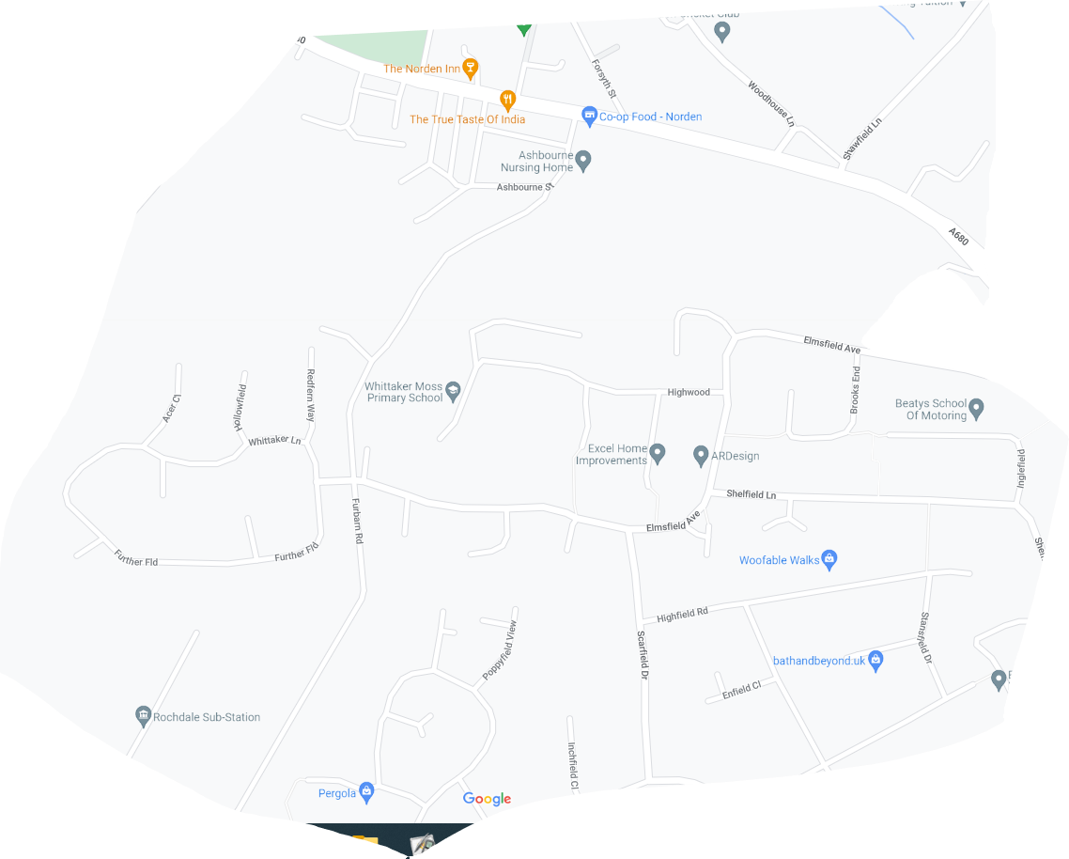

Operating Procedure for School Learning Area

The following are potentially significant issues/hazards within our School Learning Area:
- Road traffic.
- Other people / members of the public / animals.
- Losing a pupil.
- Uneven surfaces and slips, trips, and falls.
- Weather conditions.
- Activity specific issues when doing environmental fieldwork (nettles, brambles, rubbish, etc).

These are managed by a combination of the following:
- The Head or Deputy must give verbal approval before a group leaves.
- Only staff judged competent to supervise groups in this environment are approved. A current list of approved staff is maintained by the EVC and office.
- The concept and Operating Procedure of the ‘School Learning Area’ is explained to all new parents when their child joins the school, and a synopsis is in the School Prospectus.There will normally be a minimum of two adults. This number will increase in EYFS and KS1.
- Staff are familiar with the area, including any ‘no go areas’, and have practiced appropriate group management techniques.
- Pupils have been trained and have practiced standard techniques for road crossings in a group..
- Where appropriate, pupils are fully briefed on what to do if they become separated from the group. This will depend on where they are going.
- All remotely supervised work in the School Learning Area is done in ‘buddy’ pairs as a minimum.
- Pupils’ clothing and footwear is checked for appropriateness prior to leaving school.
- Staff are aware of any relevant pupil medical information and ensure that any required medication is available.
- Staff will deposit in the office a list of all pupils and staff, a proposed route, and an estimated time of return..
- A school mobile is taken with each group and the office have a note of the number.
- Appropriate personal protective equipment is taken when needed (eg gloves, goggles)
- Any trips that require children going across Edenfield road, the pelican crossing will be used if in the area. If not then two members of staff will stop the traffic on both sides of the road until all children are safely across.

Appendix 2 – Emergency Procedure

Our plan in an emergency is:

The school’s emergency response to an incident should be based on the following key factors:

- There is always a nominated emergency base contact for any visit (during school hours this is the office).
- This nominated base contact will be the Head teacher and if they are not available the Deputy Head teacher.
- For activities that take place during normal school hours, the visit leadership team will be aware of any relevant medical information for all participants, including staff.
- For activities that take place outside normal school hours, the visit leadership team and the emergency contact/s will be aware of any relevant medical information and emergency contact information for all participants, including staff.
- The visit leader/s and the base contact/s know to request support from the local authority in the event that an incident overwhelms the establishment’s emergency response capability, involves serious injury or fatality, or where it is likely to attract media attention.
- For visits that take place outside the School Learning Area, the visit leader will carry an EV7 (see below)
- This Emergency Procedure is tested through both desk top exercises and periodic scenario calls from visit leaders.

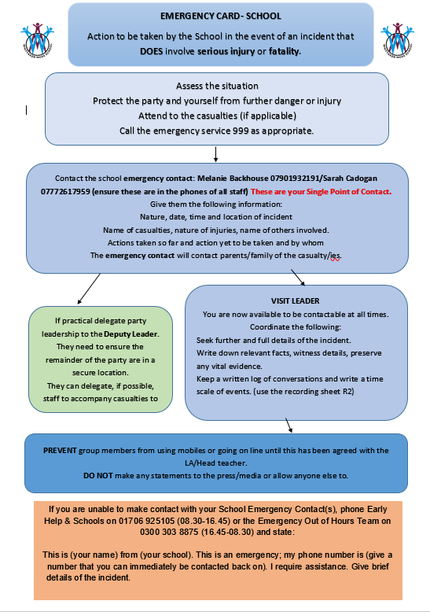

Appendix 4- Ratio of staff to pupils

A useful framework for assessing requirements for ratios and effective supervision is SAGE.
S • Staffing: who is needed/available? The plan must work within the limits of available numbers, abilities and experience.

A • Activities to be undertaken: what do you want the group to do and what is possible?

G • Group characteristics: prior experience, abilities, behaviour and maturity, sex, any specific individual needs.

E • Environment: indoors or out; a public space or restricted access; urban, rural or remote; quiet or crowded; within the establishment grounds, close to the establishment or at a distance; and the ease of communications between the group and base. Do not overlook environments to be passed through between venues. For residential visits consider the accommodation and surrounding area. For outdoor environments, consider remoteness, the impact of weather, water levels and ground conditions. Consider the implications of current guidance about avoiding infection during an epidemic.

If a child has a 1:1 support this adult cannot be included in the numbers of staff.

