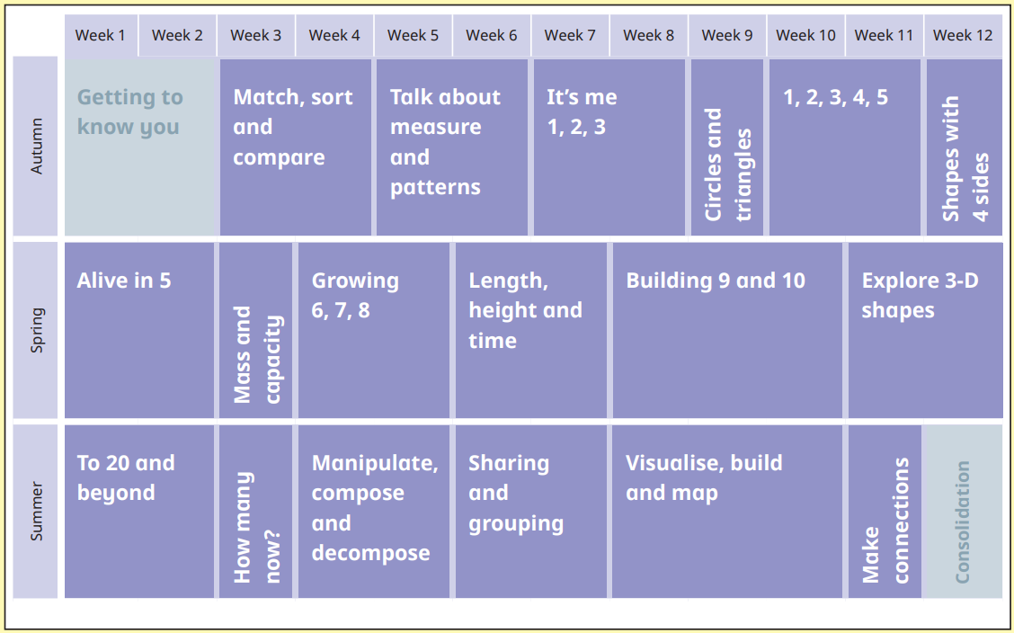
Reception- Yearly overview 25-26

Year 1 – Yearly overview 25-26
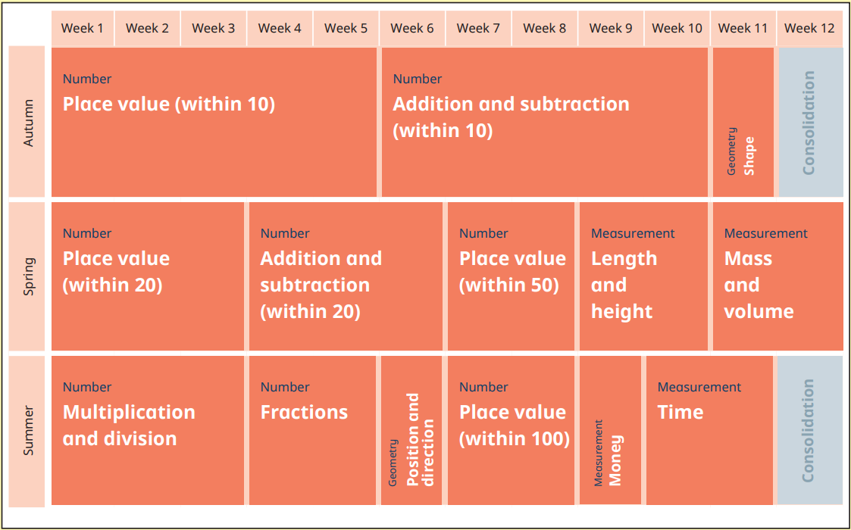

Year 2 – Yearly Overview 25-26
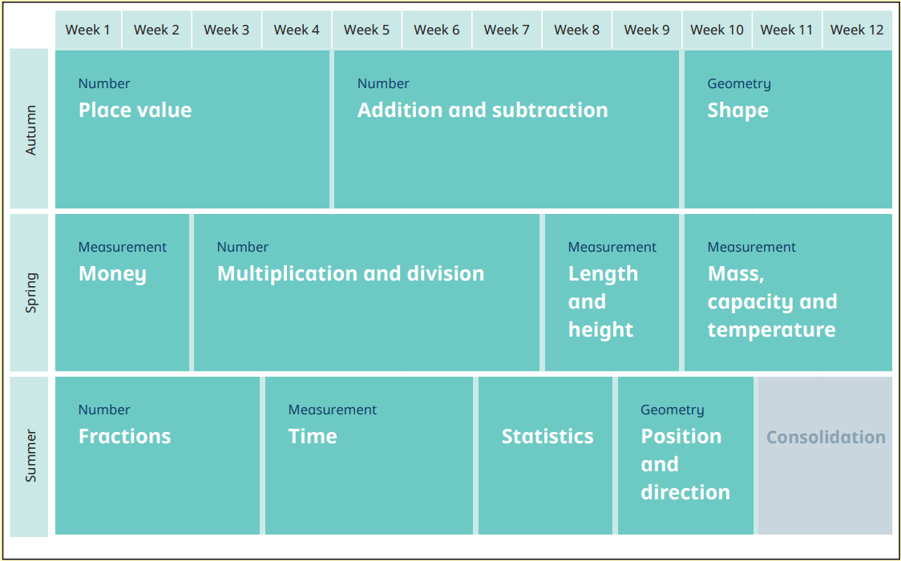

Year 3 – Yearly overview 25-26
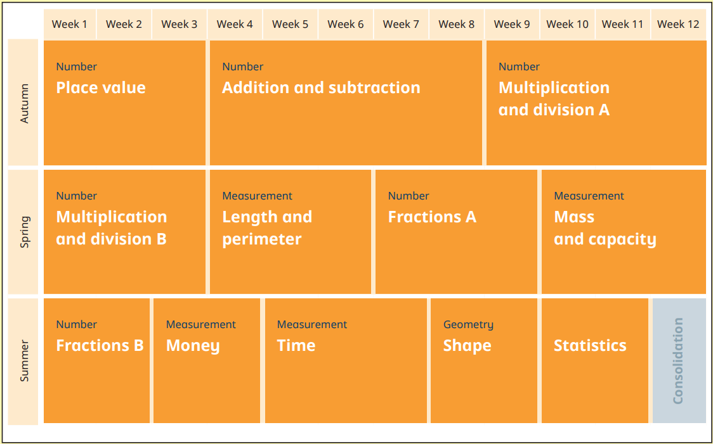

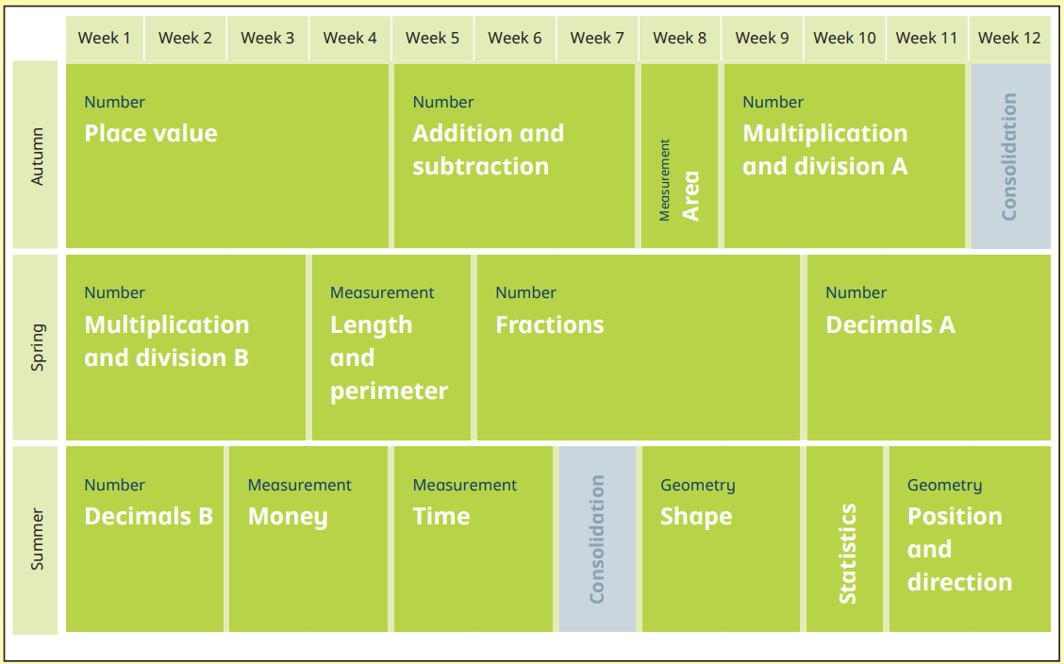
Year 4 – Yearly overview 25-26

+ negative
numbers
Mov to Spr 2
Cm, mm, g, Kg

Area

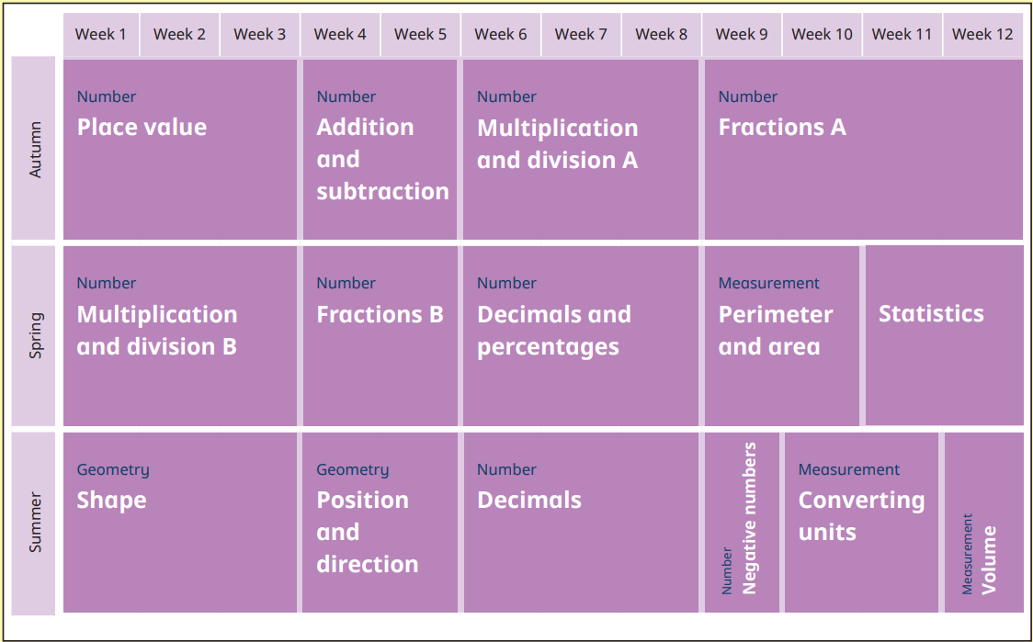
Year 5 – Yearly Overview 25-26

Year 6 – Yearly Overview 25-26
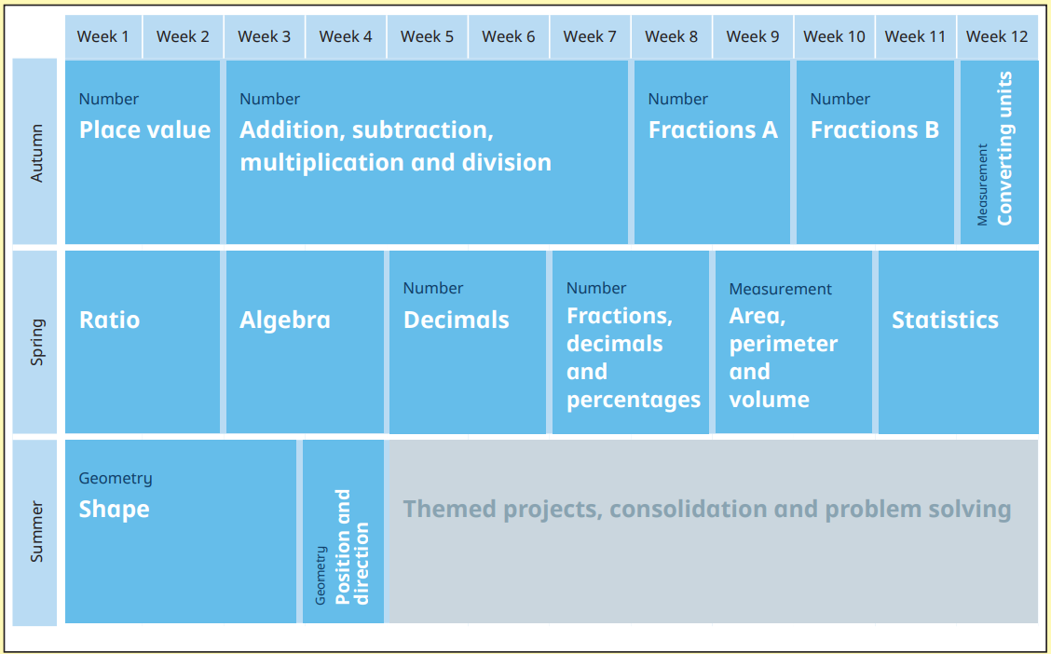

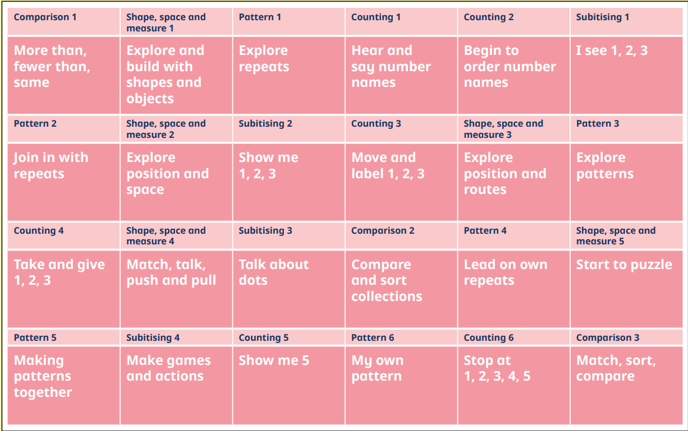
Nursery – Yearly Overview 25-26

