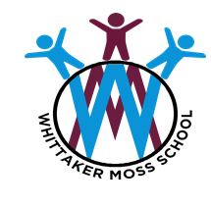
In RE we will be discovering…
- Which people are special and why.
In Life Skills (Think Equal) lessons we will be exploring…
- What is meant by bravery and times when we may need to show bravery.
- How to be responsible and look after our environment.
In Healthy Relationships Education we will be exploring …
Our Happy Mind programme and we will be practicing our happy breathing and learning lots about how are brain works.
As mathematicians we will be learning …
Growing 6,7, and 8 – Finding different representations of 6,7 and 8. Exploring 1 more and 1 less than, within 8 plus the composition of 6,7 and 8.
Length, Height and Time – Compare length and height, use the correct vocabulary and correctly sequence events.
Building 9 and 10 - Finding different representations of 9 and 10. Number bonds to 10.

Following the White Rose Scheme

As writers we will be …
- Developing our pencil grip and fine motor skills.
- Writing an innovated story linked to our key quality texts.
- Begin to use finger spaces
- Practising our letter formation, orientation and writing left to right.

As readers we will be reading …
*The Tiger Who came to Tea by Judith Kerr
* Peepo by Janet and Allan Ahlberg
*The Baby’s Catalogue by Janet and Allan Ahlberg

The children will demonstrate understanding of what has been read to them by retelling stories and narratives using their own words and recently introduced vocabulary. To children will use actions to support them to retell familiar stories.

As historians and geographers, we
will discover…
- How our school environment has changed over the years.
- Order events and use language relating to the passing of time, such as 'first', 'then', 'next', and 'after.
- Begin to look at and explore simple timelines.

Using our computing skills, we will be …
- Using the class tablets
- Finding out how to stay safe online
- Exploring how technology has changed over the years.

As scientists we will …
- Explore the different seasons and how the weather changes with each passing season.
- Look at how we have changed since being a baby. We will investigate how we have developed over time.
In phonics we will be learning…
- Phase 3 phonics sounds following the Bug Club Phonics Scheme.
- Applying Phase 2 and 3 sounds in our reading and writing.
Our Big Learning Questions

- How have I grown and changed since I was a baby?

- How was life in the past, different to today?

As artists we will be …
- Drawing our self- portraits using charcoal.
As designers we will be …
- Using resources to transform a t-shirt. Children will learn to make a simple pompom to decorate their clothing.
- Using photo stimulus of old buildings to create our own buildings using a range of wooden blocks.
In PE we will be …
- learning how to move with confidence in different ways, whilst holding an object. Children will develop a range of different ball skills including bouncing. Pupils will perform underarm and overarm throwing actions.

Reception
Spring 1

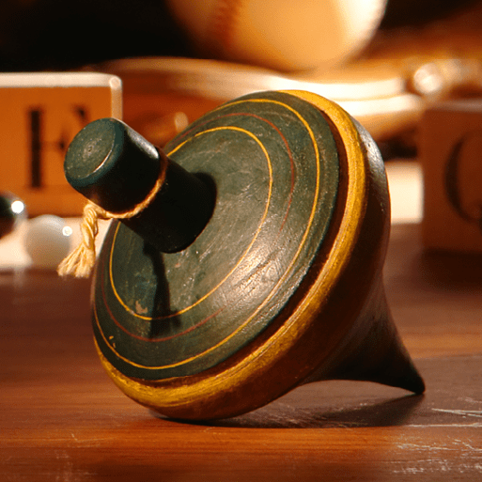
Long Ago

