Nursery Yearly overview – 2025-2026
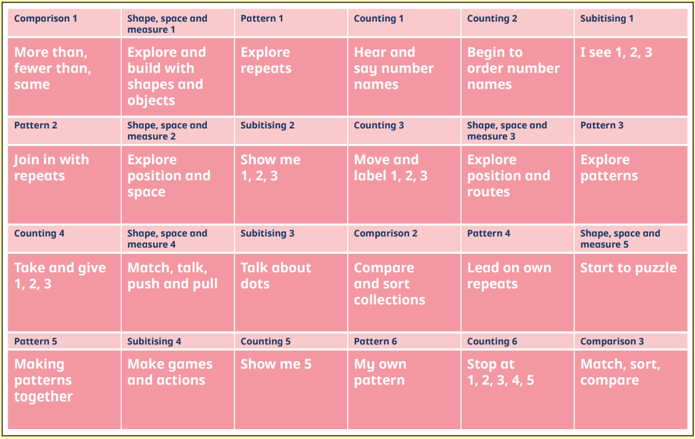

Reception Yearly Overview- 2025-2026
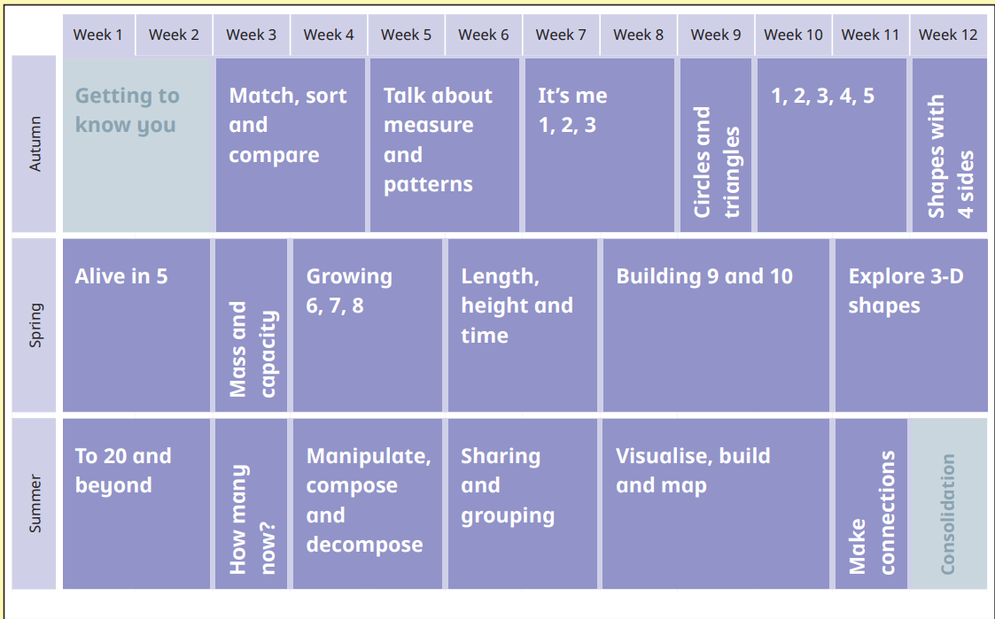

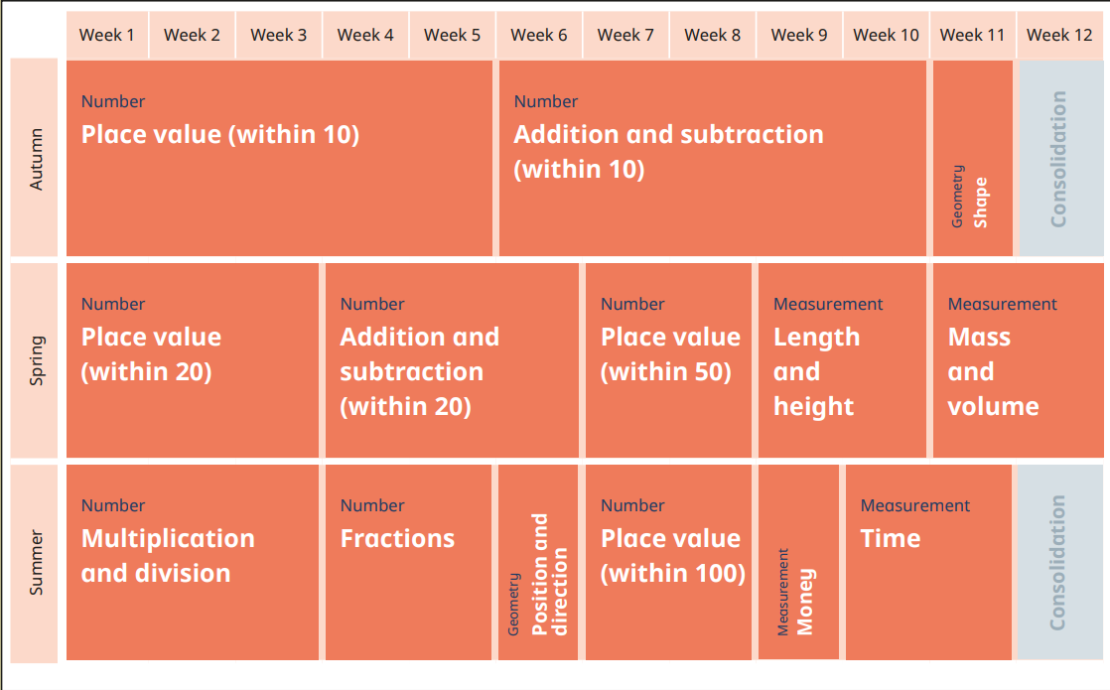
Year 1 Yearly overview- 2025-2026

Year 2 Yearly overview- 2025-2026
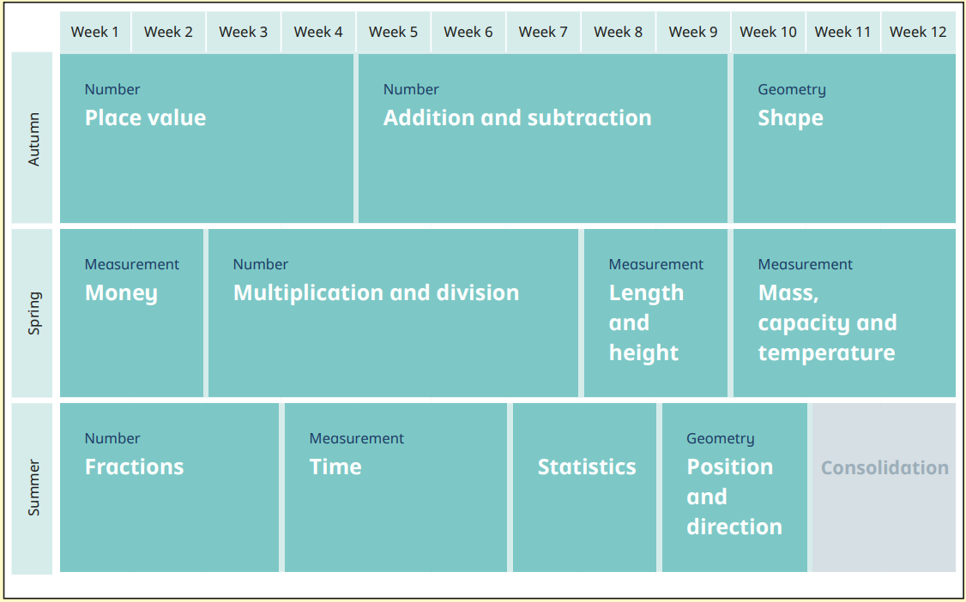

Year 3 yearly overview 2025-2026
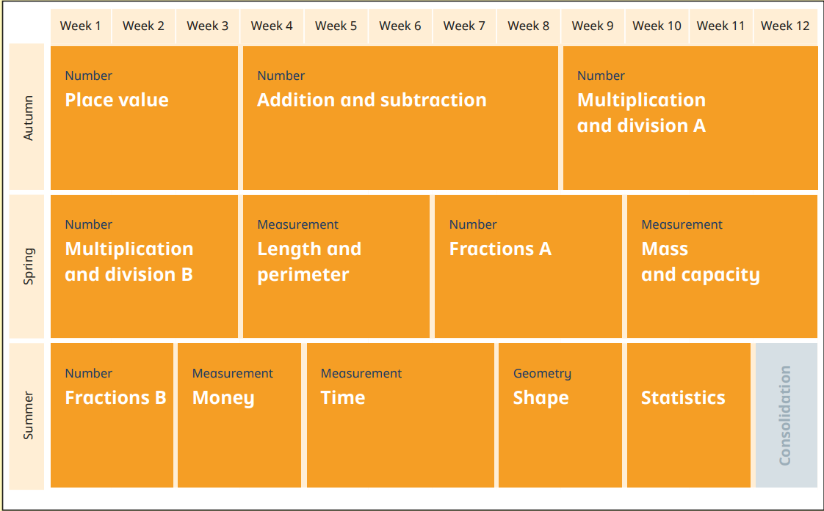

Year 4 Yearly overview 2025-2026
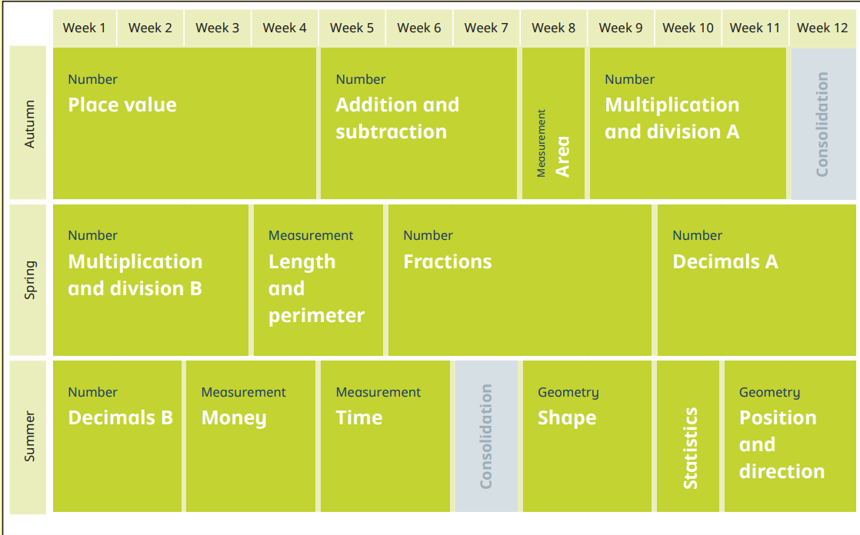

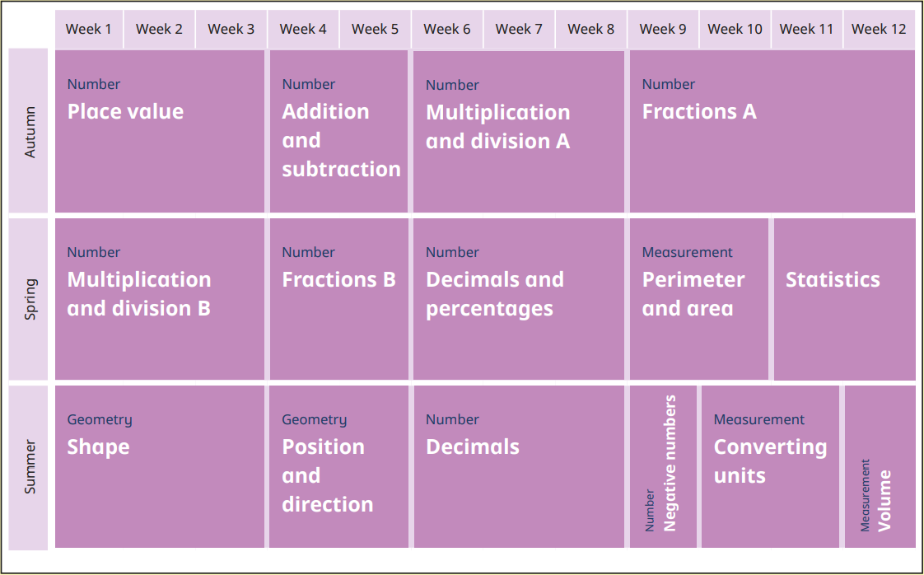
Year 5 yearly overview – 2025-2026

Year 6 yearly overview- 2025-2026


