

Whittaker Moss Primary School

HANDWRITING POLICY

REVIEWED: Dec 2025
NEXT REVIEW: Dec 2027

Handwriting policy
At Whittaker Moss Primary School, we aim for all children to be confident and comfortable when handwriting so that they can achieve their best when using writing to communicate their ideas. We recognise that handwriting is a complex process requiring the development of many different skills and we give children the support they need to match their rate of development in handwriting.

Aims
- To develop the correct posture and pencil grip for writing
- To form all letters correctly
- To use appropriate spacing
- To enable as many children as possible to achieve a neat and legible style of joined handwriting by the end of KS1
- To enable as many children as possible to develop a fluent handwriting style

Teaching Structure
In Nursery, developing children’s gross and fine motor skills is priority at Whittaker Moss Primary School. To support this, children are given lots of opportunity for outdoor play and access to wide range of gross and fine motor activities. We provide as many opportunities as possible for the development of early mark making using different tools such as paint brushes and chalk.
In Reception, the development of mark making, and gross and fine motor skills remains a priority, alongside the teaching of letter formation. Children practise handwriting patterns. We follow Bug Club phonics scheme, which teaches letter formation clearly within the lessons. Children learn to write letters using lined whiteboards or paper, including how to position ascenders and descenders correctly.
Children are introduced to the letter families at the beginning of the year so that as they learn letter formation as part of the phonics lessons, teachers will remind them which family each letter belongs to.
Children across our school are taught handwriting in discrete sessions (including Reception), focusing on the correct formation. When they are ready, children are introduced to making diagonal and horizontal joins in their writing. Depending on the class and individual needs, additional practise can take place with targeted groups.
From Year 1, we follow the guidelines from Nelson Handwriting to support the development of good practise in children’s handwriting.

Preparation for handwriting:
- Children are taught to sit with the correct posture, at a fist sized distance away from the table. They are taught to sit up straight with their feet on the floor.

- Teachers model the tripod pencil grip for both left and right handers encouraging a 2cm gap between the fingertip and pencil point (slightly greater for left handers). From reception, children are taught the ‘Charlie Crocodile’ action to aid the development of the correct grip.

- Children are taught to tilt and offset the paper according to their writing hand, and to move the paper up or down as they write.

- Teachers discuss the need for correct pressure during handwriting lessons. Gross and fine motor warm ups are be used to develop body awareness and resources such as different types of pencil or pen can be used to aid the development of appropriate pressure.

Letter formation and handwriting practise:
- Children are taught letter formation using a simple modern style. Letter formation should focus on the starting point and movement pattern, using a range of activities using their fingers and air writing before using pencil and paper. Within Reception, letter formation families should always be referred to when teaching. Letters ending on the base line, such as ‘d’, should have an exit flick.

- Children are taught about appropriate spacing.

- Children are taught about the size and position of letters.

- When children are ready, they are taught diagonal and horizontal joins. They are also taught that some letters are break letters and are better left unjoined. We follow the Nelson Handwriting guidance for joining.

- In Year 6, children are encouraged to develop their own independent style, supported by the Nelson handwriting scheme.

Additional provision
For children with SEND and/or handwriting difficulties, a range of strategies and resources can be used, such as different types of pen, pencil, pencil grip, different sized lines, wobble cushions and wedges. If a child is using a pencil grip that is uncomfortable or affecting the speed or fluency of their writing, an alternative pencil grip can be introduced.

Appendix
Posture and pencil grip – Left handers and right handers
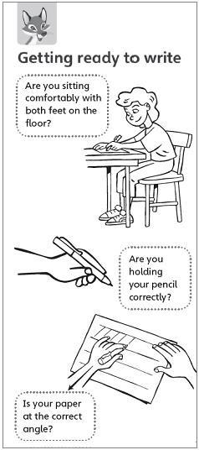
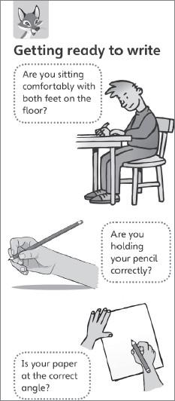

National Curriculum
EYFS Personal Development ELG:
- Hold a pencil effectively in preparation for fluent writing- using the tripod grip in almost all cases
EYFS Writing ELG:
- Write recognisable letters, most of which are correctly formed

KS1 (year 1) Pupils should be taught to:
- Sit correctly at a table, holding a pencil comfortably and correctly
- begin to form lower-case letters in the correct direction, starting and finishing in the right place
- form capital letters
- form digits 0-9
- understand which letters belong to which handwriting ‘families’ and to practise these

KS1 (Year 2) & KS2 Pupils should be taught to:
- Form lower case letters of the correct size relative to one another
- Start using some of the diagonal and horizontal strokes needed to join letters and understand which letters, when adjacent to one another, are best left unjoined
- Write capital letters and digits of the correct size, orientation and relationship to one another and to lower-case letters
- Use spacing between words that reflects the size of the letters

Letter families
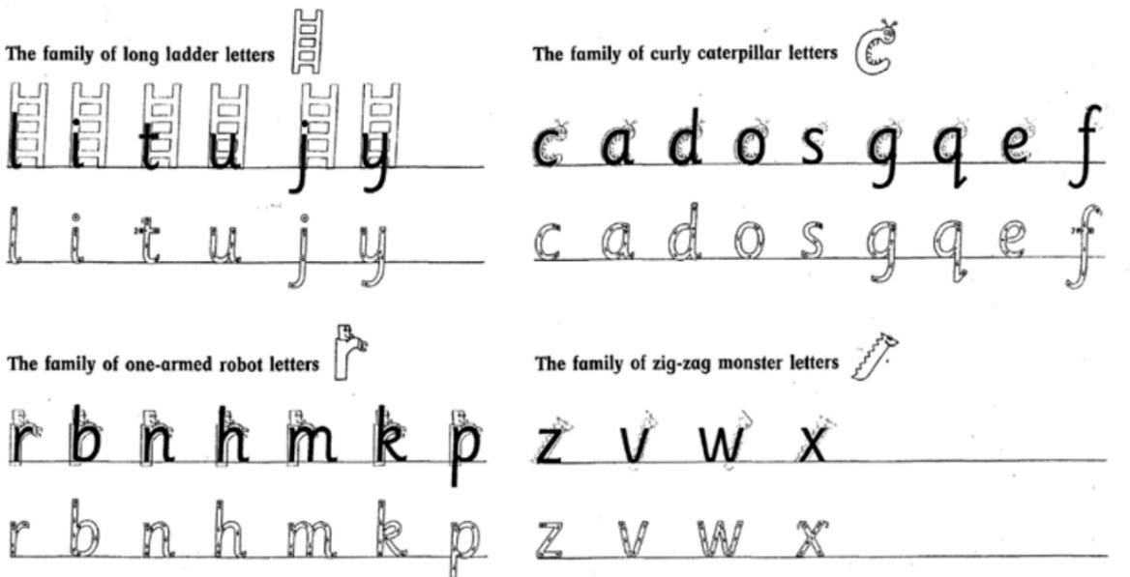

Capital letter families
E F H I L T C G O Q S B D P R U A V W X Y K M N Z

EYFS-
In EYFS children will practice their letter formation in the following order:

- Curly Caterpillar Letters

- One-armed Robot Letters

- Long Ladder Letters

- Zig-Zag Monster Letters

Capital letters will also be taught within EYFS

Handwriting joins
We teach children to join or break using the Nelson Handwriting sets of join types and break letters.

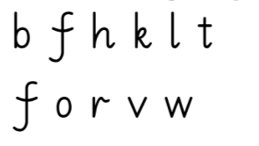
Joining Groups

1 | Letters with exit flicks, plus s
2 | Letters which start at the top of the x-height
3 | Letters that start at the top of the ascender
4 | Letters that finish at the top of the x-height
Break letters | Letters after which no join is made | 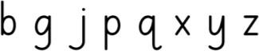

The Joins
First Join (Group 1 to  Group 2) | Diagonal join from the end point of one letter to the  start point of the next. | 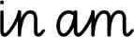  e.g
Second Join (Group 1 to  Group 3) | Diagonal join meets the ascender half way up the letter and then continues to  the top of the ascender. |   e.g.
Third Join (Group 4 to  Group 2) | A horizontal join going from the x-height of one letter  to the x-height of another. | e.g.
Fourth Join (Group 4 to  Group 3) | Diagonal join that goes from the x-height of one letter to the top of the  ascender of the next. |   e.g.
Break letters | Letters after which no join is made | 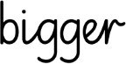  e.g.

Number Formation


