
As mathematicians we will be learning …

- To 20 and beyond – building numbers beyond 10 and verbally counting beyond 20.
- How many now? – Add more/Takeaway.
- Manipulate, Compose and Decompose – Rotate and manipulate shapes. Copy 2D pictures and find 2D shapes within 3D shapes.

Following the White Rose Scheme

As artists we will be …
- Exploring patterns, natural patterns in the animal world. The children will then explore different ways to create these patterns using a range of media.
As designers we will be …
- Designing and then constructing animal homes using a range of materials and resources.
As historians and geographers, we
will discover…
- Which animals live in hot climates and which live in colder climates.
- How to look after our environment to ensure that no animals get hurt.
- How animals help us both in the past and in the present day.
As scientists we will …
- Be looking at animals and their babies.
- Discuss and compare different animals.
- Looking at different animal patterns and exploring why animals have different patterns.

Using our computing skills, we will be …
- Using the class tablets to play educational games and take photographs and videos.
- Finding out how to stay safe online

In phonics we will be learning…
- Phase 4 phonics following the Bug Club Phonics Scheme.
- Recalling common exception words from Phase 2 and 3 and learning new Phase 4 words.
- Recalling and applying Phase 2 & 3 sounds.
Our Big Learning Questions
- Where do different animals live and why?
- How can looking after our environment help animals?

In RE we will be discovering…
- Which places are special and why?
In Life Skills (Think Equal) lessons we will be exploring…
- The 5 senses.
- How both boys and girls can both express their feelings and achieve the same things
In Healthy Relationships Education we will be exploring …
- the development of relationships with other children through circle time activities, turn-taking games and the community circle.
As readers we will be reading …
* Dear Zoo
* Monkey Puzzle
*Handa’s Hen

The children will demonstrate understanding of what has been read to them by retelling stories and narratives using their own words and recently introduced vocabulary. Children will retell the stories using actions to support them.

In PE we will be …
- Progressing towards a more fluent style of moving, with developing control and grace.
- Combining different movements with ease and fluency.
- Developing overall body-strength, balance, co-ordination and agility

Reception
Summer 1

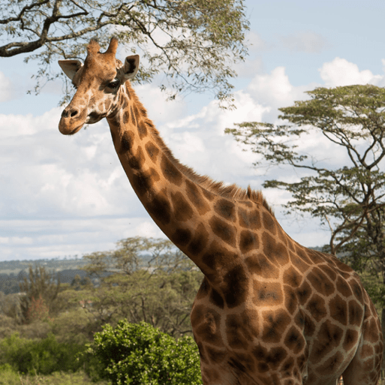
Animal Safari
As writers we will be …
- Practising letter formation through handwriting activities.
- Segmenting to spell unfamiliar words and applying common exception words in their writing
- Innovating and writing stories.
- Developing our sentence structure and use of punctuation.

