Name of the Senior Attendance Champion: Sarah Cadogan

Introduction

Whittaker Moss Primary School is proudly recognised as an Inclusive Attendance school. Our unwavering commitment to attendance centres around child-centric actions, evidence-informed practices, and a shared understanding of everyone's roles and collective responsibilities to promote exceptional attendance.
At Whittaker Moss Primary School, we are driven by an unwavering commitment to making school attendance a top priority, fully integrated with every aspect of school improvement. Using the Inclusive Attendance Model – the first and only accredited programme providing the pedagogy of practice – we support children and families to connect, belong, and thrive.

Inclusive Attendance Professional Development Model
The Inclusive Attendance professional development model fundamentally guides our attendance approach. Comprising six tailored Learning Modules, this model empowers us to deepen our understanding by facilitating continuous professional learning for all staff. Within this model, the four domains of practice ensure the provision of professional learning, professional development, evidence-based practices, and exemplary leadership and management seamlessly integrate theory into practice.

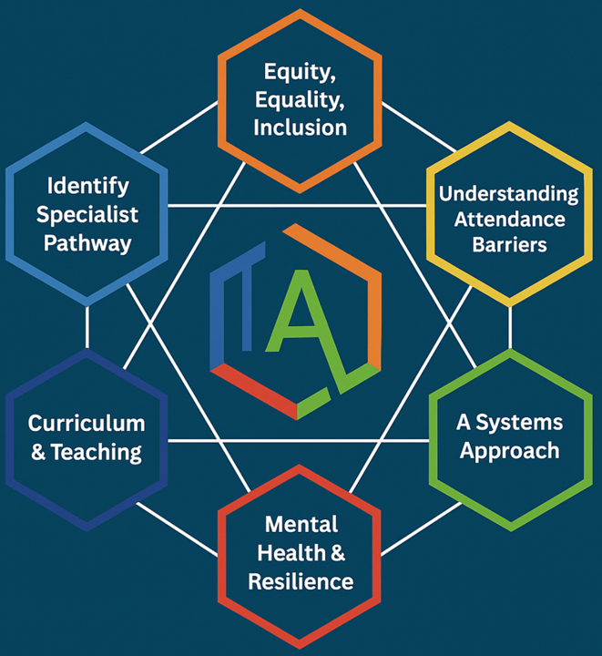

Impact and Collaboration
Through our ongoing year-long implementation programme, and five-year long-term strategy, we deliver measurable impact by creating an inclusive attendance culture and improving outcomes for children and young people. We are outward-facing in our approach and value working regionally and nationally, through a systems-led model with other schools and external agencies. We continually strengthen and enhance our offer year on year. This work is underpinned by ongoing accredited CPD for staff, ensuring sustainable change, stronger outcomes for children and young people, and a deeply embedded culture of collective responsibility.

A Multi-Tiered System of Support

To guarantee a comprehensive approach to attendance, Whittaker Moss Primary, implements a Multi-Tiered System of Support. A Multi-Tiered System of Support (MTSS) for school attendance involves three tiers of intervention, with roles for teachers, the school, children, parents, and external agencies – including the Local Authority. Data-driven decision-making and training requirements are pivotal to the implementation of this system. The system aligns with the Department for Education's (DFE) "Working Together to Improve School Attendance" statutory paper 2024.

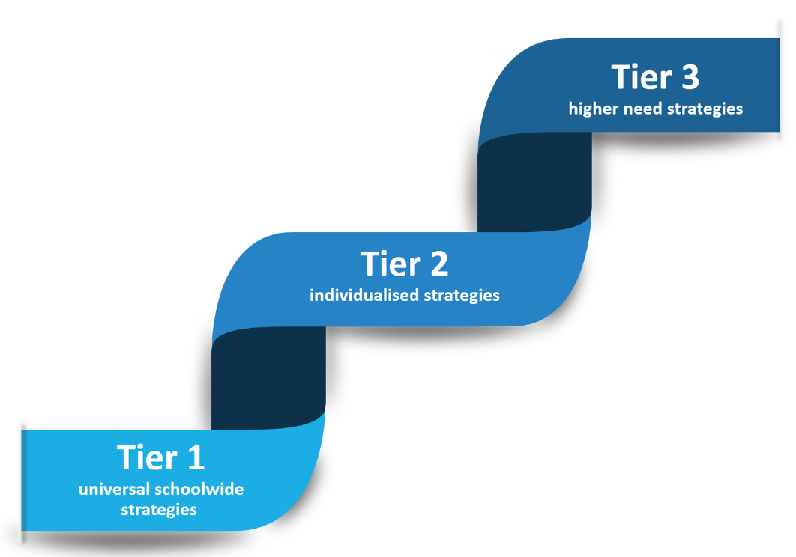

Tier 1 - Universal Approach: Establishing a baseline universal attendance approach that benefits all children.

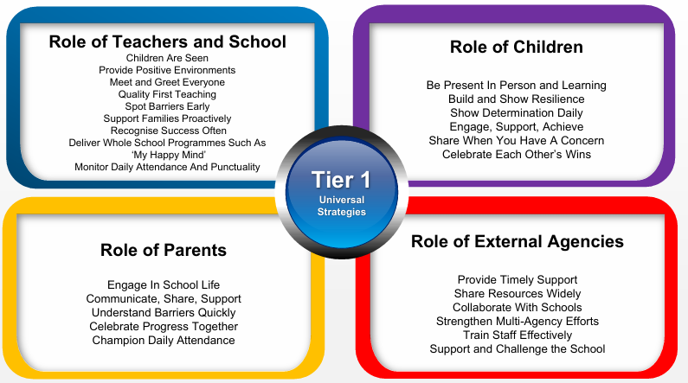

Tier 2 – Internal individualised Strategies and Early Help Support: Tailoring strategies to individual needs and providing early help support for persistent attendance challenges.

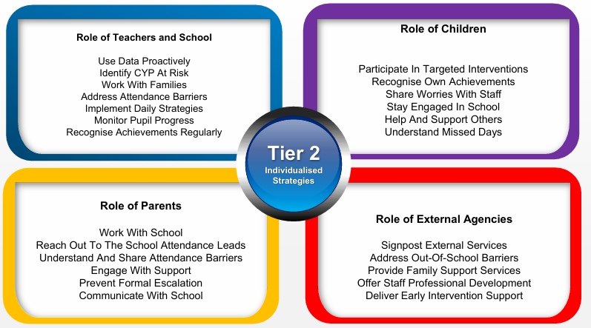

Tier 3 - Higher Needs Strategies Support: Furnishing specialised support for children, young people, and families with complex attendance requirements, including access to external agency support when necessary.

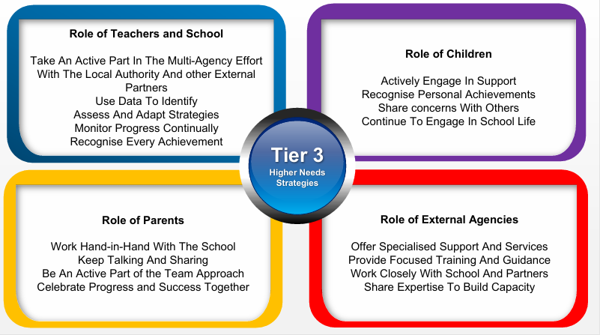

The Importance of School Attendance at Whittaker Moss Primary School

School attendance is not merely a statutory requirement but a fundamental pillar of education. It plays a pivotal role in shaping academic success, personal growth, and future prospects, making it an indispensable aspect of any educational system. Regular attendance to school can have a significant impact on:

- Academic Achievement: Regular attendance directly correlates with academic success. Children who attend school consistently are more likely to keep up with the curriculum, perform better in exams, and improve their life outcomes.
- Knowledge Acquisition: School is where children acquire knowledge and skills that are crucial for their personal and professional growth. Missing days means missing out on valuable learning opportunities.
- Social Development: School provides a vital social environment for children and adolescents to interact with peers, develop friendships, and learn essential social skills. Consistent attendance ensures children remain connected to their peer group.
- Building Routine: School attendance establishes a structured routine in children’s lives, teaching them time management and responsibility, which are valuable life skills.
- Teacher Interaction: Regular attendance allows for meaningful teacher-child interactions. Teachers can provide personalised support, address questions, and assess individual progress more effectively when children attend regularly.
- Preventing Knowledge Gaps: Frequent absences can lead to significant knowledge gaps, making it challenging for children to catch up with missed lessons, potentially resulting in long-term academic struggles.
- School Engagement: Children who attend school regularly are more likely to engage in extracurricular activities, sports, and other enriching experiences that contribute to their overall development.
- Legal and Parental Responsibility: Parents or guardians are legally responsible for ensuring their child's regular school attendance. Failing to do so can lead to legal consequences.
- Community Well-being: High levels of school attendance contribute to the overall well-being of communities.

As a parent you can help us by:

- Ensuring your child is in school for 8.50am every day – this will help them to settle into the morning routines and be ready to work.
- Ringing the school office if your child is unable to attend for any reason, on the first morning of any absence. Please state the reason why your child will be absent and the expected date of their return.
- Keeping us updated with how your child is during prolonged periods of absence – ring every other day to let us know how they are getting on.
- Arranging dental and medical appointments out of school hours or during school breaks.
- Booking any holidays during the school holidays and not in term time.

School will help by:

- Following up unexplained absences by a phone call as soon as possible.
- Reminding parents of the importance of regular attendance and punctuality in newsletters, the school brochure and the Home-School agreement.
- Acknowledging and rewarding good attendance.
- Sharing your child’s attendance at Parents’ Evenings and in their yearly report.
- Meeting with you to discuss any concerns around your child’s attendance.
- Supporting you with an attendance plan if required. This will identify any barriers to attendance, offer targeted support and suggest any adjustments needed.
- Identifying any out of school barriers to attendance and signposting you to any required services.
- Making a referral to the School Education Welfare Officer, if needed. They visit the school regularly to review and support attendance matters.
- Proactively using data to identify pupils at risk of poor attendance.
- Taking an active role in multi-agency efforts to address an attendance issue.
- Intensifying support through Children’s Social Care if there are safeguarding concerns.
- Sharing information with the local authority and other local schools to identify barriers to attendance.
- Celebrating good attendance by acknowledging class achievements with weekly attendance awards and individual attendance shout outs in assembly. We give out individual one hundred percent attendance awards at the end of term in July.
In addition to this, the School Council, in November 2024, voted for the following rewards for good attendance to be put in place:
- All pupils who have contextually good attendance will go into a prize draw. Three attendance winners will be drawn to receive a reward. An example of this is a family cinema ticket.
- Classes who win the best weekly attendance three times will receive an extra break.
- The class that wins the weekly attendance award the most times over the year, will be rewarded with a movie and snacks afternoon.

Attendance and Punctuality Expectations at Whittaker Moss Primary School

Understanding types of absence:
Every half-day absence from school has to be classified by the school (not by the parents), as either AUTHORISED or UNAUTHORISED. Therefore, information about the cause of any absence is always required. An explanation of register codes can be found in Appendix 3.
Illness / Medical Appointments:
Authorised absences are mornings or afternoons away from school for a good reason like illness, emergencies, or other unavoidable cause. Sometimes, children may have to attend hospital, speech therapy or other appointments within school time. Proof of an appointment must be provided to school. In the case of illness, where an illness extends for more than three days, medical evidence (card, prescribed medicine label etc.) must be shown to school otherwise the absence will be unauthorised. Intermittent medical absences, even if they are below three days in duration, will also
require medical evidence if the attendance of the child falls below 90% (19 days absent). We encourage parents/carers to arrange routine medical and dental appointments outside of school hours or in the holidays. When reporting an illness, we ask parents to call 01706 342342 and choose the report an absence option.

Religious Observance:

At Whittaker Moss Primary we recognise the different cultures and faith communities that reside within our school. We acknowledge that different faiths and cultures have different celebrations throughout the year. We treat religious observances as an authorised absence and in most cases, this is the day of the religious event. As per the Local Authority recommended guidelines, school will authorise one day of absence per religious event, when occurring in term time.

Exceptional Circumstances:

Parents who wish to take their child out of school for any other reason during term time are asked to make this request to the Head Teacher at least two weeks before the requested date by e-mailing head@whittakermoss.rochdale.sch.uk. Only the Head Teacher can make a decision on whether to authorise a request and will respond by e-mail.
Each request for exceptional leave will be considered as a separate case and the Head Teacher’s
decision will take into account the following, as contained in the DCSF Circular 10/99:
● The reason for the leave and why it could not be taken in school holidays;
● The number of days requested;
● Previous requests for leave during term-time;
● The child’s attendance and punctuality record (broadly speaking we would expect a pattern
of attendance consistently at or above 95%);
● The time of year proposed for the trip;
● The age of the child and stage of education, any additional needs they may have, their
current attainment and level of progress and any impact the leave will have on their
learning.

We are not unsympathetic to difficult or special circumstances and will always consider requests for absence that, if then authorised, are recorded as ‘other circumstances’. Examples of this might be urgent trips to see seriously ill relatives, or special opportunities in sport or music. Parents are informed that although these are all authorised absences, they will still affect a child’s attendance percentage and will show up in their end of year report.

Unauthorised Absence:
Unauthorised absences are those which the school does not consider reasonable and for which no permission has been given. This includes:
- Parents/carers keeping children off school unnecessarily
- absences which have never been properly explained
- children who arrive at school too late to get a mark
- shopping, looking after other children or birthdays
- day trips and holidays in term time which have not been agreed.

If school has evidence that an absence is due to an unauthorised holiday (regardless of any reasons that may have been given), school will refer this to the Local Authority for a Penalty Notice, providing them with any relevant evidence we have to confirm our suspicions. In these circumstances, the onus will be on those holding Parental Responsibility to provide evidence to the contrary.

Whilst any child may be off school because they are ill, sometimes they can be reluctant to attend school. Any problems with regular attendance are best sorted out between the school, the parents and the child. If your child is reluctant to attend, it is never better to cover up their absence or to give in to pressure to excuse them from attending. This gives the impression that attendance does not matter and usually makes things worse. The school pastoral and school senior mental health leads will support families where anxiety can impact a child’s attendance at school.

Persistent Absenteeism (PA) and Severe Absenteeism:

A pupil becomes a ‘persistent absentee’ when they miss 19 days or more of schooling across the school year for whatever reason. Absence at this level is doing considerable damage to any child’s educational prospects and we need parents’ fullest support and co-operation to tackle this.
We monitor all absence thoroughly. Any case that is seen to have reached the PA mark or is at risk of moving towards that mark is given priority and you will be informed of this immediately. Attendance data collected is used to track whole school, class, group and individual attendance. The school’s attendance data is shared daily with the DfE so that national comparisons can be made. The attendance data of PA pupils is tracked and monitored on a weekly basis. Persistent absence can have serious implications for a child’s learning, and this can often be highlighted through our assessment tracking system at Whittaker Moss.
All PA cases are also automatically made known to the Education Welfare Team at Rochdale Local Authority. We will work together with families to put in place interventions to help improve

attendance. This may include signposting families to wider support services. The impact of such interventions will be monitored through the attendance data collected. School will work with the Local Authority team to provide Attendance Panels if required.
A pupil is deemed ‘severely absent’ if they miss 95 days or more of school sessions. Such absence will be extremely detrimental to a child’s education. Any pupil whose attendance is a major concern will be quickly identified by the school and support for the family will be formalised in conjunction with the local authority. If families do not engage with the support offered, penalty notices or other legal interventions may be sought.
Telephone numbers:
There are times when we need to contact parents about lots of things, including absence, so we need to have your contact numbers at all times. Help us to help you and your child by making sure we always have an up-to-date number – if we don’t then we may conduct a home visit if a child is absent from school and contact cannot be established.

The Education Welfare Officer:
Our attendance is monitored by the Education Welfare Service. If your child’s attendance is a concern, this may lead to a referral to the Education Welfare Officer, a subsequent meeting and potential legal action from the local authority. They scrutinise all records and registers and, with the Head Teacher’s agreement, contact all those with attendance figures below 90% (19 days + missed), as listed above. Attendance is monitored daily, weekly, monthly, and half-termly by the Pastoral Lead and SLT and they will then report all attendance concerns to the EWO.

Final Penalty Notices and Legal Advisory Meetings:

The difference between a Final Penalty Notices (FPNs) and a Legal Advisory Meetings (LAMs): When a parent takes a child out of school, they may be asked to attend a LAM or pay a FPN. This depends on the duration of time the child has been away for.
Legal Advisory Meeting: The Local Authority may call in a parent to discuss the child’s attendance.
Final Penalty Notice: Rochdale Local Authority penalise families who take too much time from school. Parents can receive a FPN for: 1. Any Unauthorised Absences; 2. Exceptional Leave (extended absences); 3. Persistent Absence. The school has a legal right to refer any families to the Education Welfare Service who fall into any of these sections. Parents can be penalised if a child has been away from school for more than 5 school days (10 sessions).

CME
Where a child is absent from school for a prolonged period of time, or we have been unable to establish contact with the family to establish the child’s whereabouts, they will be classified as a ‘Child Missing Education’. This is a Safeguarding issue and the school will complete a referral to the CME team at the Local Authority who will work to make contact with the family and establish the whereabouts and what educational provision is being made for the child.

Lateness
Poor punctuality is not acceptable. If your child misses the start of the day, they can miss work and do not spend time with their class teacher getting vital information and news for the day. Arriving late can disrupt lessons, can embarrass the child and can also encourage absence.

How we manage lateness:
The school day starts at 9:00am and we expect your child to be in class at that time. The school doors are opened at 8:50am. (Nursery session times start at 8:45am and 12:45am)
Registers are marked by 9.10am and your child will receive a late mark (L) if they arrive between 9.10am and 9.30am.
At 9.30am the registers will be closed, and any child absent without a reason already communicated to school will be marked with a ‘U.’ This means that the absence is unauthorised and will remain as such unless we receive an appropriate reason from you.
If your child has a persistent late record, you will be asked to meet with the Deputy Headteacher and/or Pastoral Lead to resolve the problem, but you can approach us at any time if you are having problems getting your child to school on time.

Holidays in Term Time:
The Government has issued Local Authorities and schools with new strict guidelines about taking holidays in term time. Whittaker Moss Primary School does not authorise holidays in term time for any reason. In the School Attendance Regulations 2024, it states clearly that a leave of absence only should be given because of the exceptional circumstances of the request.
Any period of leave taken without the agreement of the school will be classed as unauthorised and may attract sanctions such as a Penalty Notice.
A five-day unauthorised holiday absence (ten school sessions) will be eligible for a fine of £160 per parent, per child (reduced to £80 per parent, per child if paid within twenty-one days). A referral for a Penalty Notice also applies for three separate holiday absences over the academic year, regardless of their duration. Failure to pay fines could lead to prosecution in magistrates’ court. The school has produced an information leaflet for parents regarding holidays in term time and fines. (Appendix 3).

Contact Details of School Staff at Whittaker Moss

Name of Staff Member | Roles and Responsibilities | Contact Details
Sarah Cadogan | Attendance Champion | scadogan@whittakermoss.rochdale.sch.uk
Maggie Beswick | Pastoral Lead | mbeswick@whittakermoss.rochdale.sch.uk
Melanie Backhouse | Safeguarding Leader (DSL) | mbackhouse@whittakermoss.rochdale.sch.uk
Melanie Backhouse | Head Teacher – if different to the Attendance Champion | mbackhouse@whittakermoss.rochdale.sch.uk
Frank Hayley | Governor for School Attendance. | fhayley@whittakermoss.rochdale.sch.uk

Coding of Attendance

Attendance will be recorded using the DFE's statutory attendance codes. Please refer to appendix 1 for coding.

Policies and Practice

This attendance policy operates within the framework of statutory attendance regulations outlined in the Education (Pupil Registration) (England) Regulations 2006 and subsequent amendments. Whittaker Moss Primary School adheres to the following key attendance acts in the UK:

Education Act 1996: The Education Act 1996 is the primary piece of legislation that sets out the legal framework for school attendance in England and Wales. It outlines the responsibilities of parents, carers, and schools in ensuring regular school attendance. Sections 444-447 of the Act deal with offenses related to non-attendance and penalties for parents and carers.

Education (Pupil Registration) Regulations 2006: These regulations specify the procedures for registering pupils and maintaining attendance records in schools in England. They also define the circumstances in which a pupil can be marked as absent or present.

Education (Pupil Registration) (England) (Amendment) Regulations 2013: These regulations amended the 2006 regulations and introduced stricter rules on authorizing term-time holidays. Under these regulations, headteachers are only allowed to grant leave of absence in exceptional circumstances.

School Attendance Code of Practice: The School Attendance Code of Practice provides guidance to schools, local authorities, and parents on the law and procedures relating to school attendance and absence. It sets out the principles for promoting good attendance and dealing with poor attendance.

Local Authority School Attendance Guidance: Each local authority in the UK may provide its own guidance and policies on school attendance. Schools should be aware of and follow the specific guidance issued by their local authority.

Department for Education (DFE) Guidance: The DFE periodically issues guidance documents and updates related to school attendance. Schools should stay informed about the latest DFE guidance 2024 and follow any recommendations or requirements outlined in these documents. (Appendix 2)

Child Employment Legislation: Legislation such as the Children and Young Persons Act 1933 and the Children (Performances) Regulations 1968 govern the employment and attendance of children involved in performances, modelling, and other activities outside of regular school hours.

Children Missing Education (CME) Statutory Guidance: This guidance outlines the responsibilities of local authorities in identifying and tracking children who may be missing education, including those who are not on a school roll or are not receiving suitable education.

Section 19 of the Education Act 1996 (England and Wales) outlines the duty of local authorities in ensuring that suitable education is provided for children of compulsory school age.

Additional Policies aligned to the Attendance Policy at Whittaker Moss Primary School

- Behaviour Policy
- Teaching and Learning Policy
- Safeguarding Policy
- Mental Health Policy
- SEND statement
- Pupil Premium Policy

Safeguarding Children and Attendance at Whittaker Moss Primary School

The school has a duty to safeguard the welfare of all students. Any concerns about a child's attendance will be investigated promptly to ensure their well-being.

Unexplained or extended absences will trigger safeguarding procedures, including home visits and communication with relevant agencies.

We follow Keeping Children Safe In Education guidance to ensure safe practices.

Summary:
The school has a legal duty to publish its absence figures to parents and to promote attendance. Equally, parents have a duty to make sure that their children attend.
The Governing Board will review attendance termly and hold Senior Leaders to account for how absence is recorded and managed.
All school staff are committed to working with parents and pupils as the best way to ensure as high a level of attendance as possible and that every child’s welfare and life opportunities are promoted.
We ask for your full support in helping us to achieve these outcomes for your child/children.

Review
This Attendance Policy will be reviewed annually by the school's governing body to ensure its effectiveness and compliance with statutory requirements. Any amendments will be communicated to staff, parents, and carers as necessary.

Policy written June 2026
Next Review Date: June 2027 (or earlier if legislation changes)
Sarah Cadogan: Deputy Head Teacher

Appendix 1: Coding Attendance in line with DFE guidance 2024:
Code /\ (Present at the school):
  - Pupils must be present during registration to be counted.
  - If a pupil leaves after registration, they are still counted as attending for statistical purposes.
Code L (Late arrival before the register is closed):
  - The pupil arrives after the register starts but before it closes.
  - Schools should discourage late arrival and set a consistent time limit for open registration, not exceeding 30 minutes.
  - If a pupil arrives late after the register closes, mark them as absent using code U or another appropriate absence code.
Code K (Attending education provision arranged by the local authority):
  - Pupil attends educational provision arranged by the local authority, not by the school.
  - Examples include attending courses at college or receiving home tutoring.
  - Schools must record the nature of the provision and ensure notification of absences.
Code V (Attending an educational visit or trip):
  - Pupil attends a school-arranged educational visit or trip supervised by school staff.
  - Must take place during the recorded session.
  - If pupil doesn't attend, record absence using relevant absence code.
Code P (Participating in a sporting activity):
  - Pupil attends an approved educational sporting activity.
  - Criteria for recording attendance include approval by the school, educational nature of the activity, and appropriate supervision.
  - Schools must ensure safeguarding measures and record absences with relevant codes.
Code W (Attending work experience):
  - Pupil attends work experience as part of their education arranged by the local authority or school.
  - Criteria for recording attendance are similar to other approved educational activities.
  - Schools must ensure safeguarding measures and record absences with relevant codes.
Code B (Attending any other approved educational activity):
  - Pupil attends an approved educational activity other than sports or work experience.
  - Criteria for recording attendance are similar to other approved educational activities.
  - Schools must record the nature of the activity and ensure safeguarding measures.
Code D (Dual registered at another school):
  - Used when a pupil is registered at more than one school, indicating absence with leave to attend the other school.
  - Main examples include attendance at a pupil referral unit, hospital school, or special school temporarily.
  - Schools must promptly follow up on unexpected or unexplained absences to avoid double counting.
Code C1 (Leave of absence for regulated performance or employment abroad):
  - Schools grant leave for pupils to participate in regulated performances or employment abroad under specific circumstances.
  - Criteria for granting leave include licenses issued by local authorities or exemptions.
  - Schools must record the absence using this code and consider its impact on the pupil's education.
Code M (Leave of absence for medical or dental appointment):
  - Schools encourage appointments outside of school hours; otherwise, prior agreement is necessary.
  - Leave of absence is granted under specific conditions, including exceptional circumstances.
  - Absences for medical or dental appointments are recorded using this code.
Code J (Leave of absence for interview for employment or admission):
  - Schools can grant leave for pupils to attend interviews for employment or admission to another educational institution.
  - Applications for leave must be made in advance, and leave is granted based on specific criteria.
  - The interview must occur during the recorded session, and the absence is classified as authorized.
Code S (Leave of absence for studying for a public examination):
  - Schools can grant leave for pupils to study for public examinations under specific conditions, agreed in advance with parents.
  - Study leave should be granted sparingly, and provisions must be made for pupils who choose to continue attending school for revision.
  - Absences for studying for public examinations are recorded using this code.
Code X (Non-compulsory school age pupil not required to attend school):
  - Schools can grant leave for non-compulsory school-age pupils to attend school part-time under certain circumstances.
  - Absences for non-compulsory school-age pupils are recorded using this code, with exceptions noted.
  - For pupils subject to a part-time timetable, this code should not be used, and appropriate absence codes should be applied.
Code C2 (Leave of absence for compulsory school age pupil subject to part-time timetable):
  - Schools can grant leave for compulsory school-age pupils to temporarily reduce their timetable to part-time in exceptional circumstances, agreed upon with parents.
  - Absences for pupils with part-time timetables are recorded using this code, ensuring agreement between the school and parents.
Code C (Leave of absence for exceptional circumstances):
  - Schools may grant leave of absence at their discretion, but only for exceptional circumstances.
  - Each application is assessed individually, considering specific facts and circumstances.
  - Absences for exceptional circumstances are recorded using this code, ensuring compliance with regulations and discretion exercised by the school.
Pregnant pupils:
  - Maternity leave for pregnant pupils is treated similarly to other leave of absence for exceptional circumstances.
  - Schools should act reasonably and grant an appropriate period of leave considering individual circumstances, at their discretion.
Code T (Parent traveling for occupational purposes):
  - Used when a pupil's parent(s) is traveling for trade or business, and the pupil is traveling with them.
  - Schools should only request proof of occupational travel when genuine doubt exists about the reason for absence.
  - Pupils should ideally attend schools where their parents are traveling, being dual registered at both their main school and the one they're temporarily attending.
  - Classified as authorized absence for statistical purposes.
Code R (Religious observance):
  - Used when a pupil is absent on a day exclusively set apart for religious observance by their religious body.
  - Schools may seek guidance from the parent's religious body to ascertain such days.
  - Strategies such as setting term dates around religious observance days are encouraged.
  - Classified as authorized absence for statistical purposes.
Code I (Illness - not medical or dental appointment):
  - Indicates a pupil's inability to attend school due to illness, both physical and mental health related.
  - Schools should not routinely request medical evidence but may do so when necessary.
  - Classified as authorized absence for statistical purposes.
Code E (Suspended or permanently excluded and no alternative provision made):
  - Used when a pupil is suspended or permanently excluded, and no alternative provision has been arranged.
  - Alternative provision should be arranged within six consecutive school days of suspension or permanent exclusion.
  - Classified as authorized absence for statistical purposes.
Code Q (Unable to attend school because of a lack of access arrangements):
  - Indicates a pupil's inability to attend school due to a failure by the local authority to provide access arrangements.
  - Classified as not a possible attendance for statistical purposes.
Code Y1 (Unable to attend due to transport normally provided not being available):
  - Used when a pupil can't attend because the school is beyond walking distance and the usual transport provided by the school or local authority is unavailable.
  - Walking distances for different age groups are specified.
  - Classified as not a possible attendance for statistical purposes.
Code Y2 (Unable to attend due to widespread disruption to travel):
  - Indicates a pupil's inability to attend school due to widespread travel disruptions caused by emergencies at the local, national, or international level.
  - Classified as not a possible attendance for statistical purposes.
Code Y3 (Unable to attend due to part of the school premises being closed):
  - Used when part of the school premises is unusable, and the pupil cannot practically be accommodated in the remaining usable parts.
  - Classified as not a possible attendance for statistical purposes.
Code Y4 (Unable to attend due to the whole school site being unexpectedly closed):
  - Applied when the entire school site is unexpectedly closed, such as due to adverse weather.
  - Attendance registers are not taken, and pupils are marked with this code to signify the closure.
  - Not applicable for planned closures like weekends or holidays.
  - Classified as not a possible attendance for statistical purposes.
Code Y5 (Unable to attend as pupil is in criminal justice detention):
  - Used when a pupil is unable to attend due to being in police detention, remanded, or serving a sentence of detention.
  - Communication with the Youth Offending Team is encouraged to support educational needs during detention.
  - Classified as not a possible attendance for statistical purposes.
Code Y6 (Unable to attend in accordance with public health guidance or law):
  - Applied when a pupil's travel or attendance at school would violate public health guidance or legislation related to disease transmission.
  - Classified as not a possible attendance for statistical purposes.
Code Y7 (Unable to attend because of any other unavoidable cause):
  - Used for an unavoidable cause preventing a pupil from attending school, not covered by other specific codes.
  - The nature of the unavoidable cause must be recorded.
  - Classified as not a possible attendance for statistical purposes.
Code G (Holiday not granted by the school):
  - Used when a pupil is absent for a holiday that the school did not approve in advance.
  - Schools cannot retrospectively grant leave of absence, and absence for holidays without prior approval is considered unauthorized.
  - Classified as unauthorized absence for statistical purposes.
Code N (Reason for absence not yet established):
  - Employed when the reason for a pupil's absence has not been determined before the register closes.
  - Schools must make efforts to ascertain the reason for absence promptly.
  - If the reason cannot be established within five school days, the absence must be amended to Code O.
  - Classified as unauthorized absence for statistical purposes.
Code O (Absent in other or unknown circumstances):
  - Used when no reason for absence is established, or the school is not satisfied with the reason given, which doesn't align with authorized codes.
  - Classified as unauthorized absence for statistical purposes.
Code U (Arrived in school after registration closed):
  - Applied when a pupil arrives late after the register has closed but before the end of the session.
  - Schools should discourage late arrival and set a specific time limit for registering attendance.
  - Late arrival beyond the specified time results in the pupil being marked as absent.
  - Classified as unauthorized absence for statistical purposes.
Administrative Code Z (Prospective pupil not on admission register):
  - Utilised to set up registers in advance for prospective pupils who have not yet officially joined the school.
  - Aims to streamline administrative processes.

Appendix 2
Link to DfE Working Together To Improve School Attendance and Summary Table Of Responsibilities for School Attendance:
https://www.gov.uk/government/publications/working-together-to-improve-school-attendance

Appendix 3


