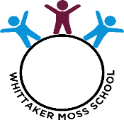
🌟 Our Learning This Unit 🌟

Year Group: 3 Unit Title: Through the Ages Term: Autumn
By the end of this unit…
✨ I can… (skill)
- chronologically order periods of time in history – The Stone Age, The Bronze Age and the Iron Age.
- think of questions about how things have changed and how things have stayed the same over time.
- research the significance of changes in tools and weapons and how this affected everyday life.
🧠 I will know… (knowledge)
- how Britain changed from the Stone Age to the Iron Age.
- about artefacts that archaeologists have found from the Stone Age to the Iron Age.
- how people lived in the Stone, Age, Bronze Age and Iron Age.

📚 Important words and what they mean
- Stonehenge – A circle of stones
- Settlement – A place where people live
- Archaeologist- A person who digs up and studies things form the past
- Hillfort- A strong, protected place on the top of a hill
- Stone, Bronze, Iron.- Metals used for tools
- Chronological- Putting things in order in the time that they happened.
- BC and AD- Before and after Jesus was born.
- Era- A long period of time
- Palaeolithic, Mesolithic,Neolithic.- Periods of time in the stone age
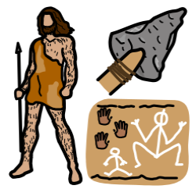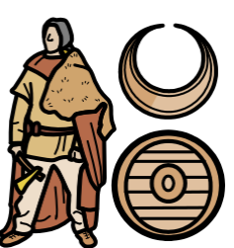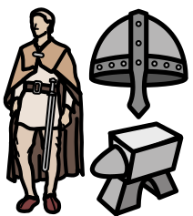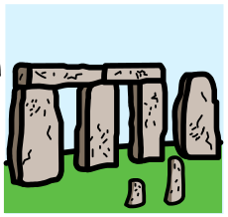
👍 How I show my learning
- I can talk about what I have learned.
- I can show my learning in my work.
- I can feel proud of my progress.
- I can answer flashback questions.

