
🌟 Our Learning This Unit 🌟

Year Group: 3 Unit Title: Animals including humans Term: Autumn 1
By the end of this unit…
✨ I can… (skill)
- make a prediction in an investigation.
- carry out a test and take measurements using standard units (cm).
- set up my own investigation.

🧠 I will know… (knowledge)
- that animals need the right types of nutrition and can talk about what different animals need.
- that animals get the nutrition from what they eat.
- that humans and some animals have skeletons and muscles for support, protection and movement.

📚 Important words and what they mean
- Nutrition- Getting the right food that the body needs
- Skeleton- The bones in our body
- Protection-Keeping things safe from harm
- Support- Holding something up
- Movement- To be able to move your body like walking and running
- Carbohydrates, Proteins, fats, vitamins and minerals. – parts of food that your body needs
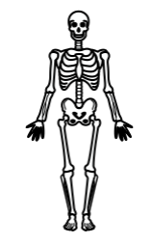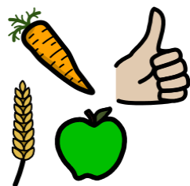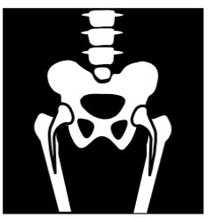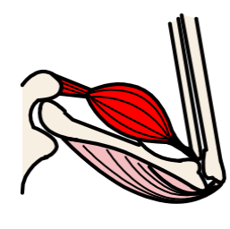
👍 How I show my learning
- I can talk about what I have learned.
- I can show my learning in my work.
- I can feel proud of my progress.
- I can answer flashback questions.

