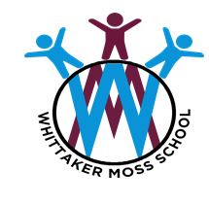
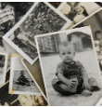
In PE we will be learning to …
- Jump, throw and catch with increasing accuracy.
- To be able to perform a variety of movements to form a group dance phrase based on the colours in a rainbow.
As readers we will be reading …
- The paper dolls by J. Donaldson
- Me and my family tree by J. Sweeney

In phonics we will be learning…
- To read and spell words with Phase 5 phonemes.
Our Big Learning Questions

- What was life like in the 1950s?
- What is a material?
Using our computing skills, we will be …
- to logon.
- Click, double-click, drag, scroll.
- Use a computer keyboard.
- Create digital content.

In RE we will be discovering…
- Who is a Christian and what do they believe?
In Life Skills lessons we will be exploring…
- Rules and expectations
In Healthy Relationships Education we will be exploring …
- Friendships- Making friends
- How I Feel- recognising and talking about different feelings.
As artists we will be …
- Representing the human face using drawing, painting and sculpting.
- Learning about primary colours.

Year 1
Autumn 1
As historians and geographers, we
will discover…
- About changes within living memory and changes beyond living memory.
- How events can be ordered chronologically on a timeline.
- Human and physical features including: beach, cliff, coast, town, city, road, bridge…
As mathematicians we will be learning to …
- Sort and count objects to 10
- Count forwards and backwards within 10.
- Find one more and one less within 10.
- Compare and order numbers within 10.
As writers we will be learning to …
- Write sentences with capital letters, full stops and finger spaces in the correct places.
- To use sequencing words and sequence events.
- To write facts about myself.
- Write an autobiography.

As scientists we will be learning …
- To name different materials.
- To distinguish between and object and what it is made from.
- To observe things closely using simple equipment.

