

WHITTAKER MOSS PRIMARY SCHOOL

ONLINE SAFETY POLICY & PROCEDURES

Designated Safeguarding Lead (DSL) | Name Melanie Backhouse
Online Safety Lead (OSL if different from DSL) | Name Sarah Cadogan
Remote Education Lead (if different from DSL) | Name Sarah Cadogan
Online Safety / Safeguarding Link Governor | Name Frank Hayley
PSHE / RSHE lead | Name Kate Mellor
Network Manager / other technical support | Name Remedian

Approved by¹
Name: | Frank Hayley
Position: | Chair of Governors
Date: | September 2026
Review date²: | September 2027

1 The Governing Body are free to delegate approval of this document to a Committee of the Governing Body, an individual Governor, or the Head Teacher.
2 Governors free to determine review period. Recommended annually.

REVIEW SHEET

The information in the table below details earlier versions of this document with a brief description of each review and how to distinguish amendments made since the previous version date (if any).

Version Number | Version Description | Date of Revision
1 | Original. Complete rewrite to take into account current national guidance on Online Safety and in light of statutory DfE guidance ‘Keeping Children Safe in Education’ Sept 2021 which newly references schools having an online safety policy and what it should contain, the 4Cs, and the continuing DfE expectation that all schools responsible for the provision of compulsory schooling (including independent schools with pupils funded by the taxpayer i.e., children looked after or children from military families attending boarding schools) will provide remote education and do it safely.
2 | Revised September 2022 in light of statutory DfE guidance ‘Keeping Children Safe in Education’ Sept 2022 which references the importance of preventative education, where to get help and support with regard to harmful online challenges and hoaxes, the need to inform parents/carers about which online sites children are accessing, and the statutory duty of governing boards to regularly review the effectiveness of school filtering and monitoring systems. Appendix I updated to include the latest useful websites for online safety support from KCSiE 2022 p157-158. | 18.09.22
3 | Revised September 2023 in light of statutory DfE guidance ‘Keeping Children Safe in Education’ Sept 2023 which references that staff training should include understanding roles and responsibilities in relation to filtering and monitoring. Appropriate filtering and monitoring on school devices and school networks should be referenced in school safeguarding policies. Also referenced is the newly published DfE filtering and monitoring standards. The standards are to support schools meet their duty to have appropriate/effective filtering and monitoring systems in place. Filtering and monitoring section of this policy revised (p27) to take account of the latest guidance in KCSIE 2023. Appendix I updated to include the latest useful websites for online safety support from KCSiE 2023 p158-160. Appendix J added to show how staff will record an internet misuse incident. | 17.09.23
4 | Revised September 2024 in light of statutory DfE guidance ‘Keeping Children Safe in Education’ Sept 2024 which makes reference to the updated document Sharing Nudes and Semi-Nudes (March 2024) which now includes the  use of artificial intelligence to create and share nudes and semi-nude images. Revisions have also been made in light of the updated DfE document, Searching, Screening and Confiscation Advice for schools. Appendix I updated to include the latest useful websites for online safety support from KCSiE 2024 p165 – 166. | 01.09.24
5 | Revised September 2025 in light of statutory DfE guidance ‘Keeping Children Safe in Education’ Sept 2025 which clarifies that misinformation, disinformation and conspiracy theories are safeguarding harms.  Revisions have also been made in light of the DfE guidance on the use of generative AI in education document. Appendix I updated to include the latest useful websites for online safety support from KCSiE 2025 p166 – 167. Reference made to the new Whittaker Moss Responsible Use of A.I. In School Policy. | 01.09.25
6 | Revised September 2026 in light of statutory DfE guidance ‘Keeping Children Safe in Education’ Sept 2026 which gives updated definitions of online risk categories, added guidance and resources on safe and effective use of Generative AI in education, a new section on a mobile phone policy and more detailed information about filtering and monitoring checks to be undertaken by an SLT member and the need to keep a record of when these have taken place. | 01.09.26

Contents

POLICY 1
- Background/Rationale 1
- Definitions 2
- Associated School Policies and procedures 2
- Communication/Monitoring/Review of this Policy and procedures 2
- Scope of the Policy 2
PROCEDURES 1
- Roles and Responsibilities 1
  - Governors 1
  - Head teacher 2
  - Designated Safeguarding Lead (DSL)/Online Safety Lead (OSL) 3
  - All Staff 4
  - PSHE/RSHE Lead(s) 5
  - Computing/Subject Lead(s) 5
  - Network Manager/Technical staff 5
  - Data Protection Officer (DPO) 6
  - Volunteers and contractors 6
  - Pupils 6
  - Parents 7
- Teaching and Learning 7
  - How internet use enhances learning 8
  - Pupils with additional needs 9
  - Remote Education 9
- Handling online safety concerns and incidents 12
  - Sharing nude and semi-nude images 14
  - Upskirting 15
  - Online bullying 15
  - Harmful online challenges or hoaxes 16
  - Sexual violence and harassment 17
  - Misuse of school technology (devices, systems, networks, or platforms) 17
  - Social media incidents 17
- Data protection and data security 17
  - Maintaining Information Systems Security 18
  - Password Security 18
- Electronic Communications 20
  - Managing Email 20
  - Emailing personal, sensitive, confidential, or classified information 20
  - Zombie accounts 21
- School Website 21
- Use of digital and video images 21
- Cloud Platforms 23
- Social Media 24
  - Managing social networking, social media, and personal publishing sites 24
- Filtering and Monitoring 27
- Managing emerging technologies 30
- Policy Decisions 30
  - Authorising internet access 31
  - Assessing risks 31
  - Responding to incidents of concern 31
- Communicating Policy and procedures 31
  - Introducing the Policy and procedures to Pupils 31
  - Discussing the Policy and procedures with Staff 32
  - Enlisting Parents’ Support 33
- Complaints 33

Appendix A - EYFS Acceptable Use Agreement
Appendix B - KS1 Acceptable Use Agreement
Appendix C - KS2 Acceptable Use Agreement
Appendix D - Parent/Carer Acceptable Use Agreement
Appendix E - Staff Acceptable Use Agreement
Appendix F - Visitor Acceptable Use Agreement
Appendix G - Response to nudes/semi-nudes disclosure
Appendix H - Response to an Incident or Concern Flow Chart
Appendix I - p175-177 KCSIE 2026 – Online Safety support
Appendix J - Response to an internet misuse incident – recording sheet

POLICY

Background/Rationale
New technologies have become integral to the lives of children and young people in society, both in school and in their lives outside school.
The Internet and other digital and information technologies are powerful tools, which open new opportunities for everyone. Electronic communication helps teachers and pupils learn from each other. These technologies can stimulate discussion, promote creativity, and increase awareness of context to promote effective learning. Children and young people have an entitlement to safe internet access.
The requirement to ensure that children and young people can use online and related communications technologies appropriately and safely is part of the wider duty of care to which all who work in schools are bound. The school Online Safety Policy and procedures will help to ensure safe and appropriate use, and the development and implementation will involve all stakeholders in a child’s education from the Head teacher and Governors to the senior leaders and classroom teachers, support staff, parents, carers, members of the community and the pupils themselves.
The use of these exciting and innovative tools in school and at home has been shown to raise educational standards and promote pupil achievement. However, the use of these new technologies can put young people at risk in and outside of school. Some of the dangers they may face include:
  - Access to illegal, harmful, or inappropriate images or other content;
  - Unauthorised access to/loss of/sharing of personal information;
  - The risk of being subject to grooming by those with whom they make contact on the internet;
  - The risk of being targeted by extremists in order to promote and encourage radicalisation;
  - The risk of being targeted by those involved in child sexual exploitation;
  - The sharing/distribution of personal images without an individual’s consent or knowledge;
  - Being drawn into taking part in unsuitable online challenges and/or hoaxes;
  - Inappropriate communication/contact with others, including strangers;
  - Cyberbullying;
  - Access to unsuitable video/internet games;
  - An inability to evaluate the quality, accuracy, and relevance of information on the Internet;
  - Plagiarism and copyright infringement;
  - Illegal downloading of music or video files;
  - The potential for excessive use which may impact on the social and emotional development and learning of the young person.
Many of these risks reflect situations in the off-line world and it is essential that this Online Safety Policy and procedures is used in conjunction with other school Policies including the Overarching Safeguarding Statement, Child Protection, Data Protection and Whole School Behaviour.
As with all other risks, it is impossible to eliminate online risks completely. It is therefore essential, through good educational provision to build pupils’ resilience to the risks to which they may be exposed, so that they have the confidence and skills to face and deal with these risks.
This school must demonstrate that it has provided the necessary safeguards to help ensure that we have done everything that could reasonably be expected of us to manage and reduce these risks. The Online Safety Policy and procedures that follows explains how we intend to do this, while also addressing wider educational issues to help young people (and their families) to be responsible users and stay safe while using the Internet and other communications technologies for educational, personal, and recreational use.

Definitions
For the purposes of this document, a child, young person, pupil, or student is referred to as a ‘child’ or a ‘pupil’ and they are normally under 18 years of age.
Wherever the term ‘parent’ is used this includes any person with parental authority over the child concerned e.g., carers, legal guardians etc.
Wherever the term ‘Head teacher’ is used this also refers to any Manager with the equivalent responsibility for children.
Wherever the term ‘school’ is used, this will include the wrap around care provided by the school such as After School Clubs, Breakfast Clubs and Extra-Curricular Clubs.

Associated School Policies and procedures
This Policy should be read in conjunction with the following school Policies/procedures and, where they exist, addendums to those Policies and procedures:
  - Overarching Safeguarding Statement
  - Child Protection Policy and procedures
  - Data Protection Policy
  - Health and Safety Policy and procedures
  - Whole School Behaviour Policy
  - Whistleblowing procedures
  - Code of Conduct for staff and other adults
  - Voluntary Home-School Agreement
  - Responsible A.I. Use Policy

Communication/Monitoring/Review of this Policy and procedures
This Policy and procedures will be communicated to staff, pupils, and the wider community by:
  - Posting it on the school website and shared staff drive
  - Making a paper copy available on request from the school office and for staff on the staffroom safeguarding board.
  - Discussing school policy and procedures during induction with new staff and other relevant adults including (where relevant) the staff Acceptable Use Agreement
  - Discussing Acceptable Use Agreements with pupils at the start of each year
  - Issuing Acceptable Use Agreements to external users of school systems (e.g. Governors) usually on entry to the school
  - Holding Acceptable Use Agreements in personnel files
The Online Safety Policy is also referenced in other school Policies and procedures as outlined above.
The review period for this Policy and procedures is determined by the Governing Board and is indicated on the front cover.

Scope of the Policy
This Policy and procedures applies to all members of the School/Academy community (including staff, pupils, volunteers, parents, visitors, community users) who have access to and are users of our ICT systems, both in and out of school.
The Education and Inspections Act 2006 empowers Head teachers, to such extent as is reasonable, to regulate the behaviour of pupils when they are off the school site and empowers members of staff to impose disciplinary penalties for inappropriate behaviour. This includes incidents of cyberbullying, or other online safety related incidents covered by this Policy and procedures, which may take place out of school, but is linked to membership of the school. The 2011 Education Act increased these powers in relation to

the searching for, and of, electronic devices and the deletion of data. In the case of both acts, action can only be taken in relation to issues covered by the published Whole School Behaviour Policy and procedures.
The school will deal with such incidents within this Policy and procedures and the Whole School Behaviour Policy which includes anti-bullying procedures and will, where known, inform parents of incidents of inappropriate online safety behaviour that take place out of school.

- Roles and Responsibilities

PROCEDURES

The following section outlines the roles and responsibilities for online safety of individuals and groups within the school:

Governors
The role of the Governors/online safety Governor is to:
    - ensure a member of the Governing Board is elected to the role of Online Safety Governor who should then lead on relevant governance requirements below;
    - ensure an appropriate senior member of staff from the school leadership team is appointed to the role of DSL with lead responsibility for safeguarding and child protection (including online safety with the appropriate status, authority, time, funding, training, resources, and support);
    - ensure online safety is a running and interrelated theme whilst devising and implementing policies and procedures and to approve the Online Safety Policy and procedures, reviewing its effectiveness e.g., through Governors or a Governor Sub-committee receiving regular information about online safety incidents and monitoring reports and making use of the UK Council for Internet Safety (UKCIS) guide Online safety in schools and colleges: Questions from the Governing Board;
    - ensure that the school follows all current online safety advice to keep both pupils and staff safe;
    - support the school in encouraging parents and the wider community to become engaged in online safety activities;
    - have regular reviews with the Online Safety Coordinator/Designated Safeguarding Lead (DSL) and incorporate online safety into standing discussions of safeguarding at Governors meetings (including incident logs, filtering and monitoring etc.)
    - ensure that where the online safety coordinator is not the named DSL or deputy DSL, there is regular review and open communication between these roles and that the DSL’s clear overarching responsibility for online safety is not compromised;
    - work with the Data Protection Officer (DPO), DSL and Head teacher to ensure a UK GDPR compliant framework for storing data, helping to ensure that child protection is always at the forefront and data protection processes support careful and legal sharing of information;
    - check that school is making good use of information and support (p 175-177 Online Safety which forms part of ‘Keeping Children Safe in Education’ 2026);
    - ensure that all staff undertake regular updated safeguarding training, including online safety training in line with advice from the Local Authority Safeguarding Officer, and that it is integrated, aligned, and considered as part of the whole school safeguarding approach and wider staff training and curriculum planning;
    - ensure that appropriate filters and appropriate monitoring systems are in place and review these at least yearly, but also consider how ‘over-blocking’ may lead to unreasonable restrictions on what pupils can be taught in relation to online teaching and safeguarding;
    - recognise that a one size fits all educational approach may not be appropriate for all children, and a more personalised or contextualised approach for more vulnerable children, victims of abuse and some SEND children might be needed
    - ensure pupils are taught how to keep themselves safe, including online as part of providing a broad and balanced curriculum with clear procedures on the use of mobile technology.

Head teacher
The Head teacher has overall responsibility for online safety provision. The day-to-day responsibility for online safety may be delegated to the Online Safety Coordinator or Lead/Designated Safeguarding Lead (DSL).
The Head teacher will:
    - take overall responsibility for data and data security;
    - foster a culture of safeguarding where online safety is fully integrated into whole school safeguarding;
    - ensure that Policies and procedures are followed by all staff and other adults working paid or unpaid in the school;
    - undertake training in offline and online safety, in accordance with statutory guidance and relevant Local Safeguarding Partnership recommendations;
    - liaise with the DDSLs on all online-safety issues which might arise and receive regular updates on school issues and broader policy and practice information;
    - take overall responsibility for data management and information security ensuring the school’s provision follows best practice in information handling; work with the DPO, DSL and Governors to ensure a Data Protection Act 2018 (DPA) compliant framework for storing data, but helping to ensure that child protection is always put first, and data-protection processes support careful and legal sharing of information;
    - ensure the school implements and makes effective use of appropriate ICT systems and services including school-safe filtering and monitoring, protected email systems and that all technology including cloud systems are implemented according to child-safety first principles;
    - be responsible for ensuring that all staff receive suitable training to carry out their child protection and online safety roles;
    - understand and make all staff aware of procedures to be followed in the event of a serious online safeguarding incident or allegation against a member of staff or other adult (see flowchart on dealing with online safety incidents – Appendix H;
    - ensure suitable risk assessments are undertaken so the curriculum meets needs of pupils, including the risk of children being radicalised;
    - ensure that there is a system in place to monitor and support staff (e.g., network manager) who carry out internal technical online safety procedures;
    - ensure Governors are regularly updated on the nature and effectiveness of the school’s arrangements for online safety;
    - ensure the school website meets statutory requirements (see KAHSC guidance on statutory and desirable website requirements).

Designated Safeguarding Lead (DSL)/Online Safety Lead (OSL)
The DSL may delegate certain online safety duties e.g. to the OSL, but not the day-to-day responsibility; this assertion and all quotes below are taken from Keeping Children Safe in Education. Where the online-safety co-ordinator is not the named DSL or deputy DSL, there must be a regular review and open communication between these roles to ensure that the DSL’s clear overarching responsibility for online safety is not compromised.
The Designated Safeguarding Lead/Online Safety Lead will:
    - take lead responsibility for safeguarding and child protection (including online safety);
    - be the first point of contact for any concerns the wider staff and other adults working in the school may have in relation to child protection and online safety harmful behaviour e.g., sharing nude or semi-nude images/online challenges or hoaxes and refer to the UKCIS and DfE guidance on these subjects;
    - ensure an effective approach to online safety is in place that empowers the school to protect and educate the whole school community in their use of technology and establish mechanisms to identify, intervene in and escalate any incident where appropriate;
    - promote an awareness and commitment to online safety throughout the school community with strong focus on parents, who are often appreciative of school support in this area, but also including ‘hard-to- reach’ parents;
    - liaise with other agencies in line with ‘Working together to Safeguard Children’ statutory guidance;
    - take day-to-day responsibility for online safety issues and be aware of the potential for serious child protection concerns;
    - ensure that online safety education is embedded in line with DfE guidance ‘Teaching Online Safety in schools’ across the curriculum (e.g. by use of the UKCIS framework ‘Education for a Connected World’) and beyond, in the wider school community;
    - work with the Head teacher, Data Protection Officer, Governors, and the school ICT technical staff to ensure a DPA compliant framework for storing data, helping to ensure that child protection is always at the fore and data protection processes support careful and legal sharing of information;
    - keep up to date with the latest local and national trends in online safety;
    - review and update this Policy and procedures, other online safety documents (e.g., Acceptable Use Agreements) and the strategy on which they are based (in line with Policies and procedures for behaviour and child protection) and submit for review on a regular basis to the Governors.
    - liaise with school technical, pastoral, and support staff as appropriate;
    - communicate regularly with SLT and the designated online safety Governor/committee to discuss current issues (anonymised), review incident logs and filtering/change control logs;
    - ensure that all staff are aware of the procedures that need to be followed in the event of an online safety incident and that these are logged in the same way as any other child protection incident;
    - oversee and discuss ‘appropriate filtering and monitoring' with Governors (both physical and technical) and ensure staff are aware of its necessity and their responsibilities with regards to filtering and monitoring;
    - ensure the DfE guidance on sexual violence and harassment is followed throughout the school and that staff adopt a zero-tolerance approach to this as well as to bullying generally;
    - communicate clearly to parents, which online sites children will be accessing and the systems used in school to filter and monitor online use. They will alert parents to sites that could compromise a child’s safety when they are made aware of them.
    - liaise with the PSHE and HRE lead to ensure that a comprehensive programme of preventative education is taught at an age-appropriate level across school, that incorporates a wide range of online safety issues;
    - facilitate training and advice for staff and others working in the school to ensure that:
      - all staff read and understand KCSiE Part one unless they work in the SLT when they must read and understand KCSiE Part one and Part two
      - all staff are aware of information relevant to their role in keeping children safe online signposted in KCSiE 2026 p44-49
      - cascade knowledge of risks and opportunities throughout the organisation;
      - all staff have read and implemented the school’s responsible use of A.I. policy
    - be aware of emerging online safety issues and legislation, and of the potential for serious child protection issues to arise from:
      - sharing of personal data;
      - access to illegal/inappropriate materials;
      - inappropriate online contact with adults/strangers;
      - potential or actual incidents of grooming;
      - cyberbullying and the use of social media.

All Staff
It is the responsibility of all staff to:
    - understand that online safety is a core part of safeguarding; as such it is part of everyone’s role. Never think that ‘someone else will pick it up’;
    - know who the Designated Safeguarding Lead and Online Safety Lead are;
    - read and understand Annex A of ‘Keeping Children Safe in Education’ unless they work in the SLT when they must read and understand Part 1 and Part 2 instead;
    - read, understand, and help promote the school’s Online Safety Policy and procedures in conjunction with the Child Protection and other related school Policies and procedures;
    - read, sign, and follow the school Staff Acceptable Use Agreement and staff Code of Conduct;
    - be aware of online safety issues related to the use of mobile technology e.g., phones, cameras and other hand-held devices and follow school procedures in relation to these devices;
    - ensure the security of their username and password for the school system, not allow other users to access the systems using their log on details and immediately report any suspicion or evidence that there has been a breach of security. Passwords will be changed on a regular basis and at least every 3 months;
    - record online safety incidents in the same way as any child protection incident and report incidents to the DSL/OSL in accordance with school procedures;
    - notify the DSL/OSL if policy does not reflect practice in the school and follow escalation procedures if concerns are not promptly acted upon;
    - identify opportunities to thread online safety through all school activities, both outside the classroom and within the curriculum, supporting curriculum/stage/subject leads, and making the most of unexpected learning opportunities as they arise;
    - whenever overseeing the use of technology (devices, the Internet, new technology such as augmented reality, etc.) in school or setting as homework tasks, encourage sensible use, monitor what pupils are doing and consider potential dangers and the age appropriateness of websites (check what appropriate filtering and monitoring processes are in place);
    - carefully supervise and guide pupils when engaged in learning activities involving online technology, supporting them with search skills, critical thinking (e.g., fake news), age-appropriate materials and signposting, and legal issues such as copyright and data law;
    - prepare and check all online source and resources before using in the classroom;
    - encourage pupils to follow their Acceptable Use Agreement, regularly remind them about it and enforce school sanctions where there is a breach of the Agreement;
    - notify the DSL/OSL of new trends and issues before they become a problem;
    - take a zero-tolerance approach to bullying and low-level sexual harassment either offline or online;
    - receive and act upon regular updates from the DSL/OSL and have a healthy curiosity for online safety issues;
    - model safe, responsible, and professional behaviours in their own use of technology. This includes outside the school hours and site, and on social media, in all aspects upholding the reputation of the school and the professional reputation of all staff;
    - ensure that any digital communications with pupils are on a professional level and only through school- based systems, never through personal mechanisms, e.g., email, text, mobile phones or social media messaging or posts.
    - know their responsibilities with regards to filtering and monitoring.

PSHE/HRE Lead(s)
Responsibilities of PSHE/HRE Leads include:
- all as listed in the ‘all staff’ section above;
- ensuring that consent, mental wellbeing, healthy relationships and staying safe online is embedded into the PSHE/Relationships education, healthy relationships education (HRE) and health education curriculum. This will include being taught what positive, healthy and respectful online relationships look like, the effects of the pupils’ online actions on others and knowing how to recognise and display respectful behaviour online. Throughout these subjects, teachers will address online safety and appropriate behaviour in an age-appropriate way that is relevant to their pupils’ lives (KCSiE);
- complementing the computing curriculum which covers the principles of online safety at all key stages, with progression in the content to reflect the different and escalating risks that pupils face. This includes how to use technology safely, responsibly, respectfully, and securely, and where to go for help and support when the pupil has concerns about content or contact on the Internet or other online technologies;
- working closely with the DSL/OSL and all other staff to ensure an understanding of the issues, approaches, and messages within PSHE/HRE.

Computing/Subject Lead(s)
Responsibilities of the Computing Lead include:
- all as listed in the ‘all staff’ section above;
- the overseeing delivery of the online safety element of the Computing curriculum in accordance with the national curriculum, ensuring that the content is relevant and up to date;
- working closely with the DSL/OSL and all other staff to ensure an understanding of the issues, approaches, and messages within Computing;
- collaboration with technical staff and others responsible for ICT use in school to ensure a common and consistent approach, in line with Acceptable Use Agreements.

Network Manager/Technical staff
Responsibilities of the Network Manager/ICT Technician include:
    - all as listed in the ‘all staff’ section above;
    - reporting any online safety related issues that arise, to the DSL/OSL in the first instance;
    - keeping up to date with the school’s Online safety Policy and technical information to effectively carryout their online safety role and to inform and update others as relevant;
    - working closely with the DSL/OSL/DPO to ensure that school systems and networks reflect school Policy;
    - ensuring that the above stakeholders understand the terms of existing services and how any changes to these systems (especially in terms of access to personal and sensitive records/data and to systems such as YouTube mode, web filtering settings, sharing permissions for files on cloud platforms etc.) might affect the system functions and safety online;
    - supporting and providing advice on the implementation of ‘appropriate filtering and monitoring’ as determined by the DSL and Senior Leadership Team;
    - ensuring that users may only access the school’s networks through an authorised and properly enforced password protection procedures, in which passwords are regularly changed;
    - ensuring that the school’s ICT infrastructure is secure and is not open to misuse or malicious attack e.g., keeping virus protection up to date;
    - ensuring that access controls/encryption exist to protect personal and sensitive information held on school-owned devices;
    - monitoring the use of the network/remote access/email and social media presence and that any misuse/attempted misuse is reported to the DSL/OSL in line with school Policy;
    - ensuring that appropriate backup procedures exist so that critical information and systems can be recovered in the event of a disaster and to complement the business continuity process;
    - maintaining up-to-date documentation of the school’s online security and technical procedures;
    - reporting online safety issues that come to their attention in line with school Policy.

Data Protection Officer (DPO)
The DPO will be familiar with references to the relationship between data protection and safeguarding in key DfE documents ‘Keeping Children Safe in Education’ and ‘Data protection: a toolkit for schools’.
Neither the Data Protection Act 2018 nor UK GDPR prevent, or limit, the sharing of information for the purposes of keeping children safe. Information which is sensitive and personal will be treated as ‘special category personal data’ for the purposes of compliance with DPA 2018. Legal and secure information sharing between schools, Children’s Social Care and other local agencies is essential for keeping children safe and ensuring they get the support they need. Information can be shared without consent if to gain consent would place a child at risk. Fears about sharing information must not be allowed to stand in the way of promoting the welfare and protecting the safety of children. As with all data sharing, appropriate organisational and technical safeguards will be in place.
Other responsibilities of the DPO include:
- working with the DSL, Head teacher and Governors to ensure frameworks are in place for the protection of data and of safeguarding information sharing as outlined above;
- ensuring that all access to safeguarding data is limited as appropriate, monitored, and audited.

Volunteers and contractors
The key responsibilities of volunteers and contractors are to:
- read, understand, sign, and adhere to any Acceptable Use Agreement issued by the school;
- report any concerns, no matter how small, to the DSL/OSL without delay;
- maintain an awareness of current online safety issues and guidance;
- model safe, responsible, and professional behaviours in their own use of technology.

Pupils
Taking into account their age and level of understanding, the key responsibilities of pupils are to:

    - use the school ICT systems in accordance with the age-appropriate Pupil Acceptable Use Agreement – see Appendix D or E, which they and/or their parents will be expected to sign before being given access to school systems. As with consent on data (privacy notices) Agreements must be written in terms the EYFS/KS1 child can understand;
    - ensure the security of their username and password for the school system, not allow other users to access the systems using their log on details and must immediately report any suspicion or evidence that there has been a breach of security;
    - understand the importance of reporting abuse, misuse or access to inappropriate materials including those involving hoaxes and on-line challenges and know how to do so;
    - know what action to take if they or someone they know feels worried or vulnerable when using online technology;
    - understand the importance of adopting safe and responsible behaviours and good online safety practice when using digital technologies outside of school and realise that the school’s acceptable use agreements cover their actions out of school, including on social media;
    - know and understand school procedures on the prohibited use of mobile phones in school, digital cameras, and hand-held digital devices;
    - know and understand school procedures on the taking/use of images and on cyberbullying/sharing nude, semi-nude and pseudo nude images;
    - understand the benefits/opportunities and risks/dangers of the online world and know who to talk to at school if there are problems.

Parents
Parents play a crucial role in ensuring that their children understand the need to use the Internet/mobile devices in an appropriate way. Research shows that many parents do not fully understand the issues and are less experienced in the use of ICT than their children. The school will therefore take every opportunity to help parents understand these issues through parents’ evenings, newsletters, letters, website and information about national/local online safety campaigns/literature.
The key responsibilities for parents are to:
    - support the school in promoting online safety which includes the pupils’ use of the Internet and the school’s use of photographic and video images;
    - read and promote the Pupil Acceptable Use Agreement and encourage their child to follow it;
    - consult with the school if they have any concerns about their child’s and others’ use of technology;
    - promote positive online safety and model safe, responsible, and positive behaviours in their own use of technology (including on social media) by ensuring that they themselves do not use the Internet/social network sites/other forms of technical communication in an inappropriate or defamatory way;
    - support the school's approach to online safety by not uploading or posting to the Internet any images or details of others without permission and refraining from posting pictures, video or text that could upset, offend, or threaten the safety of any member of the school community or bring the school into disrepute.
    - be aware of what their children are being asked to do online in school and know which sites they will be accessing.

Teaching and Learning
The breadth of issues classified within online safety is considerable, but can be categorised into four areas of risk known as the 4Cs:
- Content: being exposed to illegal, inappropriate, or harmful content, for example: pornography, racism, misogyny, self-harm, suicide, antisemitism, radicalisation, extremism, extreme sexual or physical violence, misinformation, disinformation (including fake news) and conspiracy theories,
- Contact: being subjected to harmful online interaction with other users or generative AI applications that simulate this; for example: peer to peer pressure, commercial advertising and adults posing as children or young adults with the intention to groom or exploit them for sexual, criminal, financial or other purposes,
- Conduct: online behaviour that increases the likelihood of, or causes, harm; for example, making, sending and receiving explicit images, including those generated using AI and online bullying, and
- Commerce: risks such as online gambling, inappropriate advertising, phishing and or financial scams. If you feel your pupils, students or staff are at risk, please report it to the Anti-Phishing Working Group (https://apwg.org/).

Strong links between teaching online safety and the curriculum (see also Roles above) are the clearest in:
- Personal, Social and Health Education (PSHE)
- Relationships education, healthy relationships education (HRE) and health
- Computing
- Citizenship
It is, however, the role of all staff to identify opportunities to thread online safety through all school activities, both outside the classroom and within the curriculum, supporting subject lead staff and making the most of unexpected learning opportunities as they arise.
Whenever overseeing the use of technology (devices, the Internet, new technology such as augmented reality, etc) in school or setting as homework tasks, all staff will encourage sensible use, monitor what pupils are doing and consider potential dangers and the age-appropriateness of websites.
Equally, all staff should carefully supervise and guide pupils when engaged in learning activities involving online technology (including, extra-curricular and extended school activities if relevant), supporting them with search skills, critical thinking (e.g., fake news), age-appropriate materials and signposting, and legal issues such as copyright, plagiarism, and data law.
We recognise that online safety and broader digital resilience must be included throughout the curriculum.
Annual reviews of curriculum plans / schemes of work (including for SEND pupils) are used as an opportunity to assess the key areas of Self-image and Identity, Online relationships, Online reputation, Online bullying, Managing online information, Health, Wellbeing and lifestyle, Privacy and security, and Copyright and ownership.

How internet use enhances learning
This school:
    - has a clear, progressive online safety education programme as part of the Computing/PSHE/HRE curriculum. This covers the teaching of a range of skills and behaviours which are appropriate to the age and experience of the pupils concerned and include those to:
      - STOP and THINK before they CLICK;
      - develop a range of strategies to evaluate and verify information before accepting its accuracy;
      - be aware that the author of a website/page may have a particular bias or purpose and to develop skills to recognise what that may be;
      - know how to narrow down or refine a search;
      - [for older pupils] understand how search engines work and to understand that this affects the results they see at the top of the listings;
      - understand acceptable behaviour when using an online environment/email, i.e., be polite, no bad or abusive language or other inappropriate behaviour; keeping personal information private;
      - understand how photographs can be manipulated and how web content can attract unwanted or inappropriate attention;
      - understand why they should not post or share detailed accounts of their personal lives, contact information, daily routines, location, photographs, and videos and to know how to ensure they have turned-on privacy settings;
      - understand why they must not post pictures or videos of others without their permission, including nude / pseudo nude images for older children;
      - know not to download any files – such as music files – without permission;
      - have strategies for dealing with receipt of inappropriate materials;
      - [for older pupils] understand why and how some people will ‘groom’ young people for sexual or extremist ideology reasons;
      - understand the impact of cyberbullying, sharing inappropriate images and trolling and know how to seek help if they are affected by any form of online bullying;

      - know how to report any abuse including cyberbullying; and how to seek help if they experience problems when using the Internet and related technologies, i.e., parent, teacher or trusted staff member, or an organisation such as ChildLine, the CLICK CEOP button or NCMEC’s Take It Down Tool (Take It Down (ncmec.org).
    - plans internet use carefully to ensure that it is age-appropriate and supports the learning objectives for specific curriculum areas;
    - will remind pupils about their responsibilities through an end-user Acceptable Use Agreement which will be displayed throughout the school or when they log on to the school’s network;
    - ensures staff model safe and responsible behaviour in their own use of technology during lessons;
    - ensures that when copying materials from the web, staff and pupils understand issues around plagiarism; how to check copyright and know that they must respect and acknowledge copyright/intellectual property rights;
    - ensures that staff and pupils understand the issues around aspects of the commercial use of the Internet, as age appropriate. This may include risks in pop-ups; buying online; online gaming/gambling etc.

Pupils with additional needs
We use a wide range of strategies to support children with additional needs who might need extra support to keep themselves safe, especially online.
    - Sensitively check pupil’s understanding and knowledge of general personal safety issues using reminders and explicit prompts to link their existing knowledge of “how to keep safe” to the rules that will apply specifically to, for instance, internet use.
    - Apply rules consistently to embed understanding.
    - Communicate rules clearly to parents and seek their support in implementing school rules at home. Working with parents and sharing information with them is relevant to all children, but this group especially.
    - Careful explanations about why rules might change in different situations i.e., why it is ok to give your name and address to an adult if you are lost in town, but not when using the Internet.
    - Consistent use of cause and effect linking the rules to consequences teaching realistic and practical examples of what might happen if… without frightening pupils.

Remote Education
While the remote education temporary continuity direction which required schools to provide remote education to pupils where their attendance would be contrary to government guidance or legislation in force at the time has ended, the DfE expects schools to continue to maintain their capabilities to deliver high quality remote education.
This is because government public health advice locally or nationally may require a class, group, or a small number of pupils to self-isolate, and all such pupils not physically unwell should have access to remote education as soon as reasonably practicable, which may be the next school day.
When this school is required to provide it, remote education should be equivalent in length to the core teaching pupils would receive in school and should include recorded or live direct teaching time, as well as time for pupils to complete tasks and assignments independently. As a minimum we will provide 3 hours/day on average across the cohort in Key Stage 1, with less for younger children, and 4 hours/day in Key Stage 2.
To ensure business continuity, thorough emergency preparedness, continuity of education and safeguarding arrangements, and to prevent harms, Governors may decide to implement remote learning provision in any kind of local or national emergency situation that prevents pupils or staff attending to statutory schooling.
In developing our remote education provision, we have:
Selected the Google Classroom and Purple Mash (Tapestry for reception) digital platforms to use consistently across the school to allow interaction, assessment, and feedback with procedures in place to ensure staff are trained and confident in its use. This enables us to provide online video lessons recorded by teaching staff and high-quality lessons developed by external providers as well as monitored methods of communication.
    - Identified ways to discover and overcome barriers to digital access for pupils e.g., forms or other survey methods, distributing school-owned laptops, securing appropriate internet connectivity solutions, providing printed resources, such as textbooks and workbooks, to structure learning, supplemented with other forms of communication to keep pupils on track or answer questions about work.
    - Ensured that school-owned devices distributed for the purpose of access to remote education will always include appropriate safeguarding controls and support to help children and families, and staff use them safely, including information about physically healthy computing e.g., posture, the teaching and learning environment, sleep.
    - Ensured we can teach a planned and well-sequenced curriculum so that knowledge and skills are built incrementally.
    - Published on the school website up-to-date information about what is intended to be taught and practised in each subject so that pupils can progress through the curriculum.
    - Put systems in place for checking, daily, whether pupils are engaging with their work, so we can work with families to rapidly identify effective solutions where engagement is a concern.
    - Identified a named senior leader, Sarah Cadogan, with overarching responsibility for the oversight of the quality, delivery, and safety of remote education.
    - Considered issues that specific individuals or groups of pupils may have engaging with remote education due to their age, stage of development, special educational needs, or disability e.g., where this would place significant demands on parents’ help or support, ensuring that the teachers best placed to know how the pupil’s needs can be most effectively met to ensure they continue to make progress, work with families to deliver an ambitious and appropriate curriculum
    - Sought to demonstrate that we understand the requirement for schools under the 2014 Children and Families Act to use our best endeavours to secure the special educational provision called for by the pupils’ special educational needs remains in place.
    - Identified potential personal, professional, and children’s safeguarding issues associated with the provision of remote education; put in place hardware, software, procedures, and training to reduce the risk of harm to the adults, children, and young people exposed to it; and ensured the risks are being addressed in a consistent and ongoing way through the curriculum (see below).
    - Reviewed and updated as necessary relevant Policies, procedures, and supporting documents like our Acceptable Use Agreements in light of remote education provision to ensure that they remain appropriate and useful for keeping the adults, children, and young people exposed to it safe online.

    - Continue to record attendance accurately in the register for pupils who are receiving remote education in line with any current government guidance on it.
    - Carry out an annual review of the school’s approach to online safety, supported by an annual risk assessment that considers and reflects the risks the pupils that attend this school face using a tool like the 360 safe website.
We recognise that there are additional safeguarding risks to pupils associated with them spending more time online than before the global pandemic, both in their leisure time and to be able to access remote education. There may also be risks from or to the people they live with during live video link work and staff are expected to plan accordingly and seek advice from the OSL/DSL as necessary. The pupil Acceptable Use Agreement includes expected conduct during remote education activities.
We recognise that there are additional safeguarding risks to staff as well, especially those facilitating remote learning via live video links that may also impact other people in their household or community. The Staff Code of Conduct sets out expected good remote education practice.
We will follow relevant government online safeguarding guidelines and make use of recommended technical tools and guides signposted there to help us deliver remote education safely.
In addition to the updated codes of conduct, staff, pupils (or due to their age and ability, the adults supporting them), parents, carers, and to some degree, virtual or in-person visitors using online technology for education purposes or school business are expected to:

Check security and privacy settings e.g.:
    - Adjust privacy and safety settings on all devices, in apps and other online places to control what personal data is shared.
    - Review the security settings on ‘smart’ devices and change any default, weak or guessable passwords.
    - Set up two-factor authentication if devices are capable or available.
    - Regularly update devices or apps used for school or work to improve security.
    - Think about physical privacy when appearing live online e.g., adult supervision of children at home, appropriate clothing, distractions like noise and interruptions, what other people nearby can hear.

Act regarding unsuitable content e.g.:
    - Prevent unwanted content from appearing i.e. set filters and parental controls on home broadband and mobile networks and not disable or bypass them (the UK Safer Internet Centre has advice on how).
    - Block unsuitable contact (with support as necessary)
    - Report harmful activity, to the website, platform or app, a trusted adult, and the DSL. Report Harmful Content to Safer Internet UK if not satisfied with the result of a report to a service provider.

Protect against fraud e.g.:
    - Beware of fraud and scams online including phishing emails and text messages and use appropriate cyber security and “stop, challenge, protect” information to avoid becoming a victim.
    - Never give out personal information to websites or in response to emails/text messages not recognised or trusted
    - Report being scammed, defrauded, or experiencing cyber-crime to Action Fraud, the UK’s national reporting centre.
Check the Facts e.g.: use the SHARE checklist to make sure they are not contributing to the spread of harmful content e.g.

Stay physically and mentally healthy online e.g.:
    - Take regular breaks from online activities and use tools like Apple’s Screen Time, Google’s Family link, Xbox One, PlayStation 5, Nintendo Switch if necessary to manage screen time, especially if feeling overwhelmed, or in physical discomfort.
    - Take notice of any guidance school provides on supporting children’s mental health and wellbeing or that of staff as well as practical guidance on making the home environment a good and safe one to

learn in with school adopting a sensitive appreciation for people’s different home circumstances and what is reasonable.
Staff are also expected to:
    - Provide information about their temporary home working environment insofar as it might impact on their physical health, or the safeguarding of learners or their own household.
    - Act appropriately on feedback and use any necessary online or cyber tools provided.
    - Provide information about the technology they use at home to get online i.e., to ensure compatibility with school systems, especially cyber security measures involved in accessing sensitive data like medical, behaviour or performance information on school servers remotely.
    - Implement relevant guidance on safe teaching and pastoral care from their home e.g., what is in the background of recorded or live streams, what is visible on shared screens, what can be heard by others in a household etc.
    - Pay special attention to how they protect personal data at home.
    - Report to their line manager any issues or concerns they may have either about their personal safety or that of a pupil.
    - Keep talking about staying safe online, which we can do by:
- Ensuring staff have the tools to promote a healthy balance between the positive and negative aspects of life online.
- Signposting parents and carers to tools to explain and reduce risks and help them talk to their child.
- Reiterating behaviour expectations and ways to handle and report problems, especially encouraging children to speak to a trusted adult if they come across content online that makes them uncomfortable.
- Supporting critical thinking and promoting resources like Parent Zone’s guide and Childnet’s advice and top tips which provide ways parents and carers can help their child develop these skills.

Handling online safety concerns and incidents
Our staff recognise that online safety is only one element of the wider safeguarding agenda as well as being a curriculum strand of Computing, PSHE/HRE and Citizenship.
General concerns will be handled in the same way as any other child protection concern. Early reporting to the DSL/OSL is vital to ensure that the information contributes to the overall picture or highlights what might not yet be a problem.
Support staff will often have a unique insight and opportunity to find out about issues first in the playground, corridors, toilets, and other communal areas outside the classroom (particularly relating to bullying and sexual harassment and violence).
Procedures for dealing with online safety, concerns and incidents are detailed in the following Policies:
- Child Protection Policy and procedures
- Whole School Behaviour Policy and procedures (includes anti-bullying procedures)
- Acceptable Use Agreements
- Prevent Risk Assessment
- Data Protection Policy, agreements, and other documentation (e.g., privacy statement, consent forms for data sharing image use etc.)
We are committed to taking all reasonable precautions to ensure online safety but recognise that incidents will occur both inside and outside school. All members of the school community are encouraged to report issues swiftly to school staff so that they can be dealt with quickly and sensitively through the school’s escalation processes.
Any suspected online risk or infringement should be reported to the DSL/OSL on the same day wherever possible or, if out of school, the following school day.
Any concern/allegation about misuse by staff or other adult in school will always be referred directly to the Head teacher unless the concern is about the Head teacher, in which case, the complaint will be directed to

the Chair of Governors. Staff may also use the NSPCC Whistleblowing Helpline. Call 0800 028 0285 or email: help@nspcc.org.uk.

The school will actively seek support from other agencies as needed (i.e., Local Authority Safeguarding Hub, UK Safer Internet Centre’s Professionals’ Online Safety Helpline (03443814772), NCA CEOP, LA Prevent Officer, Greater Manchester Police, Internet Watch Foundation (IWF)). We will inform parents of online safety incidents involving their child and the Police where staff or pupils engage in or are subject to behaviour which we consider is particularly disturbing or is considered illegal. See Sections below for procedures for dealing with sharing nude and semi-nude images, upskirting and online bullying.

- In this school there is strict monitoring and application of the Online Safety Policy and a differentiated and appropriate range of sanctions.
- All members of the school community will be informed about the procedure for reporting online safety concerns (such as breaches of filtering, cyberbullying, illegal content etc.).
- The Online Safety Coordinator will record all reported incidents and actions taken in the School Online Safety incident log file and other in any relevant areas e.g. CPOMs.
- The Designated Safeguarding Lead will be informed of any online safety incidents involving Child Protection concerns, which will then be escalated appropriately – See Child Protection Policy and procedures for dealing with concerns.
- The school will manage Online Safety incidents in accordance with the school discipline/behaviour policy where appropriate.
- The school will inform parents of any incidents or concerns as and when required.
- After any investigations are completed, the school will debrief, identify lessons learnt and implement any changes required.
- Where there is cause for concern or fear that illegal activity has taken place or is taking place then the school will contact the Rochdale Safeguarding Hub and escalate the concern to the Police.
- If the school is unsure how to proceed with any incidents of concern, then the incident may be escalated to the Safeguarding Hub – see Child Protection Policy and procedures.
If members of staff suspect that misuse might have taken place, but that the misuse is not illegal (as above) it is essential that correct procedures are used to investigate, preserve evidence, and protect those carrying out the investigation. More than one member of staff should be involved in the investigation which should be carried out on a “clean” designated computer.
Incidents will be dealt with as soon as possible in a proportionate manner through normal behaviour/disciplinary procedures. It is important that, where necessary, members of the school community are made aware that incidents have been dealt with.

Sharing nude, semi-nude and pseudo nude images
Where incidents of the sharing of nude, semi-nude and pseudo nude images via the internet or mobile phone by those under the age of 18 are discovered, we will refer to the UK Council for (UKCIS) guidance ‘Sharing nudes and semi-nudes: advice for education settings working with children and young people’. A copy of this document is available from the school office. Where one of the parties is over the age of 18, we will refer to it as child sexual abuse.
All staff and other relevant adults have been issued with a copy of the UKCIS overview document (Sharing nudes and semi-nudes: how to respond to an incident) in recognition of the fact that it is generally someone other than the DSL or OSL who will first become aware of an incident. Staff, other than the DSL, must not attempt to view, share, or delete the image or ask anyone else to do so but must report the incident to the DSL as soon as possible.
It is the responsibility of the DSL to follow the guidance issued by UKCIS, decide on the next steps and whether to involve other agencies as appropriate.
It is important to understand that whilst the sharing of nude, semi-nude and pseudo nude images illegal, pupils should be encouraged to discuss with staff situations if they have made a mistake or had a problem with this issue.
The UKCIS advice outlines how to respond to an incident of nudes, semi-nudes and pseudo nudes being shared including:
    - risk assessing situations;
    - safeguarding and supporting children and young people;
    - handling devices and images;
    - recording incidents, including the role of other agencies.
    - informing parents and carers
The types of incidents which this advice covers are:
    - a person under the age of 18 creates and shares nudes, semi-nudes or pseudo nudes of themselves with a peer under the age of 18;
    - a person under the age of 18 shares nudes, semi-nudes or pseudo nudes created by another person under the age of 18 with a peer under the age of 18;
    - a person under the age of 18 is in possession of nudes, semi-nudes or pseudo nudes created by another person under the age of 18.

Upskirting
All staff are aware that ‘upskirting’ (taking a photo of someone under their clothing) is now a criminal offence, but that pupils should be encouraged to discuss with staff situations if they have made a mistake or had a problem with this issue. If staff or other adults become aware of an incident of ‘upskirting’, the issue must be reported to the DSL as soon as possible.

Online bullying
Online bullying (also known as cyberbullying) will be treated in the same way as any other form of bullying and the Whole School Behaviour Policy and procedures will be followed in relation to sanctions taken against the bully. It is important not to treat online bullying separately to offline bullying and to recognise that some bullying will have both online and offline elements. Support will be provided to both the victim and the perpetrator. In some cases, it may be necessary to inform or involve the Police.
Many young people and adults find that using the Internet and mobile phones is a positive and creative part of their everyday life. Unfortunately, technologies can also be used negatively. When children are the target of bullying via mobile phones, gaming, or the Internet, they can often feel very alone, particularly if the adults around them do not understand cyberbullying and its effects. A once previously safe and enjoyable environment or activity can become threatening, harmful and a source of anxiety. It is essential that young people, school staff and parents understand how cyberbullying is different from other forms of bullying, how it can affect people and how to respond and combat misuse. Promoting a culture of confident users will support innovation and safety.
There are several statutory obligations on schools in relation to behaviour which establish clear responsibilities to respond to bullying. In particular, section 89 of the Education and Inspections Act 2006:
    - every school must have measures to encourage good behaviour and prevent all forms of bullying amongst pupils. These measures should be part of the school’s Behaviour Policy which must be communicated to all pupils, school staff and parents;
    - gives Head teachers the ability to ensure that pupils behave when they are not on school premises or under the lawful control of school staff.
Where bullying outside school (such as online or via text) is reported to the school, it will be investigated and acted on.
Although bullying in itself is not a specific criminal offence in the UK, it is important to bear in mind that some types of harassing or threatening behaviour or communications could be a criminal offence, for example under the Protection from Harassment Act 1997, the Malicious Communications Act 1988, the Communications Act 2003, and the Public Order Act 1986. If school staff feels that an offence may have been committed, they should seek assistance from the Police.
DfE and Childnet have produced resources and guidance that we expect staff to use to give practical advice and guidance on cyberbullying:
    - Cyberbullying (along with all other forms of bullying) of any member of the school community will not be tolerated. Full details are set out in the Whole School Behaviour Policy and procedures.

    - There are clear procedures in place to support anyone in the school community affected by cyberbullying.
    - All incidents of cyberbullying reported to the school will be recorded.
    - There will be clear procedures in place to investigate incidents or allegations of cyberbullying.
    - Pupils, staff, and parents will be advised to keep a record of the bullying as evidence.
    - The school will take steps to identify the bully, where possible and appropriate. This may include examining school system logs, identifying and interviewing possible witnesses, and contacting the service provider and the police, if necessary.
    - Pupils, staff, and parents will be required to work with the school to support the approach to cyberbullying and the school’s online safety ethos.
    - Sanctions for those involved in cyberbullying may include:
      - The bully will be asked to remove any material deemed to be inappropriate or offensive. (See DfE document Searching, Screening and Confiscation (publishing.service.gov.uk) for support if this requires a device such as a mobile phone to be confiscated.
      - A service provider may be contacted to remove content if the bully refuses or is unable to delete content.
      - Internet access may be suspended at school for the user for a period of time. Other sanctions for pupils and staff may also be used in accordance with the Whole School Behaviour Policy, Acceptable Use Agreement and Disciplinary Procedures.
      - Parents of pupils will be informed.
      - The Police will be contacted if a criminal offence is suspected.

Harmful online challenges or hoaxes
An online challenge will generally involve users recording themselves taking a challenge and then distributing the resulting video through social media sites, often inspiring or daring others to repeat the challenge. Whilst many will be safe and fun, others can be potentially harmful and even life threatening.
If staff are confident children and young people are aware of, and engaged in, a real challenge that may be putting them at risk of harm, then it would be appropriate for this to be directly addressed by either the DSL or a senior leader in school. Careful consideration will be given on how best to do this, and it may be appropriate to offer focused support to a particular age group or individual children at risk. We will take account of the fact that even with real challenges, many children and young people may not have seen it and may not be aware of it and will carefully weigh up the benefits of institution-wide highlighting of the potential harms related to a challenge against needlessly increasing children and young people’s exposure to it.
Where staff become aware of a potentially harmful online hoax or challenge, they will immediately inform the Designated Safeguarding Lead who will take the appropriate action either with the child concerned or with the wider group where the incident involves more than one child.
Where the DSL considers it necessary to directly address an issue, this can be achieved without exposing children and young people to scary or distressing content. In the response, we will consider the following questions:
    - is it factual?
    - is it proportional to the actual (or perceived) risk?
    - is it helpful?
    - is it age and stage of development appropriate?
    - is it supportive?
A hoax is a deliberate lie designed to seem truthful. The internet and social media provide a perfect platform for hoaxes, especially hoaxes about challenges or trends that are said to be harmful to children and young people to be spread quickly.
We will carefully consider if a challenge or scare story is a hoax. Generally speaking, naming an online hoax, and providing direct warnings is not helpful. Concerns are often fuelled by unhelpful publicity, usually generated on social media, and may not be based on confirmed or factual occurrences or any real risk to children and young people. There have been examples of hoaxes where much of the content was created

by those responding to the story being reported, needlessly increasing children and young people’s exposure to distressing content.
Evidence from Childline shows that, following viral online hoaxes, children and young people often seek support after witnessing harmful and distressing content that has been highlighted, or directly shown to them (often with the best of intentions), by parents, carers, schools, and other bodies. In this respect, staff will be mindful of the advice provided by the UK Safer Internet Centre which provides guidance on dealing with online hoaxes or challenges.
In any response, reference will be made to the DfE guidance ‘Harmful online challenges and online hoaxes’

Sexual violence and harassment
DfE guidance on sexual violence and harassment is referenced in ‘Keeping Children Safe in Education’ and separate guidance exists on this issue ‘Sexual violence and sexual harassment between children in schools and colleges’. All staff are aware of this guidance.
We take all forms of sexual violence and harassment seriously and will act appropriately on information which suggests inappropriate behaviour regardless of the considered seriousness. Any incident of sexual harassment or violence (online or offline) must be reported to the DSL at the earliest opportunity. The DSL will follow the guidance as outlined in the Child Protection Policy and procedures.

Misuse of school technology (devices, systems, networks, or platforms)
Clear and well communicated rules and procedures are essential to govern pupil and adult use of school networks, connections, internet connectivity and devices, cloud platforms and social media (both when on school site and outside of school).
These rules are defined in the relevant Acceptable Use Agreements as provided to pupils, staff, and Governors.
Where pupils contravene these rules, the Whole School Behaviour Policy and procedures will be applied; where staff contravene these rules, action will be taken as outlined in the staff code of conduct and, where necessary, the school disciplinary procedures.
The school reserves the right to withdraw, temporarily or permanently, any or all access to such technology or the right to bring mobile technology devices onto school property.

Social media incidents
See also Section 9. below. Social media incidents are governed by Acceptable Use Agreements. Breaches will be dealt with in line with these procedures, the Whole School Behaviour Policy, and procedures (for pupils) and the staff Code of Conduct/Disciplinary procedures (for staff and other adults).
Where an incident relates to an inappropriate, upsetting, violent or abusive social media post by an identifiable member of the school community, we will request that the post be deleted and will expect this to the actioned promptly.
Where an offending post has been made by a third party or is anonymous, the school may report it to the hosting platform, the Police or may contact the Professionals’ Online Safety Helpline (UK Safer Internet Centre) for support or assistance in accelerating the process of removal.

Data protection and data security
All pupils, staff, Governors, parents, and other adults working in or visiting school are bound by the school’s Data Protection Policy and procedures a copy of which is available from the school office.
There are references to the relationship between data protection and safeguarding in key DfE documents
i.e. ‘Keeping Children Safe in Education’ and ‘Data protection: a toolkit for schools’ which the DPO and DSL will seek to apply.
The Head teacher, DPO and Governors work together to ensure a DPA compliant framework for storing data, but which ensures that child protection is always the primary consideration and data protection

processes support careful and legal sharing of information. The Data Protection Act 2018 does not prevent, or limit, the sharing of information for the purposes of keeping children safe. Information which is sensitive and personal will be treated as ‘special category personal data’ for the purposes of compliance with the DPA. Legal and secure information sharing between schools, Children’s Social Care and other local agencies is essential for keeping children safe and ensuring they get the support they need. Information can be shared without consent if to gain consent would place a child at risk. Fears about sharing information must not be allowed to stand in the way of promoting the welfare and protecting the safety of children. As with all data sharing, appropriate organisational and technical safeguards will be in place.
All pupils, staff, Governors, volunteers, contractors, and parents are bound by the school’s Data Protection Policy and procedures.

Maintaining Information Systems Security

Local Area Network (LAN) security issues include:
    - Users must act reasonably e.g., the downloading of large files or viewing sporting events during the working day will affect the service that others receive.
    - Users must take responsibility for their network use. For staff, flouting the school Acceptable Use Agreement may be regarded as a reason for dismissal.
    - Workstations should be secured against user mistakes and deliberate actions.
    - Servers will be located securely and physical access restricted.
    - The server operating system is secured and kept up to date.
    - Virus protection for the whole network is installed and current.
    - Access by wireless devices will be proactively managed and secured with a minimum of WPA2 encryption.

Wide Area Network (WAN) security issues include:
    - Broadband firewalls and local CPEs (Customer Premises Equipment) are configured to prevent unauthorised access between schools.
    - Decisions on WAN security are made in partnership between school and our network provider. The following statements apply in our school:
    - The security of the school information systems and users will be reviewed regularly.
    - Virus protection will be updated regularly.
    - Personal data sent over the Internet or taken off site will be encrypted.
    - Portable media may not be used without specific permission followed by an anti-virus/malware scan.
    - Unapproved software will not be allowed in work areas or attached to email.
    - Files held on the school’s network will be regularly checked.
    - The ICT coordinator/network manager will review system capacity regularly.
    - Use of user logins and passwords to access the school network will be enforced – see Section 6.2 below.
    - All staff will complete cyber security training.
The school broadband and online suppliers are Zen.
The Head teacher, Data Protection Officer and Governors work together to ensure a DPA compliant framework for storing data, but which ensures that child protection is always put first, and data protection processes support careful and legal sharing of information.

Password Security
We will ensure that the school network is as safe and secure as is reasonably possible and that users can only access data to which they have right of access; no user is able to access another’s files without permission (or as allowed for monitoring purposes within the school’s procedures); access to personal data is securely controlled in line with the school’s personal data procedures; logs are maintained of access by users and of their actions while users of the system.

All users (adults and young people) will have responsibility for the security of their username and password, must not allow other users to access the systems using their log on details and must immediately report any suspicion or evidence that there has been a breach of security.
Passwords for new users, and replacement passwords for existing users can be allocated by the Deputy Head Teacher and/or School Business Manager. Any changes carried out must be notified to the member of staff responsible for issuing and coordinating password security (above).
Users will change their passwords every 3 months.

Training/Awareness:
It is essential that users are made aware of the need to keep passwords secure, and the risks attached to unauthorised access/data loss. This will apply to even the youngest of users, even if class log-ons are being used.
Members of staff will be made aware of the school’s password security procedures:
- at induction;
- through the school’s Online Safety Policy and procedures;
- through the Acceptable Use Agreement.
Pupils will be made aware of the school’s password security procedures:
- in Computing/ICT and/or Online Safety lessons;
- through the Acceptable Use Agreement.
The following rules apply to the use of passwords
- passwords must be changed every 90 days.
- the last four passwords cannot be re-used;
- the password will be a minimum of 8 characters long and must include three of – uppercase character, lowercase character, number, special character;
- the account should be “locked out” following six successive incorrect log-on attempts;
- temporary passwords e.g., used with new user accounts or when users have forgotten their passwords, shall be enforced to change immediately upon the next account log-on;
- passwords shall not be displayed on screen, and shall be securely hashed (use of one-way encryption);
- requests for password changes should be authenticated by Sarah Cadogan or Dorita Stevenson to ensure that the new password can only be passed to the genuine user.
The “master/administrator” passwords for the school ICT system, used by the Network Manager (or other person) are made available to the Head teacher or other nominated senior leader and kept in a secure place.

Audit/Monitoring/Reporting/Review:
The responsible person Sarah Cadogan will ensure that full records are kept of:
- User Ids and requests for password changes;
- User log-ons;
- Security incidents related to this Policy and procedures.
In the event of a serious security incident, the Police may request and will be allowed access to passwords used for encryption. Local Authority Auditors also have the right of access to passwords for audit investigation purposes.
User lists, IDs and other security related information must be given the highest security classification and stored in a secure manner. These records will be reviewed by (Online Safety Coordinator /Online Safety Governor – at regular intervals).

Electronic Communications

Managing Email
Our general principles for email use are as follows:
    - Pupils may only use approved email accounts for school purposes.
    - Pupils must immediately tell a designated member of staff if they receive an offensive email or one which upsets or worries them.
    - Pupils must not reveal personal details of themselves or others in email communication or arrange to meet anyone without specific permission from an adult.
    - All pupils, whose parents have signed an agreement, will be assigned a school e-mail address in order to access their Google account so that they can access remote learning. These addresses can only be used to send and accept e-mails to and from people with an @whittakermoss e-mail address.
    - Staff will only use official school provided email accounts to communicate with pupils and parents, as approved by the Senior Leadership Team. Any deviation from this must be agreed with the DSL/Head teacher.
    - Any digital communication between staff and pupils or parents (email, chat, VLE etc.) must be professional in tone and content. These communications may only take place on official (monitored) school systems. Personal email addresses, text messaging or public chat/social networking programs must not be used for these communications. Any unauthorised attempt to use a different
system may be a safeguarding concern or disciplinary matter and should be notified to the DSL (if by a child) or to the Head teacher (if by a staff member).
    - Staff are not permitted to use personal email accounts during school hours or for professional purposes.
    - Pupils and staff are not permitted to use the school email system for personal use and should be aware that all use is monitored, their emails may be read, and the same rules of appropriate behaviour apply at all times. Emails using inappropriate language, images, malware or to adult sites may be blocked and not arrive at their intended destination.
    - Appropriate behaviour is expected at all times, and the system should not be used to send inappropriate materials or language which is or could be construed as bullying, aggressive, rude, insulting, illegal or otherwise inappropriate, or which (for staff) might bring the school into disrepute or compromise the professionalism of staff.
    - Users must immediately report to the DSL the receipt of any email that makes them feel uncomfortable, is offensive, threatening or bullying in nature and must not respond to any such email.
    - Pupils will be taught about email safety issues, such as the risks attached to the use of personal details. They will also be taught strategies to deal with inappropriate emails and be reminded of the need to author emails clearly and correctly and not include any unsuitable or abusive material.
    - Personal information must not be posted on the school website and only official email addresses will be used to identify members of staff.
    - Spam, phishing, and virus attachments can make email dangerous. The school ICT provider ensures mail is virus checked (ingoing and outgoing), includes spam filtering and backs emails up daily.

Emailing personal, sensitive, confidential, or classified information
Staff or pupil personal data should never be sent/shared/stored in emails and any data must be encrypted prior to being sent.
    - Assess whether the information can be transmitted by other secure means before using email - emailing confidential data is not recommended and should be avoided where possible;
    - The use of Hotmail, BtInternet, G-mail or any other Internet based webmail service for sending email containing sensitive information is not permitted;
    - Where your conclusion is that email must be used to transmit such data:
      - Obtain express consent from your manager to provide the information by email;
      - Exercise caution when sending the email and always follow these checks before releasing the email:

        - Verify the details, including accurate email address, of any intended recipient of the information;
        - Verify (by phoning) the details of a requestor before responding to email requests for information;
        - Do not copy or forward the email to any more recipients than is necessary.
      - Do not send the information to any person whose details you have been unable to separately verify (usually by phone);
      - Send the information as an encrypted document attached to an email;
      - Provide the encryption key or password by a separate contact with the recipient(s) e.g., by telephone or in writing;
      - Do not identify such information in the subject line of any email;
      - Request confirmation of safe receipt.

Zombie accounts
Zombie accounts refer to accounts belonging to users who have left the school and therefore no longer have authorised access to the school’s systems. Such Zombie accounts when left active can cause a security threat by allowing unauthorised access.
    - Ensure that all user accounts are disabled once the member of the school has left;
    - Prompt action on disabling accounts will prevent unauthorised access;
    - Regularly change generic passwords to avoid unauthorised access (Microsoft© advise every 42 days). Staff will refer to further advice available at IT Governance as necessary.

School Website
The school website is a key public-facing information portal for the school community (both existing and prospective stakeholders) with a key reputational value. Sarah Cadogan has day to day editorial responsibility for online content published by the school on the school website and will ensure that content published is accurate and appropriate. The school website is managed by/hosted by E 4 Education (Juniper)
The DfE has determined information which must be available on a school website. ‘What schools must publish online’ (maintained schools).
Where other staff submit information for the website, they are asked to consider the following principles:
- The contact details on the website are the school address, email, and telephone number. Staff, Governors, or pupils’ personal information are not published.
- Email addresses will be published carefully online, to avoid being harvested for spam (e.g., by replacing ‘@’ with ‘AT’).
- The school website will comply with the school’s guidelines for publications including respect for intellectual property rights, privacy procedures and copyright.
- Where pupil work, images or videos are published on the website, their identities are protected, and full names are not published (remember also not to save images with a filename that includes a pupil’s full name).

Use of digital and video images
The development of digital imaging technologies has created significant benefits to learning, allowing staff and pupils instant use of images that they have recorded themselves or downloaded from the Internet.
However, staff, pupils and parents need to be aware of the risks associated with sharing images and with posting digital images on the Internet. Those images may remain available on the Internet forever and may cause harm or embarrassment to individuals in the short or longer term. There are many reported incidents of employers carrying out internet searches for information about potential and existing employees. The school will inform and educate users about these risks and will implement procedures to reduce the likelihood of the potential for harm:

- We gain parental permission for the use of digital photographs or video involving their child as part of the school agreement form when their child joins the school. This is a once in a school lifetime consent. Parents are required to inform the school if their consent changes.
- We seek consent for the publication of images from pupils.
- When we publish images or video, we will inform pupils and parents before publishing, so they have a chance to object as is their legal right under DPA 2018.
- We do not identify pupils in online photographic materials or include the full names of pupils in the credits of any published school produced digital materials. Photo file names/tags do not include full names to avoid accidentally sharing them.
- When using digital images, staff will inform and educate pupils about the risks associated with the taking, use, sharing, publication and distribution of images. Pupils are advised to be very careful about placing any personal photos on any ‘social’ online network space. They are taught to understand the need to maintain privacy settings so as not to make public, personal information.
- Staff are governed by their contract of employment, the staff Code of Conduct and sign the school’s Acceptable Use Agreement. This includes a clause on the use of mobile phones/personal equipment for taking pictures of pupils.
- The school blocks/filter access to social networking sites or newsgroups unless there is a specific approved educational purpose.
- Staff are permitted to take digital/video images to support educational aims, but must follow school procedures concerning the sharing, distribution. Members of staff may occasionally use personal phones to capture photos or videos of pupils. These will be appropriate, linked to school activities, taken without secrecy, and not captured in a one-to-one situation. Photos will always be moved to school storage as soon as possible after which they are deleted from personal devices and/or cloud services (Note: many phones automatically back up photos).
- Staff will ensure that when taking digital/video images that pupils are appropriately dressed and are not participating in activities that might bring the individuals or the school into disrepute.
- Digital images/videos are stored on the school network in line with the retention schedule of the school Data Protection Policy.
- Pupils are taught about how images can be manipulated in their online safety education curriculum (including deep fakes) and are taught to consider how to publish for a wide range of audiences which might include Governors, parents, or younger children as part of their ICT scheme of work;
- Pupils are taught that they should not post images or videos of others without their consent. We teach them about the risks associated with providing information with images (including the name of the file), that reveals the identity of others and their location, such as house number, street name or school. We teach them about the need to keep their data secure and what to do if they or a friend are subject to bullying or abuse.
- Staff and parents are regularly reminded about the importance of not sharing without consent, due to child protection concerns (e.g., children looked-after often have restrictions for their own protection) data protection, religious or cultural reasons or simply for reasons of personal privacy.
- If specific pupil photos (not group photos) are used on the school web site, in the prospectus or in other high-profile publications the school will obtain individual parental or pupil consent for its long-term use.
- A pupil’s work can only be published with the consent of the pupil and parents. We will seek the consent of the pupil first and then, if necessary, the parents.

Cloud Platforms
This school adheres to the principles of the DfE document ‘Cloud computing services: guidance for school leaders, school staff and governing bodies’ and our Data Protection Policy and procedures includes the use of Cloud services.
For online safety, basic rules of good password management, expert administration and training is used to keep staff and pupils safe and to avoid incidents. The DPO and network manager will analyse and document systems and procedures before they are implemented and regularly review them.

The following principles apply:
- Privacy statements inform parents and children when and what type of data is stored in the cloud.
- The DPO approves new cloud systems, what may or may not be stored in them and by whom on the basis of a data protection impact assessment (DPIA).
- Regular training ensures all staff understand sharing functionality and this is audited to ensure that pupil data is not shared by mistake. Open access or widely shared folders are clearly marked as such.
- Pupils and staff are only given access and/or sharing rights when they can demonstrate an understanding of what data may be stored and how it can be seen.
- Two-factor authentication is used for access to staff or pupil data.
- Pupil images/videos are only made public with parental consent.
- Only school-approved platforms are used by students or staff to store pupil work.
- All stakeholders understand the difference between consumer and education products (e.g., a private Gmail account or Google Drive and those belonging to a managed educational domain).

Social Media

Managing social networking, social media, and personal publishing sites
This school operates on the principle that if we don’t manage our social media reputation, someone else will. Online reputation management is about understanding and managing our digital footprint (everything that can be seen or read about the school online). Negative coverage almost always causes some level of disruption and can result in distress to individuals.
We therefore manage our social media footprint carefully to know what is being said about the school and in order to respond to criticism and praise in a fair, responsible manner.
Email is the official electronic communication channel between parents and the school, and between staff and pupils.

Staff, pupils’, and parents’ Social Media presence:
Social media is a fact of modern life and, as a school, we accept that many parents, staff, and pupils will use it. However, as stated in the Acceptable Use Agreements and our Whole School Behaviour Policy and procedures we expect everybody to behave in a positive manner, engaging respectfully with the school and each other on social media, in the same way as they would face to face.
This positive behaviour can be summarised as not making any posts which are, or could be construed as bullying, aggressive, rude, insulting, illegal or otherwise derogatory or inappropriate or which might bring the school, student body or teaching profession into disrepute. This applies to both public pages and to private posts e.g., parent chats, pages, or groups.
If parents have a concern about the school, we urge them to contact us directly and in private to resolve the matter. If an issue cannot be resolved in this way, the school complaints procedure (available via the school website) should be followed. Sharing complaints on social media is unlikely to help resolve the matter but can cause upset to staff, pupils, and parents, also undermining staff morale and the reputation of the school.
Many social media platforms have a minimum age of 13 but the school regularly deals with issues arising on social media with pupils under the age of 13. We ask parents to respect age ratings on social media platforms wherever possible and not encourage or condone underage use. However, the school accepts that there is a balance between not encouraging underage use whilst at the same time needing to acknowledge reality in order to best help our pupils to avoid or cope with issues if they arise. Online safety lessons will look at social media and other online behaviour, how to be a good friend online and how to report bullying, misuse, intimidation, or abuse. However, children will often learn most from the models of behaviour they see and experience. Parents can best support this by talking to their children about the apps, sites, and games they use, with whom, for how long, and when (late at night is not helpful for a good night’s sleep and productive teaching and learning at school the next day).

Pupils are not allowed¹ to be ‘friends’ with or make a ‘friend request²’ to any staff, Governors, volunteers or regular school contractors or otherwise communicate via social media. Pupils are discouraged from ‘following’ staff, Governors, volunteers, or regular school contractors public accounts (e.g., following a staff member with a public Instagram account). However, we accept that this can be difficult to control. This, however, highlights the need for staff to remain professional in their private lives. Conversely staff must not follow public pupil accounts.
Staff are reminded that they should not bring the school or profession into disrepute and the best way to avoid this is to have the strictest privacy settings and avoid inappropriate sharing and oversharing online. Staff must never discuss the school or its stakeholders on social media and ensure that their personal opinions are not attributed to the school.
The following principles apply:
- The school will control access to social media and social networking sites.
- Pupils will be advised never to give out personal details of any kind which may identify them and / or their location. Examples would include real name, address, mobile or landline phone numbers, school attended, IM and email addresses, full names of friends/family, specific interests, and clubs etc.
- Staff wishing to use Social Media tools with pupils as part of the curriculum will risk assess the sites before use and check the sites terms and conditions to ensure the site is age appropriate. Staff will obtain documented consent from the Senior Leadership Team before using Social Media tools in the classroom.
- Personal publishing will be taught via age-appropriate sites that are suitable for educational purposes. They will be moderated by the school where possible.
- Pupils will be advised on security and privacy online and will be encouraged to set passwords, deny access to unknown individuals and to block unwanted communications.
- Pupils will be encouraged to approve and invite known friends only on social networking sites and to deny access to others by making profiles private.
- All members of the school community are advised not to publish specific and detailed private thoughts, especially those that may be considered threatening, hurtful, or defamatory.
- Newsgroups will be blocked unless a specific use is approved.
- Concerns regarding a pupil’s use of social networking, social media, and personal publishing sites (in or out of school) will be raised with their parents, particularly when concerning the underage use of sites.
- Staff personal use of social networking, social media and personal publishing sites will be discussed as part of staff induction and outlined in the school Staff Acceptable Use Agreement – see Appendix F.

Personal devices and bring your own device (BOYD) procedures:
We recognise the widespread use of personal devices makes it essential that schools take steps to ensure mobile phones and devices, including wearable or “smart” technologies like health or fitness trackers, are used responsibly at school and it is essential that pupil use of their devices does not impede teaching, learning and good order in classrooms. Staff will be given clear boundaries on professional use.
Mobile devices can present a number of problems when not used appropriately:
- They are valuable items which may be stolen or damaged;
- Their use can render pupils or staff subject to cyberbullying;
- Apps or mobile devices which broadcast location data can make staff or pupils vulnerable to behaviours like stalking and can provide perpetrators with information to take cyberbullying into the real world.
- Internet access on phones and personal devices can allow pupils to bypass school security settings and filtering;

1Exceptions may be made, e.g. for pre-existing family links, but these must be approved by the Head teacher and should be declared upon
entry of the pupil or staff member to the school.
2Any attempt to do so may be a safeguarding concern or disciplinary matter and should be notified to the DSL (if by a child) or to the Head
teacher (if by a staff member).

- They can undermine classroom discipline as they can be used on “silent” mode;
- Mobile phones with integrated cameras could lead to child protection, bullying and data protection issues in relation to inappropriate capture, use or distribution of images of pupils or staff;
Permitted use of mobile phones and personal devices is a school decision and the following will apply:
- The use of mobile phones and other personal devices by staff in school will be decided by the school and covered in the school Acceptable Use Agreement. Pupils are prohibited from using mobile phones in school.
- The sending of abusive or inappropriate messages or content via mobile phones or personal devices is forbidden by any member of the school community and any breaches will be dealt with as part of the school discipline/Behaviour Policy.
- The school reserves the right to search the content of any mobile or handheld devices on the school premises where there is a reasonable suspicion that it may contain undesirable materials, including those which promote pornography, violence, or bullying. (See DfE Searching, Screening and Confiscation for guidance). Staff mobiles or hand-held devices may be searched at any time as part of routine monitoring.
- School staff may confiscate a phone or device if they believe it is being used to contravene the school’s behaviour Policy or bullying procedures. (See DfE Searching, Screening and Confiscation for guidance).
- If there is suspicion that the material on the mobile may provide evidence relating to a criminal offence the phone will be handed over to the police for further investigation.
- Mobile phones and personal devices will not be used in school by pupils. Year 6 pupils may bring their phones to school if they are walking home alone but they will be switched off and locked away in the school office on arrival at school and they are not to be switched on until pupils have left the school grounds at the end of the school day. Staff may use their mobile phones at break times but they must only be used in areas away from pupils such as the staffroom. All visitors are requested to keep their phones on silent whilst in the school.
- The recording, taking, and sharing of images, video and audio on any mobile phone is to be avoided, except where it has been explicitly agreed otherwise by the Head teacher. Such authorised use is to be monitored and recorded. All mobile phone use is to be open to scrutiny and the Head teacher is authorised to withdraw or restrict authorisation for use at any time if it is deemed necessary. Where permission is given by the Head teacher, no images or videos are to be taken on mobile phones or personally owned mobile devices without the prior consent of the person or people in the image.
- The Bluetooth function of a mobile phone should always be switched off and not be used to send images or files to other mobile phones.
- Electronic devices of all kinds that are brought into school are the responsibility of the user. The school accepts no responsibility for the loss, theft, or damage of such items. Nor will the school accept responsibility for any adverse health effects caused by any such devices either potential or actual.
- Where parents or pupils need to contact each other during the school day, they should do so only through the school’s telephone. If a staff member is expecting a personal call, they may leave their phone with the school office to answer on their behalf or seek specific permissions to use their phone at other than their break time.

Pupil use of personal devices:
- The school strongly advises that pupil mobile phones should not be brought into school. However, the school accepts that there may be circumstances in which a parent wishes their child to have a mobile phone for their own safety. If this is the case, the circumstances should be discussed with the class teacher and the normal rules regarding no use of the phone during the school day will apply.
- If a pupil breaches the school procedures, then the phone or device will be confiscated and will be held in a secure place in the school office. Mobile phones and devices will be released to parents in accordance with the school procedures.
- If a pupil needs to contact his/her parent, they will be allowed to use a school phone. Parents who need to get a message to their child, must do so via the school office phone.
- Pupils should protect their phone numbers by only giving them to trusted friends and family members.
- Pupils will be instructed in safe and appropriate use of mobile phones and personal devices and will be made aware of boundaries and consequences.

Staff use of personal devices:
- Staff are not permitted to use their own personal phones or devices for contacting children, young people, and their families within or outside of the setting in a professional capacity.
- Staff will be issued with a school phone where contact with pupils or parents is required.
- Mobile phones and personally owned devices will be switched off or switched to ‘silent’ mode; Bluetooth communication should be “hidden” or switched off, location data switched off unless being used only for the duration of a specific task like route directions on a school trip, and mobile phones or personally owned devices will not be used during teaching periods unless permission has been given by a member of Senior Leadership Team for emergency circumstances.
- If members of staff have an educational reason to allow children to use mobile phones or personal devices as part of an educational activity, then it will only take place when approved by the Senior Leadership Team.
- Staff should not use personal devices such as mobile phones or cameras to take photos or videos of pupils and will only use work-provided equipment for this purpose.
- Where members of staff are required to use a mobile phone for school duties, for instance in case of emergency during off-site activities, or for contacting pupils or parents, then a school mobile phone will be provided and used. In an emergency where a staff member does not have access to a school-owned device, they should use their own device and hide their own mobile number for confidentiality purposes.
- If a member of staff breaches the school Policy and procedures, then disciplinary action may be taken.
Parents are asked to keep phones out of sight whilst on the school premises. They must ask permission before taking any photos e.g., of displays in corridors or classrooms and avoid capturing other children. Parents are asked not to call pupils on their mobile phones during the school day; urgent messages can be passed via the school office.

Network/internet access on school devices
Pupils are not allowed networked file access via personal devices.

Searching, Screening and Confiscation
In line with the DfE guidance ‘Searching, screening and confiscation: advice for schools’, the Head teacher and staff authorised by them have a statutory power to search pupils/property on school premises. This includes the content of mobile phones and other devices, for example as a result of a reasonable suspicion that a device contains illegal or undesirable material, including but not exclusive to sexual images, pornography, upskirting, violence or bullying. Further details are available in the Whole School Behaviour Policy and procedures.

Filtering and Monitoring

The school filtering and monitoring provision is agreed by senior leaders, governors and the IT Service Provider and is regularly reviewed (at least annually) and updated in response to changes in technology and patterns of online safety incidents/behaviours.

Day to day management of filtering and monitoring systems requires the specialist knowledge of both safeguarding and IT staff to be effective. The DSL will have lead responsibility for safeguarding and online safety and the IT service provider will have technical responsibility.

The filtering and monitoring provision is reviewed by senior leaders, the Designated Safeguarding Lead and a governor with the involvement of the IT Service Provider.
- checks on the filtering and monitoring system are carried out by the IT Service Provider with the involvement of a senior leader, the Designated Safeguarding Lead and a governor, in particular when a safeguarding risk is identified, there is a change in working practice, e.g. remote access or BYOD or new technology is introduced e.g. using SWGfL Test Filtering

Filtering
- the school manages access to content across its systems for all users and on all devices using the schools internet provision. The filtering provided meets the standards defined in the DfE Filtering standards for schools and colleges and the guidance provided in the UK Safer Internet Centre Appropriate filtering.
- The school’s broadband access will include filtering appropriate to the age and maturity of pupils. The school uses Fortiguard for filtering content.
- The school will work with the School’s Broadband team, Zen, to ensure that filtering procedures
are continually reviewed.
- The school will have a clear procedure for reporting breaches of filtering. All members of the school community (all staff and all pupils) will be aware of this procedure. (See Appendix J).
- If staff or pupils discover unsuitable sites, the URL will be reported to the School Online Safety Coordinator who will then record the incident and escalate the concern as appropriate.
- Changes to the school filtering procedures will be risk assessed by staff with educational and technical experience prior to any changes and where appropriate with consent from the Senior Leadership Team.
- The School Senior Leadership Team will ensure that regular checks are made to ensure that the filtering methods selected are effective.
- The school’s access strategy will be designed by educators to suit the age and curriculum requirements of the pupils, with advice from network managers.
- illegal content (e.g., child sexual abuse images) is filtered by the broadband or filtering provider by actively employing the Internet Watch Foundation URL list and the police assessed list of unlawful terrorist content, produced on behalf of the Home Office. Content lists are regularly updated.
- there are established and effective routes for users to report inappropriate content, recognising that no system can be 100% effective.
- there is a clear process in place to deal with, and log, requests/approvals for filtering changes (see Appendix J for more details).
- filtering logs are regularly reviewed and alert the Designated Safeguarding Lead to breaches of the filtering policy, which are then acted upon.
- the school has provided enhanced/differentiated user-level filtering (allowing different filtering levels for different abilities/ages/stages and different groups of users: staff/learners, etc.)
- younger learners will use only websites directed to by the class teacher.
- the school has a mobile phone policy and where personal mobile devices have internet access through the school network, content is managed in ways that are consistent with school policy and practice.
- access to content through non-browser services (e.g. apps and other mobile technologies) is managed in ways that are consistent with school policy and practice.
- If necessary, the school will seek advice from, and report issues to, the SWGfL Report Harmful Content site. Any material that the school believes is illegal will be reported to appropriate agencies such as IWF, the Police or CEOP.

Monitoring
The school has monitoring systems in place to protect the school, systems and users:
- The school monitors all network use across all its devices and services. Smoothwall is the school’s monitoring provider.
- Monitoring reports are urgently picked up, acted on and outcomes are recorded by the Designated Safeguarding Lead. All users are aware that the network (and devices) are monitored.
- There are effective protocols in place to report abuse/misuse. There is a clear process for prioritising response to alerts that require rapid safeguarding intervention. (See Appendix H)
- Management of serious safeguarding alerts is consistent with safeguarding policy and practice.
The school follows the UK Safer Internet Centre Appropriate Monitoring guidance and protects users and school systems through the use of the appropriate blend of strategies informed by the school’s risk assessment. This includes:
- physical monitoring (adult supervision in the classroom)
- internet use is logged, regularly monitored and reviewed
- filtering logs are regularly analysed and breaches are reported to senior leaders
- pro-active alerts inform the school of breaches to the filtering policy, allowing effective intervention.
- where possible, school technical staff regularly monitor and record the activity of users on the school technical systems
- use of a third-party assisted monitoring service to review monitoring logs and report issues to school monitoring lead(s). The school chosen monitoring system is Smoothwall. The DSL and DDSLs are notified in a timely fashion via e-mail of any inappropriate activity. Any issues are then addressed in line with the school behaviour policy.

Managing emerging technologies
Many emerging communications technologies offer the potential to develop new teaching and learning tools, including mobile communications, internet access, collaboration, and multimedia tools. We will undertake a risk assessment on each new technology for effective and safe practice in classroom use to be developed. The safest approach is to deny access until a risk assessment has been completed and safe practice has been established.
Virtual online classrooms and communities widen the geographical boundaries of learning. Approaches such as mentoring, online learning and parental access are becoming embedded within school systems. Online communities can also be one way of encouraging a disaffected pupil to stay connected.
The safety and effectiveness of virtual communities depends on users being trusted and identifiable. This may not be easy, as authentication beyond the school may be difficult as demonstrated by social networking sites and other online tools such as Facebook, YouTube, Whatsapp, and Twitter. The registering of individuals to establish and maintain validated electronic identities is essential for safe communication but is often not possible. Video conferencing introduces new dimensions; webcams are increasingly inexpensive and, with faster internet access, enable video to be exchanged across the Internet. The availability of live video can sometimes increase safety - you can see who you are talking to - but if inappropriately used, a video link could reveal security details.
New applications are continually being developed based on the Internet, the mobile phone network, wireless, Bluetooth or infrared connections. Users can be mobile using a phone, games console or personal digital assistant with wireless internet access. This can offer immense opportunities for learning as well as dangers such as a pupil using a phone to video a teacher’s reaction in a difficult situation.
Schools should keep up to date with new technologies, including those relating to mobile phones and handheld devices, and be ready to develop appropriate strategies. For instance, text messaging via mobile phones is a frequent activity for many pupils and families; this could be used to communicate a pupil’s absence or send reminders for exam coursework. There are dangers for staff however if personal phones are used to contact pupils and therefore, we will endeavour to make a school owned phone available if this kind of contact is necessary.
The inclusion of inappropriate language or images is difficult for staff to detect. Pupils may need reminding that such use is inappropriate and conflicts with school Policy and procedures. Abusive messages should be dealt with under the Whole School Behaviour Policy.
- Emerging technologies will be examined for educational benefit and a risk assessment will be carried out before use in school is allowed.
- Pupils will be instructed about safe and appropriate use of personal devices both on and off site in accordance with the school Acceptable Use Agreement/Mobile Phone procedures.
- The use of A.I. in school will be determined by the DSL and Governing Board in line with the school Responsible Use of A.I. Policy and the DFE guidance Generative AI in Education (2025)

Policy Decisions

Authorising internet access
The school will allocate internet access to staff and pupils based on educational need. It will be clear who has internet access and who has not. Normally most pupils will be granted internet access. We will not prevent pupils from accessing the Internet unless the parents have specifically denied permission, or the child is subject to a sanction as part of the Whole School Behaviour policy.
    - The school will maintain a current record of all staff and pupils who are granted access to the school’s electronic communications.

    - All staff will read and sign the Staff Acceptable Use Agreement before using any school ICT resources.
    - Parents will be asked to read the School Acceptable Use Agreement for pupil access and discuss it with their child, where appropriate.
    - Parents will be informed that pupils will be provided with supervised internet access appropriate to their age and ability.
    - When considering access for vulnerable members of the school community (such as with children with special education needs) the school will make decisions based on the specific needs and understanding of the pupil(s).
According to Setting Type:
    - At Key Stage 1 pupils’ access to the Internet will be by adult demonstration with occasional directly supervised access to specific and approved online materials.
    - At Key Stage 2 pupils will be supervised. Pupils will use age-appropriate search engines and online tools and online activities will be teacher-directed where necessary.

Assessing risks
As the quantity and breadth of information available through the Internet continues to grow it is not possible to guard against every undesirable situation. The school will need to address the fact that it is not possible to completely remove the risk that pupils might access unsuitable materials via the school system.
Risks can be considerably greater where tools are used which are beyond the school’s control such as most popular social media sites.
    - The school will take all reasonable precautions to ensure that users access only appropriate material. However, due to the global and connected nature of internet content, it is not possible to guarantee that access to unsuitable material will never occur via a school computer. Neither the school nor the LA can accept liability for the material accessed, or any consequences resulting from internet use.
    - The school will audit ICT use to establish if the Online Safety Policy and procedures is adequate and that the implementation of the Online Safety Policy is appropriate – see Appendix A for a sample Online Safety Audit.
    - The use of computer systems without permission or for inappropriate purposes could constitute a criminal offence under the Computer Misuse Act 1990 and breaches will be reported to the Police using 101 or the appropriate online report from available from our local Constabulary website.
    - Methods to identify, assess and minimise risks will be reviewed regularly.

Responding to incidents of concern
Refer to Section 3 above.

Communicating Policy and procedures

Introducing the Policy and procedures to Pupils
Many pupils are very familiar with the culture of mobile and internet use, so we try to involve them in the development of the School Online Safety Policy, through “pupil voice” activities like the School Council. As pupils’ perceptions of the risks will vary, the online safety rules will be explained or discussed in an age- appropriate manner.
Online safety pupil and parental engagement programmes we can use include:
    - Think U Know: www.thinkuknow.co.uk
    - Childnet: http://www.childnet.com
Pupil induction and ongoing training and education will include:
    - Informing all users that network and internet use will be monitored.
    - Establishing an online safety training programme across the school to raise the awareness and highlight the importance of safe and responsible internet use.
    - Pupil instruction regarding responsible and safe use before internet access is given.

    - An online safety module in the PSHE, Citizenship and/or ICT programmes covering both safe school and home use.
    - Online safety training as part of the transition programme across the Key Stages and when moving between schools or other educational or training settings.
    - Accessible Online Safety rules or copies of the pupil Acceptable Use Agreement including posters in all rooms with computers/internet access.
    - Regular reinforcement of safe and responsible use of the Internet and technology across the curriculum, in all subject areas, and extended schools or extra-curricular activities.
    - Particular attention paid to Online Safety education where pupils are considered to be vulnerable.
    - Whole school assemblies dedicated to online safety at least half-termly.

Discussing the Policy and procedures with Staff
It is important that all staff feel confident meeting the demands of using ICT appropriately in teaching, administration, and all other aspects of their school and personal life and the School Online Safety Policy and procedures will only be effective if all staff subscribe to its values and methods.
Staff will be given opportunities to discuss the issues and develop appropriate teaching or other work strategies. It would be unreasonable, for instance, if cover or supply staff were asked to take charge of an internet activity without preparation.
Any member of staff who has concerns about any aspect of their own or anyone else’s ICT or internet use either on or off site, they should discuss this with their line manager. Where concerns are related to children’s safeguarding, they should also be reported to the DSL who should follow the Child Protection Policy and procedure for recording and reporting allegations that meet the harm threshold and recording (and in some case reporting i.e., to a contractor’s employer) low level concerns that do not.
Consideration is given when members of staff are provided with devices by the school which may be accessed outside of the school network. Staff are made aware of their responsibility to maintain the security and confidentiality of school information.
All staff have a universal duty to understand harms and protect children from them, including online. ICT use is widespread and all staff including administration, midday supervisors, facilities staff, Governors, and volunteers who use it or work with children who use it are included in awareness raising and training.
Induction of all new staff will include:
- A copy of the Online Safety Policy and procedures and a scheduled opportunity to discuss them.
- That internet traffic can be monitored and traced to the individual user, and the importance of having high professional standards and always following current policies and procedures.
- Up-to-date and appropriate staff training in safe and responsible internet use, both professionally and personally.
- Requirement to read, understand and sign relevant Acceptable Use Agreements.
- For staff who manage filtering systems or monitor ICT use: that they will be supervised by the Senior Leadership Team and what the procedures for reporting issues are.
- How the school will promote online tools which staff should use for work purposes, especially with children, and the procedure staff should go through if there is a new tool they want to use.
- That their online conduct out of school could have an impact on their role and reputation in school. Civil, legal, or disciplinary action could be taken if they are found to bring the profession or institution into disrepute, or if something is felt to have undermined confidence in their professional abilities.
Volunteers will receive an online safety induction based on what staff receive but suitable for the role they have been asked to fulfil.
When we employ an Early Career Teacher or work with trainee teachers the OSL will ensure use of the UKCIS Online Safety Audit Tool or similar self-assessment with them to help them better understand their role in keeping children safe online and our policy and practice.

Enlisting Parents’ Support
Internet use in pupils’ homes is increasingly widespread. Unless parents are aware of the dangers, pupils may have unrestricted and unsupervised access to the Internet in the home. The school may be able to help parents plan appropriate, supervised use of the Internet at home and educate them about the risks.
To engage with parents and carers we will:
    - draw attention to our Online Safety Policy and procedures in newsletters, and on the school website;
    - encourage a partnership approach to online safety at home and at school which may include demonstration evenings, regular suggestions for safe home internet use, promoting educational online safety activities for families, or highlighting online safety issues at other attended events e.g., parent evenings and sports days;
    - ask parents and carers to read the school Acceptable Use Agreement for pupils and discuss its implications with their children and offer support to do this if required;
    - provide information and guidance for families about on online safety in a variety of formats;
    - provide advice on useful resources and websites, filtering systems and educational and leisure activities which include responsible use of the Internet;
    - refer interested parents to organisations listed in the “online safety Links” at Appendix K;
    - advise that they check whether their child’s use of the Internet elsewhere in the community is covered by an appropriate Acceptable Use Agreement and if they understand the rules.

Complaints
The school will take all reasonable precautions to ensure online safety. However, owing to the international scale and linked nature of internet content, the availability of mobile technologies and speed of change, it is not possible to guarantee that unsuitable materials will never appear on a school computer or mobile device. Neither the school staff nor the Governing Body/Board of Directors can accept liability for material accessed, or any consequences of internet access.
- Complaints about the misuse of on-line systems will be dealt with under the school’s Complaints procedure.
- Complaints about cyberbullying are dealt with in accordance with our Anti-bullying procedures which form part of our Whole School Behaviour Policy and procedures.
- Complaints related to child protection are dealt with in accordance with school Child Protection Policy and procedures.
- Any complaints about staff misuse will be referred to the Head teacher.
- All online safety complaints and incidents will be recorded by the school including any actions taken (see Appendix H).
Staff and pupils are given information about infringements in use and possible sanctions. Sanctions available include:
- interview/counselling by class teacher/Head of Year/Online Safety Coordinator/Head teacher;
- informing parents;
- removal of internet or computer access for a period, which could ultimately prevent access to files held on the system, including examination coursework);
- referral to the Police.

Appendix A

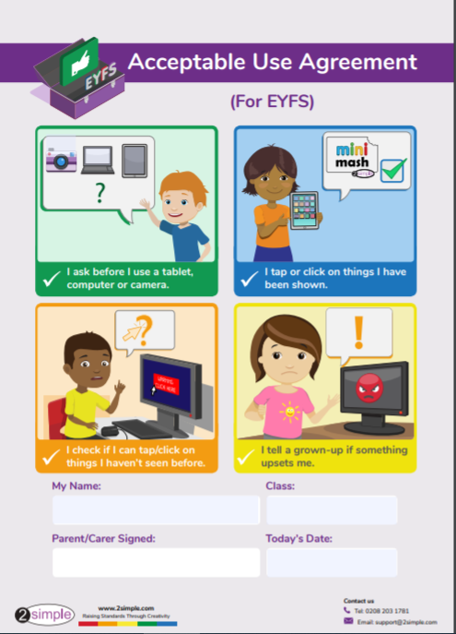
Appendix B

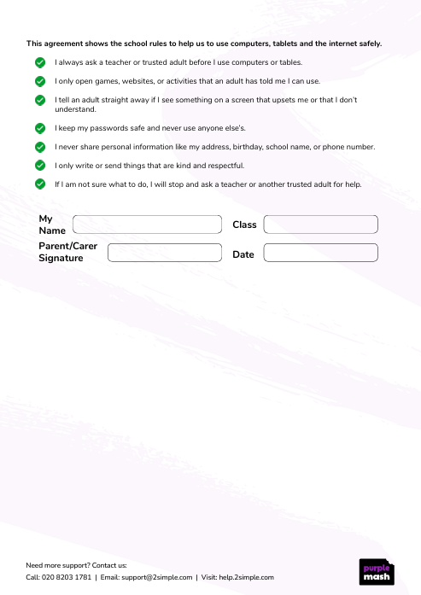
Appendix C
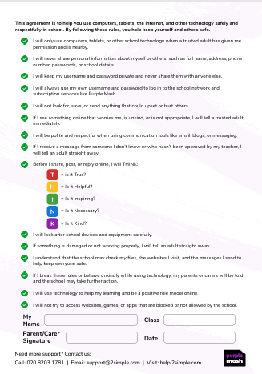

Appendix D
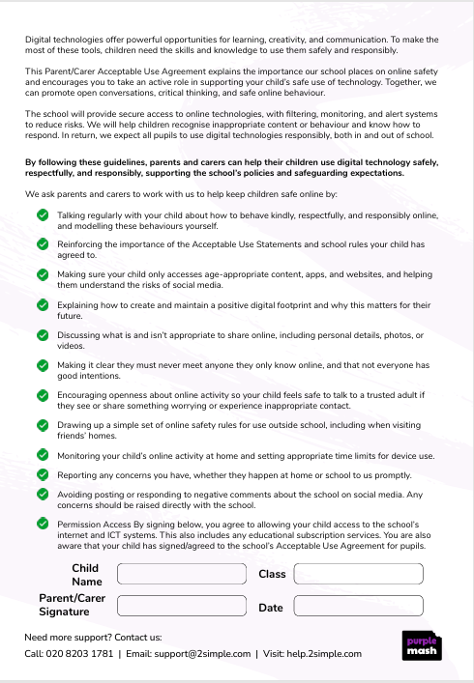
Appendix E
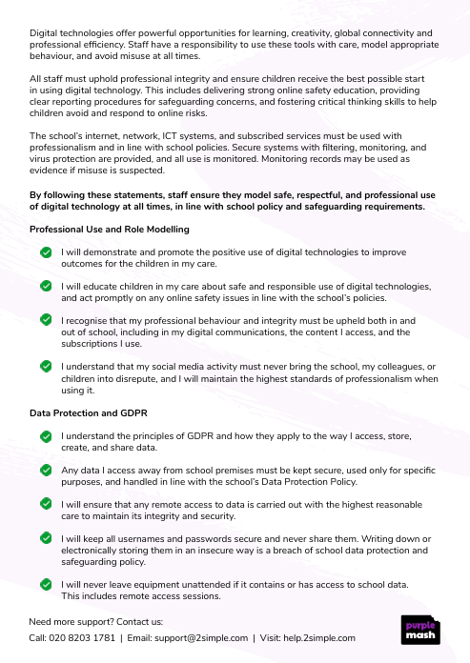

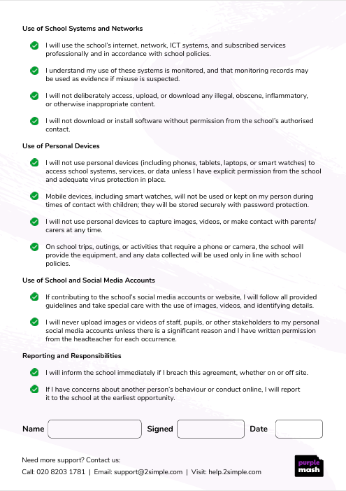
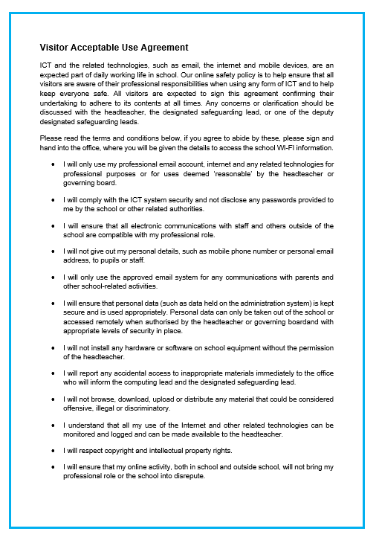
Appendix F

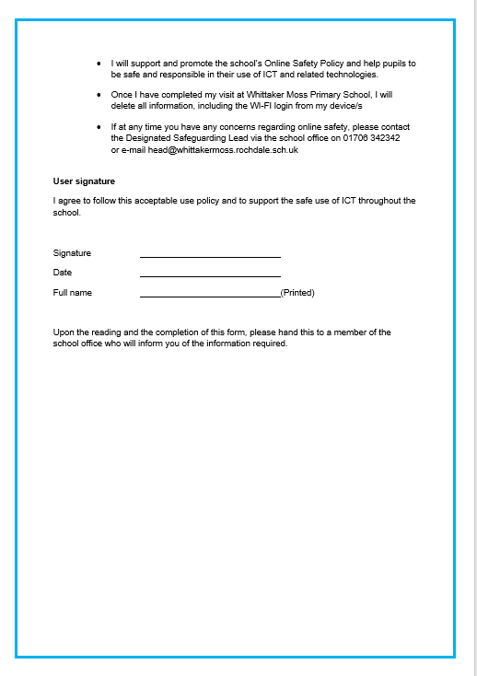
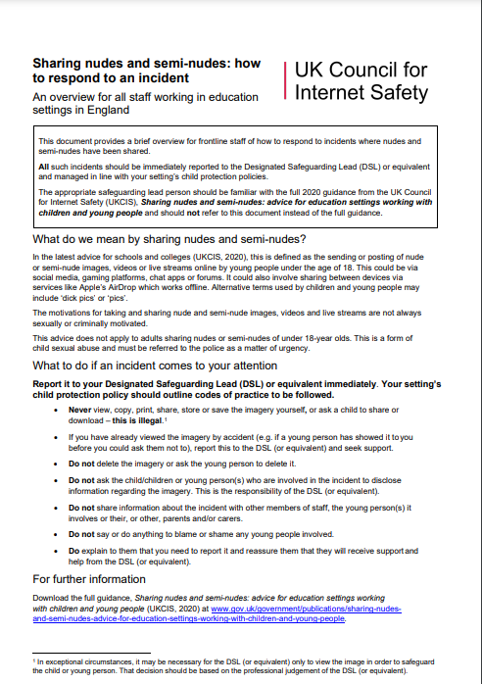
Appendix G

Appendix H
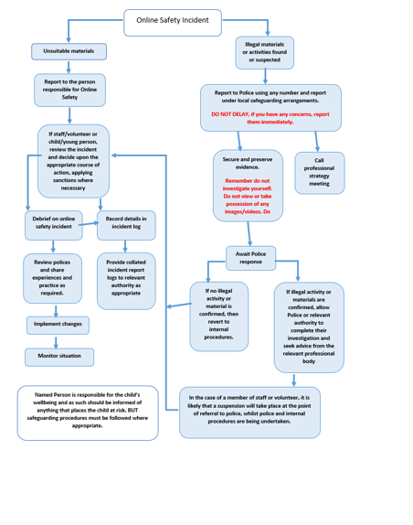
Responding To An Online Safety Incident
Appendix I

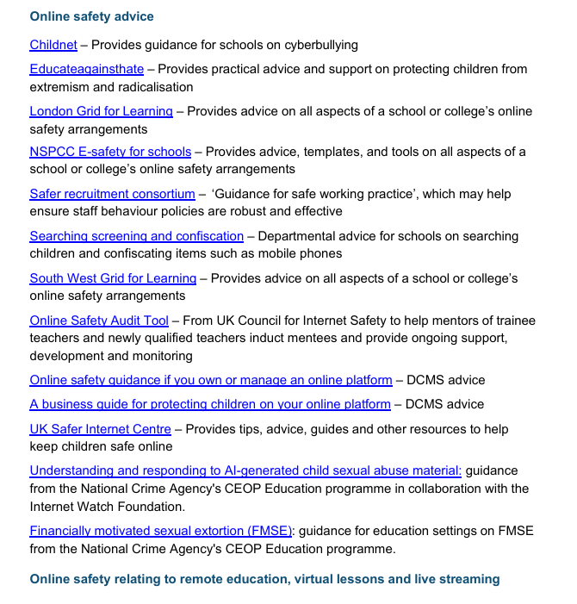

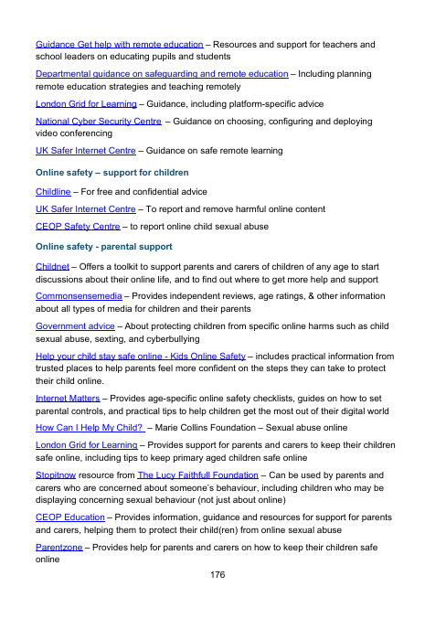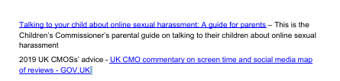

Appendix J


