Art/Design Technology
Embossed pattern and pictures/Making jewellery/ Making Vehicles/ Neolithic art/ Clay-tool design

Numeracy
- Place value, including negative numbers
- Addition and subtraction
- Multiplication and division
- Geometry- 2D/ 3D shape
- Time
- Fractions and Decimals

Literacy
Fiction– Authors and Letters/ Adventure and mystery/ Myths and legends
Non-fiction – Instructions
Quality Texts - Duffy’s Lucky Escape/ Operation Gadgetman/ Traction Man/ Stone Age Boy/ How to Wash a Wooly Mammoth

Year 3 and 4

Mighty Metals / Tribal Tales

Curriculum Overview
Autumn Term

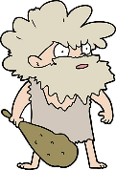
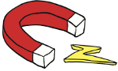

Cross Curricular Themes:
History- Prehistoric Britain from the Stone Age to Iron Age
Geography- Fieldwork/human and physical geography
Computing- Creating spreadsheets/ using presentation software
Mathematics-measuring length
Music-performing using metal objects for instrument
PE- Using PE Equipment to explore forces

Science
Forces and Magnets/Materials
-Group materials
-How magnets attract and repel
-Exploring forces

PE/Games
Football
Netball
Hockey
Gymnastics
Dance

