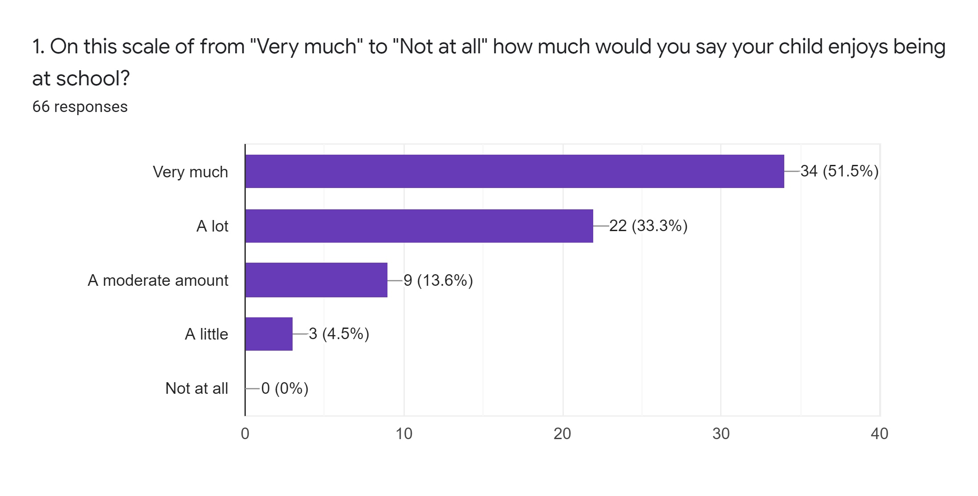
Action: We will take pupil voice through surveys and suggestions at school council meetings on what we can do to improve school.

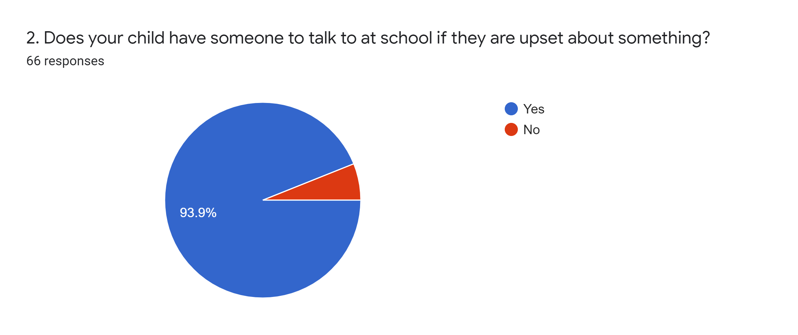
Action: We will create posters to highlight who they can speak to and signpost children in assemblies to all support available to them. The school council is raising money for friendship benches in both playgrounds.

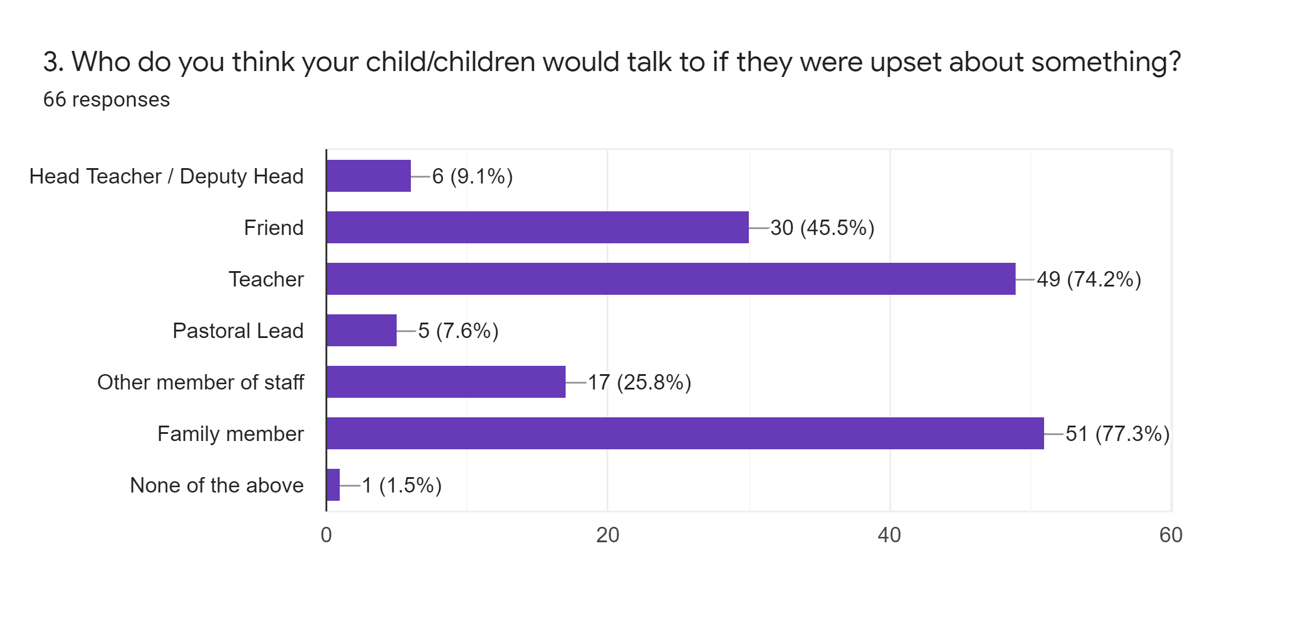
Action: We will create posters to highlight who they can speak to and signpost children in assemblies to all support available to them. The school council is raising money for friendship benches in both playgrounds.

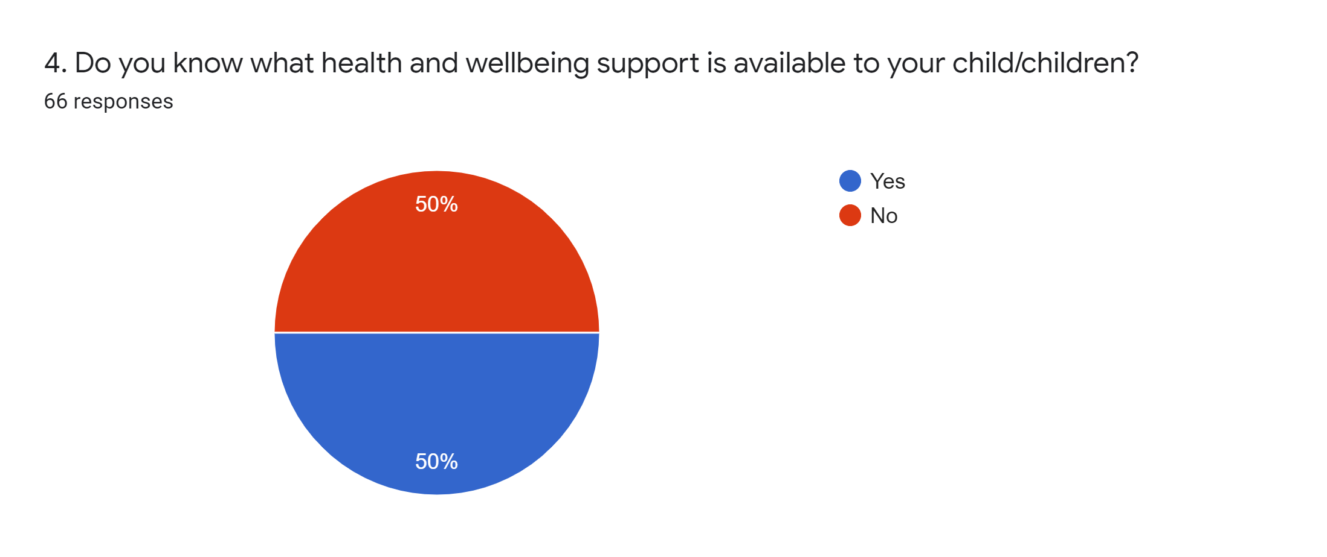
Action: We now produce a termly mental health and wellbeing newsletter for parents. We also have an area dedicated to mental health and wellbeing in the parents’ section of the school website which contains a wealth of mental health and wellbeing resources and signposts parents to local mental health and wellbeing services.

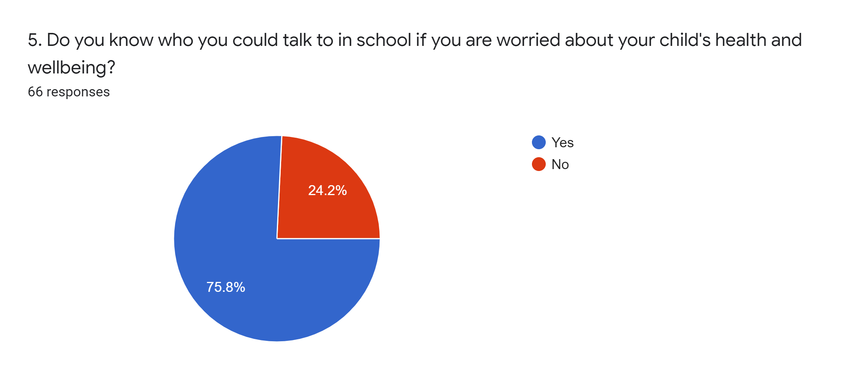
Action: Mrs Cadogan has completed Senior Mental Health training. We now produce a termly mental health and wellbeing newsletter for parents. We also have an area dedicated to mental health and wellbeing in the parents’ section of the school website which contains a wealth of mental health and wellbeing resources and signposts parents to local mental health and wellbeing services. We will display information about the school’s mental health and wellbeing team around school.

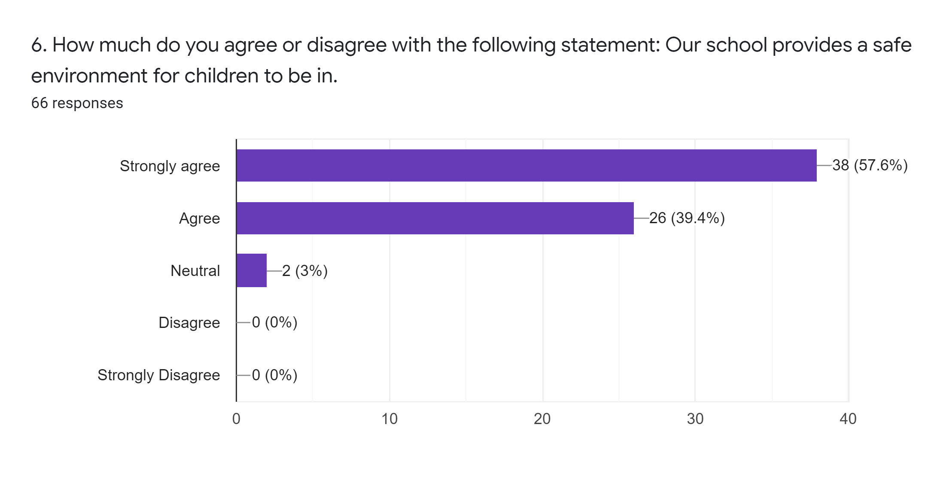
Action: Governors have completed pupil interviews with pupils about feeling safe in school.

7. In this time after lockdowns due to Covid, what do you think our school could do to support the Health and Wellbeing of the community?

Summary of responses:

Guide people on where to go for support.
Keep running Wellbeing Warriors.
More time outdoors.
Keep running Yoga sessions.
More opportunities for team work activities.
Events for the community that are not just for fundraising.
Work with the elderly.
Ensure that there is a good level of communication between home and school.
Get everything back to normal as soon as possible.

8. Is there anything else you would like to share about how we support your child/children with their wellbeing at school?

Summary of responses:

Some parents would like to be signposted to available support.
Make sure children know where to go to receive support.
Would like more small groups to allow children the opportunity to develop their confidence.
Some parents would like further information about the catch-up programme.
Some parents felt they would like to see more opportunities for children to be rewarded for their efforts e.g. lunch with the Headteacher.
Several parents commented that the school had supported their child well.

