**Our Big Learning Questions**

* Which machines are part of our everyday life?
* How do machines help us?

As artists we will be …

* Using age appropriate software to create images and record sounds and videos.
* Exploring ways to create simple rhythms and sound effects using found objects, percussion instruments and our voices.

As designers we will be …

* Making large scale models of different vehicles.

In RE we will be discovering…

* Which stories are special and why.

In Life Skills (Think Equal) lessons we will be exploring…

* Kindness and performing acts of kindness
* 5 different emotions: shy, bored, nervous, confused and surprised.

In Healthy Relationships Education we will be exploring …

* the development of relationships with other children through circle time activities and turn-taking games.

As historians and geographers, we

will discover…

* The different transport that has existed through the ages.
* How machines have changed over time.

In PE we will be …

* using basic choreography, we will increase our body awareness, creativity and develop choreographic skills, performance skills and appreciation.

In phonics we will be learning…

* Phase 2 phonics sounds following the Bug Club Phonics Scheme.
* We will then be moving on to Phase 3

Using our computing skills, we will be …

* Using the class tablets
* Finding out how to stay safe online
* Exploring how machines help us in everyday life

As mathematicians we will be learning …

Number

* Subitisng to 5
* Looking at the composition of 4,5
* Introducing 0
* Finding 1 more and 1 less
* Composition of numbers to 5

Shape

* Shapes with 4 sides

Following the White Rose Scheme

**Reception**

**Autumn 2**

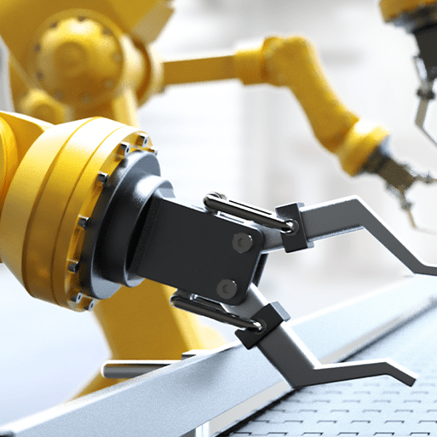

**Marvellous Machines**

As readers we will be reading …

*Izzy Gizmo by Pip Jones

*Chicken Clicking by Jeanne Willis and Tony Ross

*No Bot the Robot with No Bottom by Paul Linnet and Sue Hendra

The children will demonstrate understanding of what has been read to them by retelling stories and narratives using their own words and recently introduced vocabulary.

As writers we will be …

* Developing our pencil grip and fine motor skills.
* Writing labels, lists and captions using our phonics knowledge
* Giving meaning to all of our marks.
* Writing a character description linked to our key quality texts.

As scientists we will …

* be using our senses and communication skills to explore and talk about our immediate environment.
* Exploring collections of materials with similar and/or different properties.