Literacy

Determiners

Clauses

Direct speech

Narrative

Myths and legends

Descriptive language

i

Mathematics

Mental multiplication and division up to 12x

Written division and multiplication methods up to 2 digits.

Area

Fractions – recognising, fractions of amounts, counting in tenths, fractions greater than one, equivalent fractions, adding and subtracting fractions.

Decimals – recognising and ordering tenths and hundredths.

MC900239011[1]

Art/Design Technology **Anglo Saxon** patterns(printing), brooches. Vikings – long ship, warrior sketch, Northern Lights

**Cooking** – granola bars

Burps – mirror faces, Paul Klee & Picasso style abstract faces, Digestive system models, Da Vinci sketches.

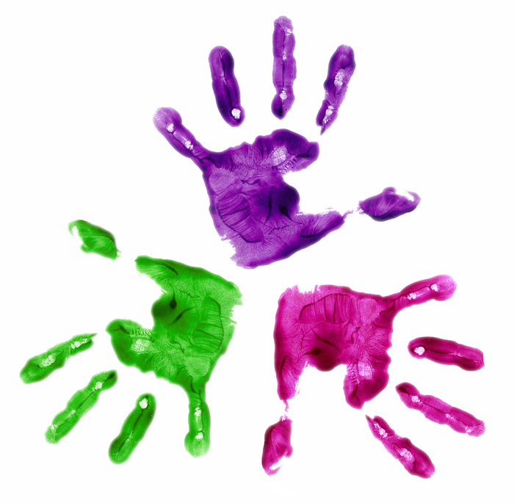

Class 4M

Curriculum Overview

Spring Term

History/Geography

Vikings and Anglo-Saxons

Invasions, settlements, way of life, evidence, homes, influence on modern life.

Counties of England, major cities, reasons for settlement.

Science

Teeth and eating/healthy diet

Human digestive system

.

PE/Games

Games – Hockey and Basketball

PE – Gymnastics and Dance

MC900292470[1]