In RE we will be discovering…

* Which people are special and why.

In Life Skills (Think Equal) lessons we will be exploring…

* The 5 senses.
* How both boys and girls can both express their feelings and achieve the same things

In Healthy Relationships Education we will be exploring …

* the development of relationships with other children through circle time activities, turn-taking games and the community circle.

**Our Big Learning Questions**

* How have we grown and changed since we were babies?
* How was life in the past, different to today?

As readers we will be reading …

*The Tiger Who Came to Tea by Judith Kerr

*Peepo by Janet and Allan Ahlberg

The children will demonstrate understanding of what has been read to them by retelling stories and narratives using their own words and recently introduced vocabulary. Children will retell the stories using actions to support them.

In PE we will be …

* Travelling and making fundamental gymnastic shapes.
* Rolling – forward, backwards, side to side and circle (teddy rolls)
* Using apparatus to travel and balance and travelling at different levels.
* Balancing using different parts of their body.

In phonics we will be learning…

* Phase 3 phonics sounds following the Bug Club Phonics Scheme.
* Recalling common exception words from Phase 2 and learning Phase 3 words.

As artists we will be …

* Exploring ways to create simple rhythms and sound effects using found objects, percussion instruments and our voices to create a lullaby.

As designers we will be …

* Constructing models to represent objects and buildings from the past.

As historians and geographers, we

will discover…

* Objects from the past and how they have changed.
* How we have changed over time.
* Pictures of the local area (Greenbooth) and how it has changed over time.

Using our computing skills, we will be …

* Using the class tablets to play educational games and take photographs.
* Finding out how to stay safe online

As mathematicians we will be learning …

Number

* Mass and Capacity
* Growing 6,7,8 (making pairs, odd and even numbers, doubles to 8 and finding 1 more or 1 less, combining 2 groups)

Following the White Rose Scheme

**Reception**

**Spring 1**

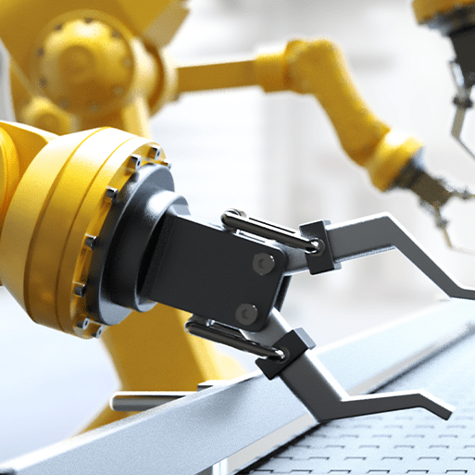

**Long Ago**

As writers we will be …

* Refining our pencil grip and fine motor skills.
* Practicing letter formation through handwriting activities.
* Segmenting to spell unfamiliar words.
* Writing a recount and instructions/recipes.

As scientists we will …

* be exploring how we have changed over time.
* exploring how the weather and the seasons change.