 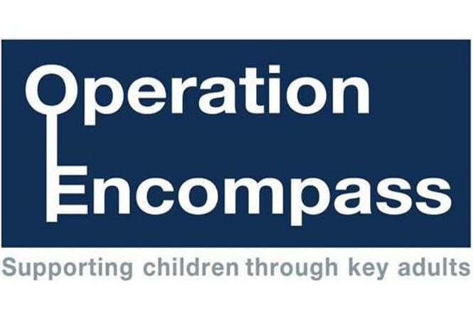

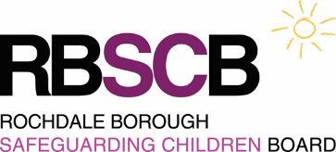 

**School commitment statement**

As part of Whittaker Moss Primary School’s commitment to keeping children safe we have signed up to implement the principles and aims of the Encompass Model.

In signing up to Encompass the Governing Body and Senior Leadership Team:

• Endorse the Encompass Model and support the Key Adults in our school to fulfil the requirements of the Rochdale Encompass Protocol

• Promote and implement Rochdale Encompass processes and use these in accordance with internal safeguarding children processes

• Recognise the sensitive nature of the information provided and ensure that this is retained in accordance with the principles of data protection

Signature 1 Signature 2



Mr Frank Hayley

**Chair of Governors Head Teacher**