**Our Big Learning Questions**

* Where does food come from?
* What do animals and plants need to grow and survive?
* What is a healthy lifestyle?

In RE we will be discovering…

* Which people are special and why.

In Life Skills (Think Equal) lessons we will be exploring…

* The 5 senses.
* How both boys and girls can both express their feelings and achieve the same things

In Healthy Relationships Education we will be exploring …

* the development of relationships with other children through circle time activities, turn-taking games and the community circle.

As readers we will be reading …

* The Enormous Turnip (Ladybird version)

* Oliver’s Vegetables by Alison Bartlett and Vivian French

The children will demonstrate understanding of what has been read to them by retelling stories and narratives using their own words and recently introduced vocabulary. Children will retell the stories using actions to support them.

In PE we will be …

* Travelling and making fundamental gymnastic shapes.
* Rolling – forward, backwards, side to side and circle (teddy rolls)
* Using apparatus to travel and balance and travelling at different levels.
* Balancing using different parts of their body.

In phonics we will be learning…

* Phase 3 phonics sounds following the Bug Club Phonics Scheme.
* Recalling common exception words from Phase 2 and learning Phase 3 words.

As artists we will be …

* Using fruit and vegetables to create faces in the style of Giuseppe Arcimboldo.

As designers we will be …

* Designing and then constructing seed shakers using a range of materials.

As historians and geographers, we

will discover…

* How farming has changed over the years.
* Spring walk – signs of Spring.

Using our computing skills, we will be …

* Using the class tablets to play educational games and take photographs.
* Finding out how to stay safe online

As mathematicians we will be learning …

* Building 9 & 10 – finding 1 more and 1 less, number bonds to 10, odd and even numbers and doubles to 10.
* Exploring 3D shapes – recognising and naming 3d shapes. Exploring shapes in the environment and creating patterns.

Following the White Rose Scheme

**Reception**

**Spring 2**

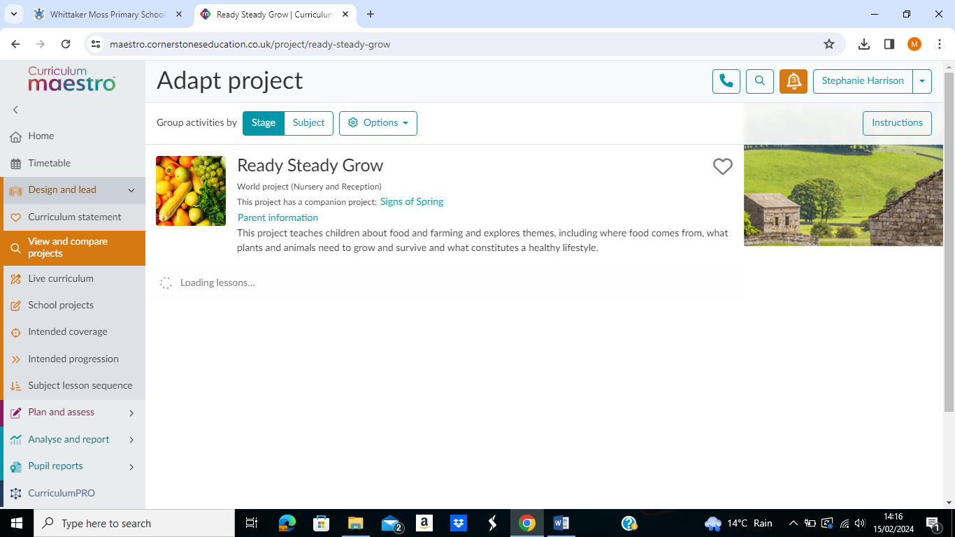

**Ready, Steady, Grow!**

As writers we will be …

* Refining our pencil grip and fine motor skills.
* Practicing letter formation through handwriting activities.
* Segmenting to spell unfamiliar words.
* Writing a recount and instructions/recipes.

As scientists we will …

* Planting and growing
* Looking at animals and their babies
* Taking part in Science week – Activities linked to Time.