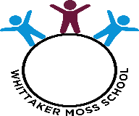
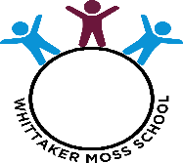
Knowledge and Skills Map – Geography – Geographical Enquiry

Year 1 | Year 2 | Year 3
- Can they identify what they like and don’t like about a locality?  - Can they answer questions using different resources, such as books, the internet and atlases/maps?  - Can they think of a few relevant questions to ask about locality? | - Can they label a diagram or photograph using some geographical words?  - Can they find out about a locality by asking some relevant questions? | - Can they use correct geographical words to describe a place and the events that happen there?  - Can they use some basic map symbols?
Year 4 | Year 5 | Year 6
- Can they carry out research, such as a survey, to discover features of a location?  - Can they find the same place on a globe, atlas or map?  - Can they label the same features on an aerial photograph as on a map?  - Can they plan a journey to a place? | - Can they research and collect information about a place and present it? E.g., a report, a poster, a brochure.  - Can they find possible answers to their own geographical questions? | - Can they confidently explain scale and use maps with a range of scales?  - Can they choose the best way to collect information needed and decide the most appropriate units of measure?  - Can they take careful measurements and use the data? E.g., rainfall, population, temperature, sea level.

